Risk Assessment
Risk Assessment for the activity of | SUSU Fresher’s Bunfight |  | Date | Week Zero of Academic Year 2026/2027
Unit/Faculty/Directorate/Club or Society | Neurodiversity and Disability Society | Assessor | Joseph Robbins
Line Manager/Supervisor/President | Millie Carter | Signed off
Description of activity/event | An event to provide Freshers with information about NDD soc and offer them the opportunity to join.  We aim to bring a sports wheelchair for students to try to see if they would like to participate in accessible sports and to raise awareness of Jubilee having them.

PART A
(1) Risk identification |  |  | (2) Risk assessment |  |  |  | (3) Risk management
Hazard | Potential Consequences | Who might be harmed  (user; those nearby; those in the vicinity; members of the public) | Inherent |  |  |  | Residual |  |  | Further controls (use the risk hierarchy)
Hazard | Potential Consequences |  | Likelihood | Impact | Score | Control measures (use the risk hierarchy) | Likelihood | Impact | Score | Further controls (use the risk hierarchy)
Slips, trips and falls | Physical injury, potentially exacerbated by alcohol consumption. | Event organisers, event attendees | 2 | 3 | 6 | Committee to check that chosen venues meet the following requirements:  - Venue is in good condition with no major trip hazards.  - Staff monitor the condition of the floors & mop up split drinks.  - Security staff & staff provide first aid cover.  Report any trip hazards to venue staff asap. | 1 | 3 | 3 | If the injury is serious and participant in a lot of pain or discomfort, seek medical attention immediately.  Call 999 in an emergency.  Any incidents need to be reported as soon as possible ensuring duty manager/health and safety officers have been informed.  Follow SUSU incident report policy.
Fire | Smoke inhalation, burns. Risk of extreme harm. | All participants and organisers | 1 | 5 | 5 | Those leading the session must ensure they are aware of and fully understand the venue or location’s fire procedures.  Those leading must make sure that all exit routes are clearly highlighted and report any issues immediately to the venue.  Avoid build-up of debris in the activity area.  Consider accessibility requirements. | 1 | 4 | 4 | In case of an emergency, pull nearest fire alarm and ensure all participants leave the venue calmly and safely.  Once in a safe position to do so, call the emergency services on 999.  Any incidents need to be reported as soon as possible ensuring duty manager/health and safety officers have been informed.  Follow SUSU incident report policy.
Overcrowding | Physical injury, distress, exclusion | Event organisers and attendees | 2 | 3 | 6 | Do not push/shove.  Committee checks on space, lighting, access, tech available, etc.  Ensure space meets needs of members e.g. considering location & accessibility of space (use AcessAble database to check accessibility information).  Committee to consult members on needs and make reasonable adjustments where possible. | 1 | 3 | 3 | Seek medical attention if problem arises  Welfare Officer to complete WIDE training.  All incidents are to be reported on the as soon as possible ensuring the duty manager/health and safety officer have been informed.  Follow SUSU incident report policy
Medical emergency | Members may sustain injury /become unwell  Pre-existing medical conditions, sickness, distress | Event organisers and attendees | 1 | 5 | 5 | Advise participants to bring their personal medication if it might be required.  Committee to carry out first aid if necessary and only if qualified and confident to do so.  Contact emergency services as required 111/999.  Contact venue staff for first aid support. | 1 | 4 | 4 | Incidents are to be reported on the as soon as possible ensuring the duty manager/health and safety officer have been informed.  Follow SUSU incident report policy.
Manual setup and handling of the stall. | Potential injury such as cuts, bruises, and muscle strains. | Attending committee, SUSU staff. | 3 | 3 | 9 | The stall/table should be carried by two people.  Teamwork and communication when handling other large and heavy items.  Committee will ask for help from SUSU staff if unable to move the stall themselves. | 2 | 2 | 4
Sports wheelchair | Potential injury such as rolling over someone’s foot. | Attending committee, students, staff. | 4 | 1 | 4 | The attending committee will clearly communicate the rules of trying the sports wheelchair.  Attending committee will make sure students stand back from the sports wheelchair while in use. | 2 | 1 | 2

PART B – Action Plan

Risk Assessment Action Plan
Part no. | Action to be taken, incl. Cost | By whom | Target date |  | Review date | Outcome at review date
1 | Organisers to ensure they have read the Expect Respect policy, and shared with members | Attending committee
2 | WIDE training completed by welfare officer | Joseph Robbins | Completed
3 | Any major incidents will be logged with SUSU the next day | Relevant committee member
4 | Communication with SUSU to provide an accessible stall location | Millie Carter | 30th August 2026

5

6

7
8
Responsible committee member signatures: Date: 03/08/26  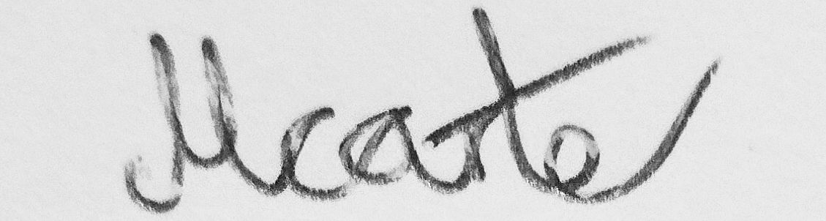  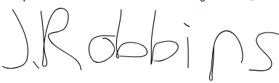 |  |  |  |  | Responsible manager’s signature:
Print names: Joseph Robbins & Millie Carter |  |  |  |  | Print name: |  | Date:

Assessment Guidance
- Eliminate | Remove the hazard wherever possible which negates the need for further controls | If this is not possible then explain why
- Substitute | Replace the hazard with one less hazardous | If not possible then explain why
- Physical controls | Examples: enclosure, fume cupboard, glove box | Likely to still require admin controls as well
- Admin controls | Examples: training, supervision, signage
- Personal protection | Examples: respirators, safety specs, gloves | Last resort as it only protects the individual
LIKELIHOOD | 5 | 5 | 10 | 15 | 20 | 25
LIKELIHOOD | 4 | 4 | 8 | 12 | 16 | 20
LIKELIHOOD | 3 | 3 | 6 | 9 | 12 | 15
LIKELIHOOD | 2 | 2 | 4 | 6 | 8 | 10
LIKELIHOOD | 1 | 1 | 2 | 3 | 4 | 5
 |  | 1 | 2 | 3 | 4 | 5
 |  | IMPACT

Impact |  | Health & Safety
1 | Trivial - insignificant | Very minor injuries e.g. slight bruising
2 | Minor | Injuries or illness e.g. small cut or abrasion which require basic first aid treatment even in self-administered.
3 | Moderate | Injuries or illness e.g. strain or sprain requiring first aid or medical support.
4 | Major | Injuries or illness e.g. broken bone requiring medical support >24 hours and time off work >4 weeks.
5 | Severe – extremely significant | Fatality or multiple serious injuries or illness requiring hospital admission or significant time off work.
Risk process
- Identify the impact and likelihood using the tables above.
- Identify the risk rating by multiplying the Impact by the likelihood using the coloured matrix.
- If the risk is amber or red – identify control measures to reduce the risk to as low as is reasonably practicable.
- If the residual risk is green, additional controls are not necessary.
- If the residual risk is amber the activity can continue but you must identify and implement further controls to reduce the risk to as low as reasonably practicable.
- If the residual risk is red do not continue with the activity until additional controls have been implemented and the risk is reduced.
- Control measures should follow the risk hierarchy, where appropriate as per the pyramid above.
- The cost of implementing control measures can be taken into account but should be proportional to the risk i.e. a control to reduce low risk may not need to be carried out if the cost is high but a control to manage high risk means that even at high cost the control would be necessary.

Likelihood
1 | Rare e.g. 1 in 100,000 chance or higher
2 | Unlikely e.g. 1 in 10,000 chance or higher
3 | Possible e.g. 1 in 1,000 chance or higher
4 | Likely e.g. 1 in 100 chance or higher
5 | Very Likely e.g. 1 in 10 chance or higher

