 |  | Risk Assessment
Risk Assessment for the  activity of |  | Fresher’s Football |  |  |  |  |  |  |  |  |  |  | Date |  |  |  | 22/09/2025
 |  |  | EVENT TIME – 3:30 PM |  |  |  |  |  |  |  |  |  |  |  |  |  | 22/09/2025
 |  |  | EVENT LOCATION – CANTELL SCHOOL. POSTCODE: SO16 3GJ |  |  |  |  |  |  |  |  |  |  |  |  |  | 22/09/2025
Unit/Faculty/Directorate |  | University of Southampton Islamic Society |  |  |  |  |  |  |  | Assessor |  |  | Ahmed Hamidan Rabiu
Line  Manager/Supervisor |  | Ibrahim Khan |  |  |  |  |  |  |  | Signed off
Description of event/activity |  | An annual fresher’s event held by the ISOC where attendees play football in teams of 7.  Venue Location: Cantell School, Violet Road, Southampton, SO16 3GJ  Venue Contact Information: 07484921691  Event Time: 15:30 – 17:30  Event Date: 27/09/2025  Max No. Attendees: 50
PARTA
(1) Risk identification |  |  |  |  | (2) Risk assessment |  |  |  |  |  |  | (3) Risk management
Hazard | Potential  Consequences |  |  | Who might be harmed  (user; those nearby; those in the vicinity;  members of the  public) | Inherent |  |  |  |  |  |  | Residual |  |  |  | Further controls (use the risk hierarchy)
 |  |  |  |  | Likelihood |  | I  m p a  c  t | S c o r e | Control measures (use the risk hierarchy) |  |  | L  i  - e  - i h  o o d |  | I  m p a  c  t | S c o r e

Injuries to players | Physical injuries…  - Broken bones  - Grazes  - Muscle  injuries/pulled muscles  - Cuts and Bruises  - Nose bleeds  - Head injuries | Whoever is playing | 3 | 4 | 12 | - First aid kit available  - Having someone in charge to invigilate the match | 2 | 4 | 8 | - Players should warm up and cool down before and after the match.  - Someone should be refereeing the matches to ensure nothing gets out of hand (i.e. no one is making any silly  challenges)  - Someone making rash challenges should be removed from the pitch and should not be allowed to continue playing
Footwear  (inappropriate footwear,  such as sharp studs) | - Injury to other players  - Injury to themselves | - Opposition players  - The user | 1 | 3 | 3 | Players should only wear astro-shoes/rubber studs | 1 | 3 | 3 | Organiser to ensure everyone is wearing  suitable footwear before getting onto the pitch
General state of the pitch | ● Slipping and sliding causing injuries | Players | 1 | 3 | 3 | Inspecting the pitches regularly to see if they are  playable | 1 | 2 | 2 | Organiser should check the condition of the pitch  before every session to see  if it is in playable condition  or not

PARTA
(1) Risk identification |  |  | (2) Risk assessment |  |  |  |  | (3) Risk management
Hazard | Potential  Consequences | Who might be harmed  (user; those nearby; those in the vicinity;  members of the  public) | Inherent |  |  |  |  | Residual |  |  | Further controls (use the risk hierarchy)
Hazard | Potential  Consequences |  | Likelihood | I  m p a  c  t | S c  o r e | Control measures (use the risk hierarchy) |  | Likelihood | I  m p a  c  t | S c  o r e | Further controls (use the risk hierarchy)
Jewellery | - Jewellery could get caught in something or on someone  - Earrings can be sharp and potentially could stab  someone/themselves | ● The user ● Other players | 1 | 3 | 3 | All jewellery and watches must be  removed before a session |  | 1 | 3 | 3 | Organiser should check this before every session and  players should informed not to have harmful object during sessions
Weather conditions | Cold weather could cause…  - Hypothermia  - Colds  Hot weather could cause…  - Dehydration  - Over heating  Rainy/snowy weather… ●  Slipping and sliding causing injuries | Players | 2 | 4 | 8 | ● | Closing off pitches during times of  extreme weather conditions (e.g. during snow, heavy rain) | 1 | 3 | 3 | - Wearing suitable  clothing, i.e. in times of cold weather wearing something warm and in times of hot weather wearing something cool.  - Bringing water to stay hydrated

PARTA
(1) Risk identification |  |  |  | (2) Risk assessmen |  |  |  | (3) Risk management
Hazard |  | Potential  Consequences | Who might be harmed  (user; those nearby; those in the vicinity;  members of the  public) | Inherent |  |  |  | Residual |  |  | Further controls (use the risk hierarchy)
 |  | Potential  Consequences |  | Likelihood | I  m p a c  t | S c  o r e | Control measures (use the risk hierarchy) | Likelihood | I  m p a c  t | S c  o r e
 | State of footballs | - Hard balls could cause injuries to the foot or the head  - Torn balls can be dangerous as could cause cuts | Players | 1 | 2 | 2 | - Checking the pressure of each ball  - Checking if the balls are in good condition | 1 | 2 | 2 | - Buying new balls if need be  - Pumping/deflating the balls to optimum pressure
 | Aggressive behaviour (verbal or physical) | - Conflict, emotional harm, physical injury | Players | 3 | 3 | 9 | - Set clear behaviour expectations at start; enforce rules fairly; | 2 | 2 | 4 | - remove individuals if  behaviour escalates.
 | Goal posts and fences  around the pitches | ● Players could run into the goal posts or fences causing injury | Players/goalkeepers | 2 | 4 | 8 | ● There is distance between the football pitch and the fence allowing players to slow down and stop themselves before hitting the fence | 1 | 4 | 4 | ● Ensuring players wear the right footwear and the conditions of the pitches are suitable and will allow players to stop themselves quickly before  hitting the fence/goal post
 | Medical emergency | - Members may sustain injury /become unwell  - pre-existing medical conditions Sickness Distress | Players | 3 | 5 | 15 | - Advise participants; to bring their personal medication  - Members/Committee to carry out first aid if necessary and only if qualified and confident to do so  - Contact emergency services as required 111/999 | 2 | 5 | 10 | Seek assistance if in need of extra help from facilities staff/venue staff if needed  Seek medical attention from  SUSU Reception if in need  Contact emergency services if needed  All incidents are to be reported on the as soon as possible ensuring the duty manager/health and safety officer have been informed.  Follow SUSU incident report policy
 | Overcrowding | - Physical injury | players | 1 | 3 | 3 | - Do not push  - Book cantell during quieter times when less activites take place | 1 | 3 | 3 | Seek assistance if in need of extra help from facilities staff/venue staff if needed  Seek medical attention from  SUSU Reception if in need  Contact emergency services if needed  All incidents are to be reported on the as soon as possible ensuring the duty manager/health and safety officer have been informed.  Follow SUSU incident report policy
 | Theft (personal items, kit, cash, club equipment) | - Loss of property; distress; disruption to session; financial loss | Players, organisers | 2 | 3 | 6 | - Advise participants not to bring valuables; announce secure area for bags; keep equipment supervised | 1 | 2 | 2 | Seek assistance if in need of extra help from facilities staff/venue staff if needed  Seek medical attention from  SUSU Reception if in need  Contact emergency services if needed  All incidents are to be reported on the as soon as possible ensuring the duty manager/health and safety officer have been informed.  Follow SUSU incident report policy
 | PARTB–ActionPlan

Risk Assessment Action Plan
Par t no. | Action to be taken, incl. Cost | By whom | Target date | Review date | Outcome at review date
1 | Ensure all control measures are implemented | Relevant committee members – president to ensure complete | 27/09/25 | 27/09/25 | Follow Guidance
2 | Committee to read and share SUSU Expect Respect Policy | Relevant committee members – president to ensure complete | 27/09/25 | 27/09/25 | Follow Guidance
3 | Individual risk assessments and football safety briefing to be completed by each attending individual | Committee members to ensure all attendees have completed health and safety briefing | 27/09/25 | 27/09/25 | Minimise risk
4 | Ensure a first aid kit and first aid trained individual is present in case of any sporting injuries | Relevant member in charge of event | 27/09/25 | 27/09/25 | Follow Guidance
5 | Ensure good sportsmanship is discussed before-hand to avoid serious injuries | Committee member in charge of the event | 27/09/25 | 27/09/25 | Follow Guidance

1. Eliminate | Remove the hazard wherever possible which negates the need for further controls | If this is not possible then explain why |  | 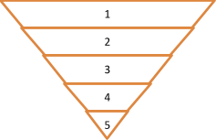
2. Substitute | Replace the hazard with one less hazardous | If not possible then explain why
3. Physical controls | Examples: enclosure, fume cupboard, glove box | Likely to still require admin controls as well
4. Admin controls | Examples: training, supervision, signage
5. Personal protection | Examples: respirators, safety specs, gloves | Last resort as it only protects the individual
Print name: Ahmed Hamidan Rabiu |  | Date:  10/09/2025 | Print name: Ibrahim Khan  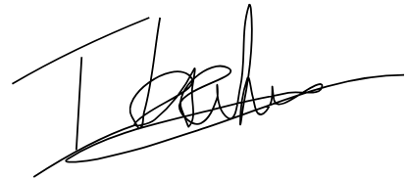 Date:  22/09/2025

Assessment Guidance
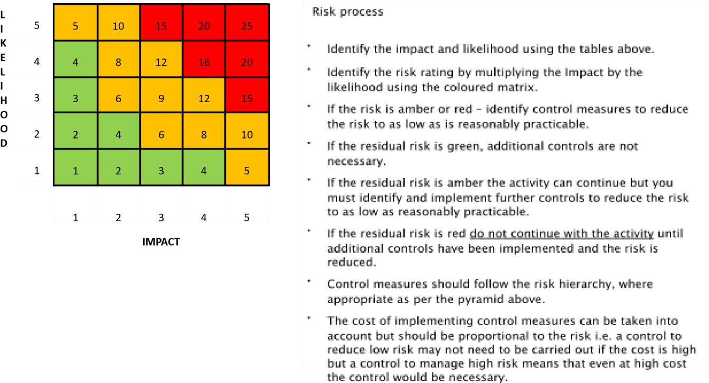
  Impact |  |  | Health & Safety
  1 | Trivial insignificant |  | Very minor injuries e.g. slight bruising
  2  Likeli | hood Minor |  | Injuries or illness e.g. small cut or abrasion which require basic first aid treatment even in
  1 |  | Rare e.g. | 1 inself-administered.100,000 chance or
   |  |  | higher
  23 | Mode | rateUnlikely  e | .g.Injuries1 in 10,000or  chanceillnessore.g.higherstrain or
  3 |  | Possible e | sprain requiring first aid or medical .g.support.1 in 1,000 chance or higher
  44 | Major | Likely e.g. | 1Injuriesin 100 chanceor illnessor highere.g. broken bone
  5 |  | Very Likel | y e.g.requiring1 in 10 chancemedicalor highersupport >24
   |  |  | hours and time off work >4 weeks.
  5 | Severe – extremely significant |  | Fatality or multiple serious injuries or illness requiring hospital admission or significant time off work.

