Risk Assessment
Risk Assessment for the activity of | University of Southampton Islamic Society (ISOC)’s General Activity throughout the academic year 2025–26 including:  - Weekly Islamic Classes (Qur’an, Arabic, Tafsir)  - Jummah (Friday Prayer)  - Daily congregational prayers  - Social events (meals, bowling, city socials)  - Charity dinners  - Fundraising events  - Information stands (Bunfight & awareness stalls)  - External speaker events  - Weekly football (Cantell School)  - Occasional trips (Fareham Nando’s, New Forrest etc) |  | Date | Date of completing the RA 17/02/26
Group name | Islamic Society | Assessor | Jubar Bari
Supervisor | Ibrahim Khan | Signed off | SUSU USE ONLY
Description of event/activity | ISOC runs regular religious, social and sporting activities throughout the academic year 2025–26. These include:  Weekly Islamic Classes:  - Tuesdays 6:30–8:30pm  - Usually in the Muslim Prayer room  - 10-25 attendees  - Organised and delivered by current members  - Equipment: TV, Microphone, Laptop, Camera  Weekly football:  - Every Saturday 3:30pm-5:30pm  - Cantell School 3G Pitch  - 20-30 participants  - Supervised by Sports Officer. Other committee member may step in if Sports Officer is not present  - Participants arrange own transport  - Warm-up supervised before play  - Weather dependent (cancelled if unsafe)  Jummah (Friday Prayer):  - Friday afternoon (usually between 12-1:30pm)  - Prayer room and/or Garden Court  - 150-300 attendees  - All committee members help organise  - Equipment: speakers and microphone  Social events:  - 2-3 a semester  - Restaurants (Portswood, St Mary’s etc)  - Bowling  - Study socials  - 20-60 attendees  - Typically in the evening  - Some events on campus (prayer room, lecture theatre etc)  - Alcohol is not organised, promoted or encouraged by the ISOC  - Code of Conduct shared before events  - WhatsApp groups created for coordination  Charity dinner:  - Twice a year  - External licensed venue (usually Khan’s in St Mary’s)  - Ticketed event via SUSU Box office  - Approx. 50 attendees  - Allergen information collected at ticket purchase  - Venue food hygiene rating checked prior to booking  - Committee arrives early for setup and safety briefing  Information stands:  - Bunfight  - Occasional awareness stalls (Discover Islam Week)  - No more than 2-3 committee members present  - Happens maybe two or three times a year  Ramadan:  - Daily Congregational prayers increased attendance. (150-250 for Maghrib and Taraweeh)  - Daily Iftar gatherings (150-250 attendees)  - Food from an external supplier (would be covered in Ramadan RA)  - Events run after Sunset  - Separate risk assessment made  Daily prayers:  - Held in muslim prayer room  - Up to 5 times daily  - Attendance 5-40 members  - Self-organised by members  - Microphone and speakers required  speaker events:  - 2-3 a year  - Held in lecture theatres or prayer room  - 30-60 attendees depending on speaker  - External speaker approval form submitted prior to confirmation  - Projector, microphone and speakers used

PART A
Hazard | Potential  Consequences | Who  might  be  harm  ed  (user;  those  nearb  y;  those  in the  vicini  ty;  mem  bers  of the  publi  c) | Inherent |  |  |  | Residua |  |  | Further controls (use the risk
Hazard | Potential  Consequences |  | L  i  k  e  l  i  h  o  o  d | I  p  a  c  t | S  c  o  r  e | Control measures  (use the risk  hierarchy) | L  i  k  e  l  i  h  o  o  d | I  p  a  c  t | r
ISOC meetings, socials and weekly classes (Arabic, Qur’an, Tafsir, etc.,)
Slips, trips and  falls | Physical injury | Event  Organis  ers and  attende  es | 2 | 4 | 8 | • All boxes and equipment  to be stored away from  main meeting area, e.g.  stored under tables  • Any cables to be  organised as best as  possible.  • Cable ties/to be used if  necessary.  • Floors to be kept clear  and dry, and visual checks  to be maintained  throughout the meeting  by organizers.  • Extra vigilance will be  paid to make sure that  any spilled food  products/objects are | 1 | 4 | 4 | • Seek medical attention from SUSU  Reception/venue staff if in need.  • Contact facilities team via SUSU reception/venue  staff.  • Contact emergency services if needed.  • All incidents are to be reported on the as soon as  possible ensuring the duty manager/health and  safety officer have been informed. Follow SUSU  incident report policy

cleaned up quickly and
efficiently in the area.
• Report any trip hazards to
facilities teams/venue
staff asap. If cannot be
removed mark off with
hazard signs
Setting up of  Equipment.  E.g., Table and  chairs | Bruising or  broken bones  from tripping  over table and  chairs. | Meetin  g  organis  ers and  attende  es | 2 | 3 | 6 | • Make stall operators  aware of the potential  risks, follow manual  handling guidelines.  • Ensure that at least 2  people carry tables.  • Setting up tables will be  done by organisers.  • Work in teams when  handling other large and  bulky items.  • Request tools to support  with move of heavy  objects- SUSU  Facilities/venue. E.g.,  hand truck, dolly, skates  • Make sure anyone with  any pre-existing  conditions isn’t doing any  unnecessary lifting and  they are comfortable | 1 | 3 | 3 | • Seek assistance if in need of extra help from  facilities staff/venue staff if needed.  • Seek medical attention from SUSU Reception if in  need.  • Contact emergency services if needed.  • All incidents are to be reported on the as soon as  possible ensuring the duty manager/health and  safety officer have been informed. Follow SUSU  incident report policy
Inadequate  meeting space-  overcrowding,  not inclusive to  all members | Physical injury,  distress,  exclusion | Event  organis  ers and  attende  es | 1 | 3 | 3 | • Committee check on  room pre-booking, checks  on space, lighting, access,  tech available.  • Ensure space meets  needs of members e.g.,  considering location &  accessibility of space. | 1 | 3 | 3 | • Seek medical attention if problem arises.  • Liaise with SUSU reception/activities team on  available spaces for meetings.  • Postpone meetings where space cannot be found.  • Look at remote meeting options for members.  • Committee WIDE training

• Committee to
consult members on needs
and make reasonable
adjustments where possible.
Activities  involving  electrical  equipment  e.g., laptops/  computers | Risk of eye strain,  injury, electric  shock | Event  organis  ers and  attende  es | 2 | 4 | 8 | • Ensure regular breaks  (ideally every 20mins)  when using screens.  • Ensure screen is set up to  avoid glare, is at eye  height where possible.  • Ensure no liquids are  placed near electrical  equipment.  • Ensure all leads are  secured with cable  ties/mats etc. | 1 | 4 | 4 | • Request support and advice from SUSU IT/Tech  teams e.g., via activities team  • For external venues pre-check equipment and last  PAT testing dates  • Seek medical attention as required
Socials-Travel | Vehicles collision  -causing serious  injury | Event  organis  ers,  event  attende  es,  Membe  rs of  the  public | 4 | 3 | 12 | • Members are responsible  for their individual safety  though and are expected  to act sensibly.  • local venues known to  UoS students chosen.  • Event organisers will be  available to direct people  between venues.  • Attendees will be  encouraged to identify a  ‘buddy’, this will make it  easier for people to stay  together. They will be  encouraged (but not  expected) to look out for  one another and check in  throughout the night  where possible. | 2 | 2 | 4 | • Where possible venues chosen for socials will  be local/known to members and within a short  distance from each other.  • Contact emergency services as required  111/999  • Incidents are to be reported on the as soon as  possible ensuring the duty manager/health and  safety officer have been informed.  • Follow SUSU incident report policy

• Avoid large groups of
people totally blocking
the pavement or spilling
into the road.
• Anybody in the group
who is very drunk or
appears unwell and
therefore not safe should
be encouraged to go
home ideally with
someone else. If required
a taxi will be called for
them (ideally SUSU safety
bus will be used, or radio
taxis).
• Be considerate of other
pedestrians & road users,
keep disturbance & noise
down.
Socials/Meetin  gs- Medical  emergency | Members may  sustain injury  /become unwell.  pre-existing  medical  conditions  Sickness  Distress | Membe  rs | 3 | 5 | 15 | • Advise participants; to  bring their personal  medication.  • Members/Committee to  carry out first aid if  necessary and only if  qualified and confident to  do so.  • Contact emergency  services as required  111/999  • Contact SUSU  Reception/Venue staff for  first aid support | 2 | 5 | 1  5 | - Incidents are to be reported on the as soon as  possible ensuring the duty manager/health and  safety officer have been informed.  - Follow SUSU incident report policy
Insufficient  Fire Safety  awareness | If a fire alarm is  triggered, people | Membe  rs | 2 | 10 | 5 | • ensure that members  know where the nearest  fire exist are and the | 1 | 5 | 5 | • All incidents are to be reported as soon as  possible ensuring the duty manager/health and  safety officer have been informed.

 | may not know  where to go-  Crushing, falls,  burns and smoke  inhalation arising  from induced  panic, reduced  space in buildings  and external  walkways,  obstructed fire  exits, build-up of  flammable  materials i.e.  waste  cardboard/boxes. |  |  |  |  | meeting place is outside,  should it be needed  • Build-up of rubbish is to  be kept to a minimum.  Excess build up is to be  removed promptly and  deposited in the  designated areas. |  |  |  | • Call emergency services and University  Security:  • Emergency contact number for Campus  Security:  • Tel: +44 (0)23 8059 3311  • (Ext:3311).
Fundraising Events - For own society or Charity
Handling money | - Card machine theft  - Financial loss to susu  - Technical failure  - Fraudulent transactions  - Data protection risk  - Personal safety risk still exists | Membe  rs,  Particip  ants | 3 | 4 | 12 | No cash is to be collected or handled at any time.  All payments must be made via:  SUSU card machinesOnline ticketing platforms  Approved SUSU payment systems  No society member is permitted to personally store or transport funds.  All fundraising must be approved through the RA/G process.  Encourage pre-purchase of tickets to avoid on-the-day payments.  Where necessary, hire/loan SUSU contactless payment machines.  Committee members must not take responsibility for holding money privately. | 2 | 3 | 6 | In the event of theft committee members will:  • Highlight the incident to any community police  officers in the area/report to 111  • Report incident to SUSU duty manager and c  HYPERLINK  "https://www.susu.org/groups/admin/howto/prote  ctionaccident"omplete a SUSU incident report

Handling &  Storing  Money-  Charity  fundraiser | Theft  Individuals being  mugged/robbed  Loss/misplaceme  nt leading to  financial loss | Membe  rs,  Particip  ants,  Charity | 3 | 4 | 12 | Southampton RAG procedures  will be followed:  • Charity Event form  completed, and RAG  approval will be given  • All food hygiene  certificates and event risk  assessment to be  approved by activities  team  • Sealed collection buckets  with charity banner to be  requested and collected  from SUSU activities/RAG  office at an agreed time  (office hours, Mon-Fri 9-  5)  • Agree time for return  of funds and buckets to  activities team who will | 2 | 3 | 6 | In the event of theft committee members will:  • Highlight the incident to any community police  officers in the area/report to 111  • Report to SUSU Duty manager and Complete a  SUSU incident report

deposit funds and make
payment to the charity.
• Collection buckets to
remain sealed and to not
be left unattended
• Collectors will prioritise
own safety, advised to
not confront any
potential thief. If
confronted will give up
the funds.
• Nominated person will be
tasked with storing cash
in nominated location
when SUSU office not
open.
• Avoid giving cash to
committee member if
they will be travelling by
foot alone (request taxis
where possible/travel by
car. Ensure cash is not
visible/advertised when
out in public)
Events  involving Food | Allergies  Food poisoning  Choking | All | 3 | 5 | 15 | • Individual event risk  assessment to be carried  out for events involving  members making/serving  food.  • Homemade items to be  avoided by those with  allergies and should be  made by those with | 1 | 5 | 5 | • SUSU food hygiene level 2 course available for  completion- requests made to activities team  • Call for first aid/emergency services a required  • Report incidents via SUSU incident report  procedure

appropriate food hygiene
training (Level 2 +)
• Only order/buy food at
establishments with
appropriate food hygiene
rating
• Food to only be
provided/eaten when
other activities are
stopped
• Follow good food hygiene
practices- no handling
food when ill, tie back
hair, wash hands and
equipment regularly
using warm water and
cleaning products,
refrigerate necessary
products
Awareness/Promotional Stand e.g., Bunfight, Dawah Stalls
Overcrowding  at Stall | Reduced space in  walkways and  entrances.  Risk of Students  panicking  because of tight  spaces /  confinement.  Crushing against  fixed structures  from pushing and  shoving.  Aggressive  behaviour. | Membe  rs,  visitors | 2 | 3 | 6 | • A maximum of 2  representatives to be at  the stall at any one time  • Request that orderly ques  are formed.  • Ensure all items are  stored under tables and  monitor area in front of  stall to ensure this is  clear.  • Ensure that organisers  /volunteers do not block  walkways when engaging  with attendees. | 1 | 3 | 3 | • Seek medical attention if problem arises.  • Seek support from facilities staff.

• Follow instructions given
by support staff/staff on
directions and entry and
exit points.
• Do not move tables if this
has been placed for you
by staff.
Falling Objects  e.g. banners | Injury  Bruising  Damage to  equipment | Membe  rs,  visitors | 2 | 3 | 6 | • Tables to be safely  secured by staff where  possible – ask for support  from facilities team  • Ensure banner is secured  and on a flat surface  • Ensure banners or objects  are not obscuring  walkways or exits-ideally  place behind or to the  side of stall where space  allows- ensuring distance  between stalls/stall  holders | 1 | 2 | 2 | • Seek medical attention if problem arises  • Seek support from facilities staff
ISOC Charity Dinner Brothers/Sisters + Other social events

Food Allergy | Example- a person with a nut allergy  comes in contact  with nuts resulting in anallergic  reaction | Person with any  allergy | 2 | 3 | 6 | Inform the staff of anyone who  has a food allergy - Avoiding  any desserts which may have  come in contact with nuts –  Ask the workers to use  different utilities when  preparing the dessert for  the person with the food  allergy  - Ensure person with food  allergy carries their EpiPen  along with them | 1 | 3 | 3 | Medical attention will be sought by calling emergency  services if required.
Food | Food poisoning  Allergies  Choking | All | 3 | 5 | 15 | Guest will be made aware that  Food is hot  Food only be provided/eaten  when other activities are  stopped.  Follow good food hygiene  Practices – no handling food  when ill.  For store bought items/snacks,  Keep packaging to hand for  Ingredient and allergen  Information. | 1 | 5 | 5 | SUSU food hygiene level 2 course available for completion- requests made to Activities Team.  Call for first aid/emergency services a required  Report incidents via SUSU incident report  procedure
Adverse weather | Hypo- hypothermia,  Illness, injury,  slipping, burns | Event organisers,  event attendees | 3 | 3 | 9 | lead organiser to check the  whether are suitable for  activities of the day.  Worn those attending to wear  Appropriate clothing and  Footwear e.g. via social media  post, email invites.  In the case of hot weather organisers to advice participants to bring/wear appropriate level sunscreen, and to hydrate (especially if drinking alcohol). | 2 | 2 | 4 | If adverse weather is too extreme to be controlled, the event should ultimately be cancelled or postponed to a different date.  Contact emergency services if needed.  All incidents are to be reported on the as soon as possible ensuring the duty manager/health and safety officer have been informed.  Follow SUSU incident report policy.
Anti-social, violent, or offensive behaviour | Disturbance to the neighborhood, reputational damage, injury and distress as a result of violence | Event organisers, event attendees, public. | 1 | 5 | 10 | Bouncers/security will be present at most licensed venues.  Bar/venue security staff will need to be alerted and emergency services called as required.  Do not personally engage with any violent behaviour. Stay safe and inform the bar staff/police if necessary.  Society to follow and share with members Code of conduct/SUSU Expect Respect policy. | 2 | 2 | 4 | If the situation becomes very serious and results in the participant being arrested then it will be made clear that they cannot be accompanied to the police station.  Follow SUSU incident report policy.  Call emergency services as required.
Fire | Smoke inhalation, burns. Risk of extreme harm. | All participants and organisers, any staff and spectators. | 1 | 5 | 5 | Those leading the session must ensure they are aware of and fully understand the venue or location’s fire procedures | 1 | 4 | 4 | In case of an emergency, please pull nearest fire alarm and ensure all participants leave the venue calmly and safely.  Once in a safe position to do so, call the emergency services on 999.  Any incidents need to be reported as soon as possible ensuring duty manager/health and safety officers have been informed.  Follow SUSU incident report policy.
Travel by car, train, bus, plane when leaving the local area. | Vehicle collision – causing anything from minor to severe injuries, as well as mental health issues | Members, those driving, members of the public | 2 | 5 | 10 | Group committee to check that drivers have the relevant licences and insurance for the mode of travel. This includes if they have completed a SUSU minibus test.  Members expected to drive or travel in a sensible manner, with those doing otherwise to face disciplinary action (from the club/society in the first instance). | 1 | 5 | 5 | Contact emergency services as required 111/999.  Incidents are to be reported on the as soon as possible ensuring the duty manager/health and safety officer have been informed.  Follow SUSU incident report policy
Travel by foot | Disturbance to neighbourhood, participants getting lost, increased risk to personal safety, vehicle collision causing serious injury | Event organisers, event attendees, Members of the public | 4 | 3 | 12 | Members are responsible for their individual safety and are expected to act sensibly.  Local venues known to UoS students chosen.  Event organisers will be available to direct people between venues.  Attendees will be encouraged to identify a ‘buddy’, this will make it easier for people to stay together.  Avoid large groups of people totally blocking the pavement or spilling in to the road.  Anybody in the group who is very drunk or appears unwell and therefore not safe | 2 | 3 | 5 | Where possible venue chosen for the event will be local/known to members and within a short travel distance for members.  Contact emergency services as required 111/999.  Incidents are to be reported as soon as possible ensuring the duty manager/health and safety officer have been informed.  Follow SUSU incident report policy
Overcrowding / Inadequate Meeting Space | Physical injury, distress, exclusion | Event organisers and attendees | 2 | 3 | 6 | Do not push/shove.  If large crowds form, request barriers from SUSU facilities team or external venue to assist with crowd management.  Committee checks on space, lighting, access, tech available, etc.  Use ticketing system (SUSU Box Office) for regular sessions/meetings to avoid exceeding venue capacity.  Ensure space meets needs of members e.g. considering location & accessibility of space (use AcessAble database to check accessibility information of venues).  If an open activity, committee will consider all accessibility requirements and ensure that the area chosen is as accessible as possible. | 1 | 3 | 3 | Seek medical attention if problem arises.  Liaise with SUSU reception/Activities Team and UoS Room Booking team on available spaces for meetings.  Postpone meetings where space cannot be found.  Welfare Officer to complete WIDE training.  All incidents are to be reported on the as soon as possible ensuring the duty manager/health and safety officer have been informed.  Follow SUSU incident report policy.
Weekly ISOC Football held at Cantell school
Equipment | Goal post  collapse/ netting  tear leading to  injury during play | All  participants  and  bystanders. | 2 | 2 | 4 | • Check goalposts are set  up correctly just prior to  play.  • Warn all players  (especially the goalie)  about the dangers  associated with the goal  posts.  • Ensure that players  do not play or tamper with  the goal posts in between  games. | 1 | 1 | 2 | • Call for first aid/emergency services a required.  • Report incidents via SUSU incident report  procedure  • If injury is severe call emergency services (999)  and University Security  Emergency contact number for Campus Security:  Tel: +44 (0)23 8059 3311  (Ext:3311).
Overcrowding / Inadequate Meeting Space | Physical injury, distress, exclusion | Event organisers and attendees | 2 | 3 | 6 | Do not push/shove.  If large crowds form, request barriers from SUSU facilities team or external venue to assist with crowd management.  Committee checks on space, lighting, access, tech available, etc.  Use ticketing system (SUSU Box Office) for regular sessions/meetings to avoid exceeding venue capacity.  Ensure space meets needs of members e.g. considering location & accessibility of space (use AcessAble database to check accessibility information of venues).

Being hit by a  football | Concussion if hit  on the head.  Otherwise,  potential  bruising. | All  particip  ants  and  organis  ers/staf  f and  spectat  ors as  well as  membe  rs of  the  public  who  may be  walking  past | 2 | 4 | 8 | • Ensure any bystanders  are kept a safe distance  away from the pitch and  are informed of the risks.  • Inform players about the  possibility of getting hit  by the ball and urge them  to stay vigilant. For the  duration of the game. | 1 | 4 | 4 | • Call for first aid/emergency services a required.  • Report incidents via SUSU incident report  procedure  • If injury is severe call emergency services (999)  and University Security  Emergency contact number for Campus Security:  Tel: +44 (0)23 8059 3311  (Ext:3311).
Setting up the  goal posts | Goal post  collapse/ netting  tear leading to  injury during set  up or movement. | All  particip  ants  and  organis  ers/staf  f. | 2 | 2 | 4 | • Ensure goalposts are  carried by two  individuals.  • Ensure that the event  lead knows how to  assemble the goalposts.  • Have the event lead  check the goalposts after  assembly. | 1 | 2 | 3 | • Call for first aid/emergency services a required.  • Report incidents via SUSU incident report  procedure  • If injury is severe call emergency services (999)  and University Security  Emergency contact number for Campus Security:  Tel: +44 (0)23 8059 3311  (Ext:3311).
Jewellery and  other objects  in pockets | Entrapment/  things getting  stuck, collisions  with others that  could cause cuts  or bruises. | All  particip  ants  and  organis  ers/staf  f. | 2 | 2 | 4 | • Event lead must urge all  participants to empty  their pockets.  • The event lead must also  ensure that this has been  done. | 1 | 2 | 2 | • Call for first aid/emergency services a required.  • Report incidents via SUSU incident report  procedure  • If injury is severe call emergency services (999)  and University Security  Emergency contact number for Campus Security:  Tel: +44 (0)23 8059 3311  (Ext:3311).

Participant’s  over-exerting  themselves | Muscle injury –  strains and pulls. | All  particip  ants  and  organis  ers/staf  f | 3 | 3 | 9 | • The event lead must have  all players warm up  before the session with  the warmup focusing on  the players legs.  • The event lead must  monitor the condition of  all players and ensure no  one is at risk of over  exertion, this is especially  true for cases of adverse  weather. | 2 | 3 | 6 | • Call for first aid/emergency services a required.  • Report incidents via SUSU incident report  procedure  • If injury is severe call emergency services (999)  and University Security  Emergency contact number for Campus Security:  Tel: +44 (0)23 8059 3311  (Ext:3311).
Slips, trips and  falls | Soft tissue injury  e.g., sprain,  bruising.  Potential broken  ankle or other  breaks i.e. wrists  etc. Links directly  to weather and  ground surfaces  (see below). | All  particip  ants  and  organis  ers/staf  f and  spectat  ors | 2 | 3 | 6 | • The event lead must  check the pitches for any  possible hazards prior to  players arrival and  remove any obstacles.  • Players must be warned  about the danger of  slipping and are required  to have proper footwear  and attire, the event lead  must ensure that all  players adhere to this. | 1 | 3 | 3 | • Call for first aid/emergency services a required.  • Report incidents via SUSU incident report  procedure  • If injury is severe call emergency services (999)  and University Security  Emergency contact number for Campus Security:  Tel: +44 (0)23 8059 3311  (Ext:3311).
Participant  Attire | Injury due to lack  of proper attire | All  particip  ants  and  organis  ers/staf  f and  spectat  ors | 2 | 3 | 6 | • Players beforehand will  be told to wear  appropriate attire and  shoes.  • The event lead must  ensure that all players are  wearing appropriate  attire for the event. | 1 | 3 | 3 | • Call for first aid/emergency services a required.  • Report incidents via SUSU incident report  procedure  • If injury is severe call emergency services (999)  and University Security  Emergency contact number for Campus Security:  Tel: +44 (0)23 8059 3311  (Ext:3311).

• The event lead must urge
the players to empty
their pockets (see above)
Weather | Sunburns/heat  exhaustion/dehy  dration due to  heat exposure  Hypothermia/fro  stbite due to cold  exposure  Rain or other  adverse weather  phenomena  causing poor  ground surfaces  (see below)  and/or increased  the risk of slips,  trips and falls  (see above) | All  particip  ants  and  organis  ers/staf  f and  spectat  ors | 3 | 3 | 9 | • For excessive heat/sun,  the event lead must  ensure that regular drinks  breaks are taken and that  players are urged to bring  water bottles. Urge  players to wear  sunscreen and stay in the  shade during breaks.  • For excessive cold, urge  players to wear suitable  attire to enable them to  keep warm.  • For all cases Consider  cancelation if conditions  are too dangerous. | 1 | 3 | 3 | • Call for first aid/emergency services a required.  • Report incidents via SUSU incident report  procedure  • If injury is severe call emergency services (999)  and University Security  Emergency contact number for Campus Security:  Tel: +44 (0)23 8059 3311  (Ext:3311).
Ground  surfaces | Uneven or  slippery surfaces,  usually linked to  weather, that can  cause slips trips  and falls (see  section above) | All  particip  ants  and  organis  ers/staf  f and  spectat  ors | 2 | 3 | 6 | • The event lead must  check the pitches for any  possible hazards prior to  players arrival and  remove any obstacles.  • Players must be warned  about the danger of  slipping and are required  to have proper footwear  and attire, the event lead  must ensure that all  players adhere to this. | 1 | 3 | 3 | • Call for first aid/emergency services a required.  • Report incidents via SUSU incident report  procedure  • If injury is severe call emergency services (999)  and University Security  Emergency contact number for Campus Security:  Tel: +44 (0)23 8059 3311  (Ext:3311).
Weekly Jummah (Friday congregational prayer) in the prayer room or Garden Court and Daily Prayers

Slips on stairs | Slips on the stairs  leading to the  prayer room or  up to garden  court leading to  possible severe  injury | All  particip  ants  and  organis  ers/staf  f | 2 | 4 | 8 | • Have an organiser  positioned at the top of  the stairs to ensure  people walk up and down  safely.  • Urge all attendees to  walk up and down the  stairs with care.  • Have 2 organizers assist  with any attendees who  are unable to climb the  stairs themselves. | 1 | 3 | 3 | • Call for first aid/emergency services a required.  • Report incidents via SUSU incident report  procedure  • If injury is severe call emergency services (999)  and University Security  Emergency contact number for Campus Security:  Tel: +44 (0)23 8059 3311  (Ext:3311).
Slips in the  wudu facilities | Slips due to  puddles in the  Wudu area | All  particip  ants  and  organis  ers/staf  f | 2 | 3 | 6 | • Have an organiser check  the Wudu facilities  frequently for any  puddles of water and  clean them up.  • Urge attendees to wipe  up any spills after  themselves.  • Before the event, ensure  that the Wudu facility is  cleaned and issue roll is  available to mop up any  spills. | 1 | 2 | 2 | • Call for first aid/emergency services a required.  • Report incidents via SUSU incident report  procedure  • If injury is severe call emergency services (999)  and University Security  Emergency contact number for Campus Security:  Tel: +44 (0)23 8059 3311  (Ext:3311).
Overcrowding  in prayer room | Overcrowding in  the prayer  room/at the  entrance of the  prayer room/in  Wudu facilities  causing injury | All  particip  ants  and  organis  ers/staf  f | 2 | 4 | 8 | • Have organisers control  the flow of attendees  into/out of the prayer  room to avoid  overcrowding.  • Urge attendees to leave  the prayer room in an  orderly manner.  • Have organisers clear the  foyer, prayer room and  Wudu facilities of any | 2 | 2 | 4 | • Try to use Garden court for congregational prayers  to ease overcrowding.  • Call for first aid/emergency services a required.  • Report incidents via SUSU incident report  procedure  • If injury is severe call emergency services (999)  and University Security  Emergency contact number for Campus Security:  Tel: +44 (0)23 8059 3311  (Ext:3311).

obstacles that may lead
to blockage.
Fire | Fire in the prayer  room/Garden  Court leading to  smoke  inhalation, burns,  overcrowding  (see above) and  other fire related  injuries. | All  particip  ants  and  organis  ers/staf  f as well  as  membe  rs of  the  public | 2 | 10 | 5 | • Ensure that attendees  know where the nearest  fire exist are and that fire  exits are clearly  signposted.  • Any build-up of rubbish is  to be kept to a minimum.  Excess build up is to be  removed before the  event and deposited in  the designated areas. | 1 | 5 | 5 | • All incidents are to be reported as soon as  possible ensuring the duty manager/health and  safety officer have been informed.  • Call emergency services and University  Security:  • Emergency contact number for Campus  Security:  • Tel: +44 (0)23 8059 3311  (Ext:3311).
Excessive heat  in prayer room | Heat  exhaustion/dehy  dration due to  excessive heat in  the prayer room | All  particip  ants  and  organis  ers/staf  f | 1 | 3 | 3 | • Ensure that all windows  are open to allow the  prayer room to cool.  • If the heat is still too  much, step up osscilating  fans and distribute water  bottles if needed.  • Extra vigilance is required  when there is a possibility  of overcrowding (see  above) which will  compound the effects. | 1 | 2 | 2 | • Try to use Garden court for congregational prayers  to ease overcrowding.  • Call for first aid/emergency services a required.  • Report incidents via SUSU incident report  procedure  • If injury is severe call emergency services (999)  and University Security  Emergency contact number for Campus Security:  Tel: +44 (0)23 8059 3311  (Ext:3311).
Medical  emergencies  not including  food allergies | Members may  sustain injury  /become unwell.  pre-existing  medical  conditions  Sickness  Distress | All  particip  ants  and  organis  ers/staf  f | 3 | 5 | 15 | • Advise participants; to  bring their personal  medication.  • Members/Committee to  carry out first aid if  necessary and only if  qualified and confident to  do so. | 2 | 5 | 1  5 | • Incidents are to be reported on the as soon as  possible ensuring the duty manager/health and  safety officer have been informed.  Follow SUSU incident report policy

• Contact emergency
services as required
111/999
• Contact SUSU
Reception/Venue staff for
first aid support
Events  involving Food | Allergies  Food poisoning  Choking | All  particip  ants  and  organis  ers/staf  f | 3 | 5 | 15 | • Individual event risk  assessment to be carried  out for events involving  members making/serving  food.  • Homemade items to be  avoided by those with  allergies and should be  made by those with  appropriate food hygiene  training (Level 2 +)  • Only order/buy food at  establishments with  appropriate food hygiene  rating.  • Food to only be  provided/eaten when  other activities are  stopped.  • Follow good food hygiene  practices- no handling  food when ill, tie back  hair, wash hands and  equipment regularly  using warm water and  cleaning products,  refrigerate necessary  products. | 1 | 5 | 5 | • SUSU food hygiene level 2 course available for  completion- requests made to activities team  • Call for first aid/emergency services a required  Report incidents via SUSU incident report procedure

Blocking of  path outside of  prayer room | Blocking of  walking path or  adjacent bike  lane next to  prayer  room/Garden  Court leading to  disruption,  collision or injury | All  particip  ants  and  organis  ers/staf  f as well  as  membe  rs of  the  public | 2 | 2 | 4 | • Ensure that organizers  urge people not to block  paths.  • Have organizers direct  people away from the  busy bike path.  • Have people wait or  congregate on the open  grassy area to avoid  distruption | 1 | 1 | 1 | • Call for first aid/emergency services a required  Report incidents via SUSU incident report procedure
Lack of  accessibility | Lack of  accessibility in  Prayer room/  garden court  leading to  physical injury,  distress,  exclusion | All  particip  ants  and  organis  ers/staf  f | 1 | 3 | 3 | • Committee to consult  members on needs and  make reasonable  adjustments where  possible.  • Have chairs available in  the prayer room/Garden  Court for people with  accessibility needs.  • Have organizers assist  with the movement of  persons with mobility  needs, especially up and  down stairs (see above).  • Urge persons with  mobility needs to arrive  early to avoid  overcrowding (see above) | 1 | 3 | 3 | • Seek medical attention if problem arises.  Committee WIDE training
Adverse  weather | Rain or winds  causing increase  in slipping (see  above) | All  particip  ants  and  organis | 1 | 4 | 4 | • Urge attendees to travel  to and from Jummah with  caution.  • Have organizers wipe up  any puddles which may  form in the foyer. | 1 | 3 | 3 | • Check the weather forecast in advance to urge  attendees to take cautionary mesures.  • Call for first aid/emergency services a required.  • Report incidents via SUSU incident report  procedure

 |  | ers/staf  f |  |  |  | • Urge attendees to not  congregate outside and  to leave after the prayer. |  |  |  | • If injury is severe call emergency services (999)  and University Security  Emergency contact number for Campus Security:  Tel: +44 (0)23 8059 3311  (Ext:3311).
Poor air quality | Poor air quality  due to poor  ventilation  leading to  sickness and  claustrophobia | All  particip  ants  and  organis  ers/staf  f | 1 | 2 | 2 | • Keep all windows open  for the prayer.  • If the air quality is still  poor, use oscillating fans  to circulate air. | 1 | 2 | 2 | • Seek medical attention if problem arises.  • Try and have Jummah in Garden Court.
Poor hygiene  and sanitation | Poor conditions  in the wudu  facilities and  toilets leading to  sickness | All  particip  ants  and  organis  ers/staf  f | 2 | 3 | 6 | • Ensure that the Wudu  facilities are cleaned well  before Jummah.  • Urge attendees to clean  up after themselves.  • Have organizers  frequently check the  conditions of the wudu  facilities and toilets and  clean them if needed. | 2 | 2 | 4 | • Seek medical attention if problem arises.  • Contact faculty for cleaning if needed.  • Report incidents via SUSU incident report  procedure  • If injury is severe call emergency services (999)  and University Security  Emergency contact number for Campus Security:  Tel: +44 (0)23 8059 3311  (Ext:3311).
Injury when  moving  equipment | Injury when  moving  equipment  from the prayer  room to Garden  Court | All  particip  ants  and  organis  ers/staf  f as well  as  membe  rs of  the  public | 2 | 3 | 6 | • Have organizers set up  Garden Court well  before attendees  arrive.  • Have at least 2  organizers move heavy  equipment.  • Wait until all attendees  have left to pack away  equipment. | 1 | 3 | 3 | • Seek medical attention if problem arises.  • Report incidents via SUSU incident report  procedure  • If injury is severe call emergency services (999)  and University Security  Emergency contact number for Campus Security:  Tel: +44 (0)23 8059 3311  (Ext:3311).

Speaker events

.

.
PART A
(1) Risk identification |  |  | (2) Risk assessment |  |  |  | (3) Risk management
Hazard | Potential Consequences | Who might be harmed  (user; those nearby; those in the vicinity; members of the public) | Inherent |  |  |  | Residual |  |  | Further controls (use the risk hierarchy)
Hazard | Potential Consequences |  | Likelihood | Impact | Score | Control measures (use the risk hierarchy) | Likelihood | Impact | Score | Further controls (use the risk hierarchy)
Slips, trips and falls | Physical injury | Members attending, those in the vicinity | 2 | 4 | 8 | - Any cables to be organised as best as possible  - Cable ties/to be used if necessary  - Floors to be kept clear and dry, and visual checks to be maintained throughout the meeting by organizers.  - Extra vigilance will be paid to make sure that any spilled food products/objects are cleaned up quickly and efficiently in the area.  - Report any trip hazards to facilities teams/venue staff asap. If cannot be removed mark off with hazard signs.  - Provide adequate lighting to ensure venue is well-lit and risk of tripping is reduced. | 1 | 4 | 4 | - Seek medical attention from SUSU Reception/venue staff if in need  - Contact facilities team via SUSU reception/venue staff  - Contact emergency services if needed  - All incidents are to be reported on the as soon as possible ensuring the duty manager/health and safety officer have been informed.  - Follow SUSU incident report policy
Medical emergency | Members may sustain injury /become unwell.  Pre-existing medical conditions/Sickness/ Distress | Members attending | 2 | 5 | 10 | - Advise participants; to bring their personal medication.  - Session facilitators or committee to carry out first aid if necessary and only if qualified and confident to do so.  - Contact emergency services as required 111/999 | 1 | 5 | 5 | Follow SUSU incident report policy
Insufficient Fire Safety awareness | If a fire alarm is triggered, people may not know where to go-  Crushing, falls, burns and smoke inhalation arising from induced panic, reduced space in buildings and external walkways, obstructed fire exits, build-up of flammable materials i.e. waste cardboard/boxes. | Those in the vicinity | 2 | 5 | 10 | - ensure that members know where the nearest fire exist are and the meeting place is outside, should it be needed  - Build-up of rubbish is to be kept to a minimum. Excess build up is to be removed promptly and deposited in the designated areas. | 1 | 5 | 5 | - All incidents are to be reported as soon as possible ensuring the duty manager/health and safety officer have been informed.  - Call emergency services and University Security:  - Emergency contact number for Campus Security:  - Tel: +44 (0)23 8059 3311  (Ext:3311).
Overcrowding | Physical injury, distress | Event organisers and attendees | 2 | 3 | 6 | Committee to consult members on needs and make reasonable adjustments where possible.  Committee check on room prebooking, checks on space, lighting, access, tech available.  Ensure space meets needs of members  e.g., considering location & accessibility of space. | 1 | 3 | 3

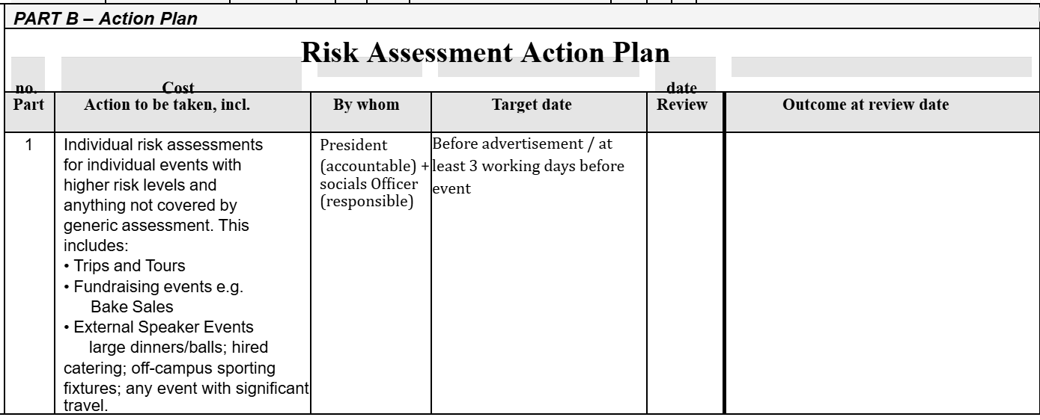
Before advertisement + no less than 2 weeks before event, ideally 3 weeks beforehand
Each semester
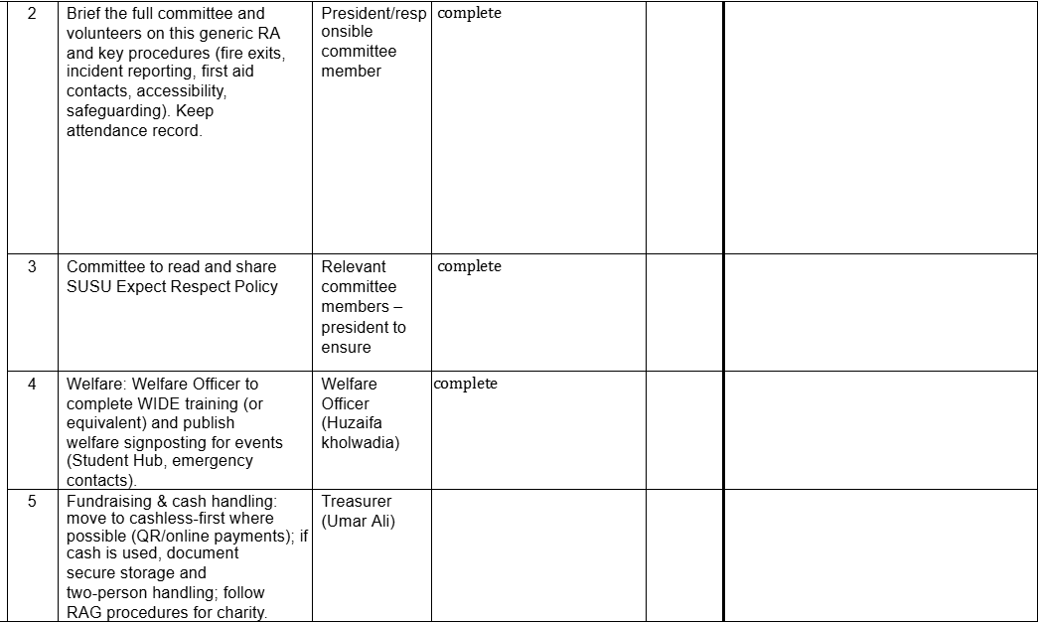
Yearly

Before each event

Start of year

Everytime money is collected

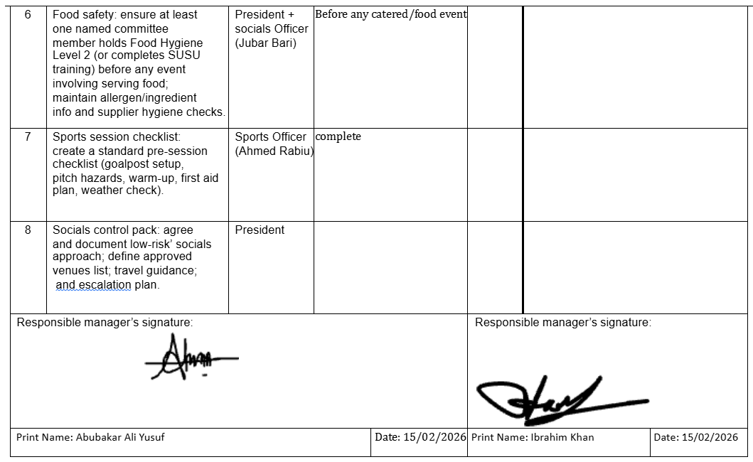
Date: 17/02/26
Date: 17/02/26
Jubar Bari

Each year

Each year

Each semester

Assessment Guidance

 |  |  |  |  | Remove the hazard wherever possible  which negates the need for further |  |  | If this is not possible then explain  why | 
  • | Eliminate
• Substitute |  |  |  |  | Replace the hazard with one less
• Physical controls |  |  |  |  | Examples: enclosure, fume cupboard, |  |  | Likely to still require admin controls
• Admin controls
• Personal protection |  |  |  |  | Examples: respirators, safety specs, |  |  | Last resort as it only protects the

Impact
 | Trivial - | Very minor injuries e.g. slight
Injuries or illness e.g. small cut or
abrasion which require basic first
aid treatment even in self-
Injuries or illness e.g. strain or
sprain requiring first aid or medical
Injuries or illness e.g. broken bone
requiring medical support >24
 | Severe –  extremely  significant | Fatality or multiple serious injuries  or illness requiring hospital  admission or significant time off

