Risk Assessment
Risk Assessment for the activity of | Sisters’ Bowling |  | Date | 01/09/26
Unit/Faculty/Directorate | Southampton Islamic Society | Assessor | Fatima Nadeem
Line Manager/Supervisor | Mahira Sumra | Signed off
Risk Assessment Information | Location – Hollywood Bowl Southampton, Westquay, Harbour Parade, Southampton S015 1DE  Date: 22/09/2026  Time: 17:00  Details: Indoor venue. We have booked for 32 people. Activity is open to other members of the public. All equipment and briefing are given on arrival at the location. Attendees are to organise their own travel or travel together with committee via bus. Places are booked ahead of time to ensure there is no overcrowding in the venue. There is a maximum number of people that can attend for a certain time controlled by the venue staff to avoid overcrowding.

PART A
(1) Risk identification |  |  | (2) Risk assessment |  |  |  | (3) Risk management
Hazard | Potential Consequences | Who might be harmed  (user; those nearby; those in the vicinity; members of the public) | Inherent |  |  |  | Residual |  |  | Further controls (use the risk hierarchy)
Hazard | Potential Consequences |  | Likelihood | Impact | Score | Control measures (use the risk hierarchy) | Likelihood | Impact | Score | Further controls (use the risk hierarchy)
Injury caused by bowling ball. | Severe bruising amongst other injuries. | All attending the event. | 2 | 4 | 8 | Make sure to take care when handling the ball. Take into consideration the weight of the ball before choosing which to use. | 2 | 2 | 4 | Taking care when throwing the ball.
Slips, trips, and falls. | Physical injury. | All attending the event. | 2 | 2 | 4 | -Taking to care to wear appropriate shoes to minimise the risk of slipping. Also stay withing parameters outlined by the bowling staff and venue.  -Ensure all equipment to be used are neatly and carefully organised.  -Extra vigilance will be paid to make sure that any spilled food products/objects are cleaned up quickly and efficiently in the area.  -Report any trip hazards to venue staff asap. If cannot be removed mark off with hazard signs. | 2 | 1 | 2 | -Taking special care to ensure people stand safely behind the bowler.  -Seek medical attention from venue staff if in need.  -Contact emergency services if needed.  - All incidents are to be reported as soon as possible ensuring the duty manager/health and safety officer have been informed, following the SUSU incident report policy (linked below).  https://www.susu.org/groups/admin/ howto/protectionaccident
Fingers getting stuck or twisted in ball. | Strain caused to fingers and wrist. Could also cause fingers to break. | Users. | 2 | 2 | 4 | Taking special consideration when selecting the weight of the ball to throw. Make sure the bowler holds the ball securely before bowling. | 1 | 2 | 2 | Teach any newcomers the proper technique before bowling.
Spread of contact related or air-borne diseases and illnesses, including COVID-19, from the public space. | The spread of such diseases resulting in possible health problems. | All attending the event. | 2 | 3 | 6 | -Those known to be affected by such should prepare precautionary equipment, e.g. tissues, gloves, face masks, etc. and should not attend if there are serious health concerns. | 1 | 2 | 2 | Ensure all attendees are aware of the risks of spreading such illnesses and the possible threat of catching anything from the public space.
Insufficient Fire Safety awareness. | If a fire alarm is triggered, people may not know where to go - Crushing, falls, burns and smoke inhalation arising from induced panic, reduced space in buildings and external walkways, obstructed fire exits, build-up of flammable materials i.e. waste cardboard/boxes. | All attending the event. | 2 | 3 | 6 | - Ensure that people know where the nearest fire exist are and the meeting place is outside, should it be needed.  - Build-up of rubbish is to be kept to a minimum. Excess build up is to be removed promptly and deposited in the designated areas. | 1 | 3 | 3 | Have a member of staff on hand from the facility who can answer any safety related questions any student may have.
Medical emergency. | Members may sustain injury/become unwell. Pre-existing medical conditions, sickness, distress. | All attending the event. | 3 | 5 | 15 | -Advise participant to bring their personal medication.  -Members/committee to carry out first aid if necessary and only if qualified and confident to do so.  -Contact emergency services as required (111/999).  -Contact venue staff for first aid support. | 2 | 5 | 10 | -Incidents are to be reported as soon as possible ensuring the duty manager/health and safety officer have been informed.  -Follow SUSU incident report policy.

PART B – Action Plan
Risk Assessment Action Plan
Part no. | Action to be taken, incl. Cost | By whom | Target date | Review date | Outcome at review date
 | Ensure all control measures are implemented. | Relevant committee members – president to ensure complete. | 15/09/2026 | 15/09/2026
 | Committee to read and share SUSU Expect Respect Policy. | Relevant committee members – president to ensure complete. | 15/09/2026 | 15/09/2026
Responsible manager’s signature: 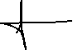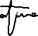 |  |  |  | Responsible manager’s signature:  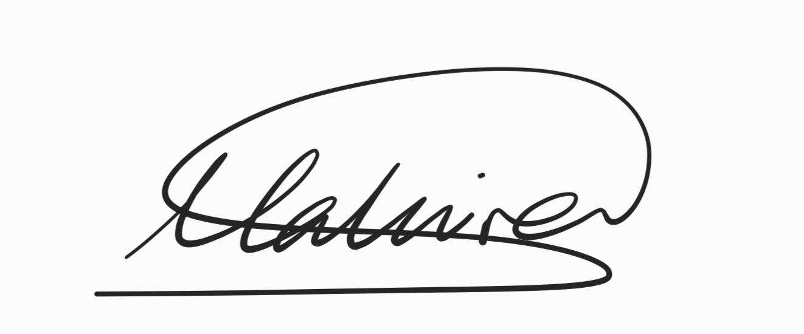
Print name: Fatima Nadeem |  |  | Date: 01/09/2026 | Print name: Mahira Sumra |  | Date 01/09/2026

Assessment Guidance
- Eliminate | Remove the hazard wherever possible which negates the need for further controls | If this is not possible then explain why
- Substitute | Replace the hazard with one less hazardous | If not possible then explain why
- Physical controls | Examples: enclosure, fume cupboard, glove box | Likely to still require admin controls as well
- Admin controls | Examples: training, supervision, signage
- Personal protection | Examples: respirators, safety specs, gloves | Last resort as it only protects the individual

LIKELIHOOD | 5 | 5 | 10 | 15 | 20 | 25
LIKELIHOOD | 4 | 4 | 8 | 12 | 16 | 20
LIKELIHOOD | 3 | 3 | 6 | 9 | 12 | 15
LIKELIHOOD | 2 | 2 | 4 | 6 | 8 | 10
LIKELIHOOD | 1 | 1 | 2 | 3 | 4 | 5
 |  | 1 | 2 | 3 | 4 | 5
 |  | IMPACT

Impact |  | Health & Safety
1 | Trivial - insignificant | Very minor injuries e.g. slight bruising
2 | Minor | Injuries or illness e.g. small cut or abrasion which require basic first aid treatment even in self-administered.
3 | Moderate | Injuries or illness e.g. strain or sprain requiring first aid or medical support.
4 | Major | Injuries or illness e.g. broken bone requiring medical support >24 hours and time off work >4 weeks.
5 | Severe – extremely significant | Fatality or multiple serious injuries or illness requiring hospital admission or significant time off work.
Risk process
- Identify the impact and likelihood using the tables above.
- Identify the risk rating by multiplying the Impact by the likelihood using the coloured matrix.
- If the risk is amber or red – identify control measures to reduce the risk to as low as is reasonably practicable.
- If the residual risk is green, additional controls are not necessary.
- If the residual risk is amber the activity can continue but you must identify and implement further controls to reduce the risk to as low as reasonably practicable.
- If the residual risk is red do not continue with the activity until additional controls have been implemented and the risk is reduced.
- Control measures should follow the risk hierarchy, where appropriate as per the pyramid above.
- The cost of implementing control measures can be taken into account but should be proportional to the risk i.e. a control to reduce low risk may not need to be carried out if the cost is high but a control to manage high risk means that even at high cost the control would be necessary.

Likelihood
1 | Rare e.g. 1 in 100,000 chance or higher
2 | Unlikely e.g. 1 in 10,000 chance or higher
3 | Possible e.g. 1 in 1,000 chance or higher
4 | Likely e.g. 1 in 100 chance or higher
5 | Very Likely e.g. 1 in 10 chance or higher

