Risk Assessment
Risk Assessment for the activity of | Sisters’ Laser Quest |  | Date | 01/09/26
Unit/Faculty/Directorate | Southampton Islamic Society | Assessor | Fatima Nadeem
Line Manager/Supervisor | Mahira Sumra | Signed off
Risk Assessment Information | Location – Tenpin Southampton, Auckland Rd, Southampton SO15 0SD  Date: 25/09/2026  Time: 18:00  Details: 1 game of laser quest in an indoor venue. We have booked for 20 people. Activity is open to other members of the public. All equipment and briefing are given on arrival at the location. Attendees are to organise their own travel. Laser beams emitted from guns are entirely safe – not real lasers, just lights. Places are booked ahead of time to ensure there is no overcrowding in the venue. There is a maximum number of people that can attend for a certain time controlled by the venue staff to avoid overcrowding.

PART A
(1) Risk identification |  |  | (2) Risk assessment |  |  |  | (3) Risk management
Hazard | Potential Consequences | Who might be harmed  (user; those nearby; those in the vicinity; members of the public) | Inherent |  |  |  | Residual |  |  | Further controls (use the risk hierarchy)
Hazard | Potential Consequences |  | Likelihood | Impact | Score | Control measures (use the risk hierarchy) | Likelihood | Impact | Score | Further controls (use the risk hierarchy)
Injury or disruption caused by travel to the venue | Attendees are to organise their own travel, may choose to travel in groups/share taxis. Vehicle’s collision causing minor to serious injuries, attendees becoming lost on their way to the event. | Attendees, road users. | 1 | 4 | 4 | - Have all attendees meet first at Highfield Interchange and then head down in groups to minimize risk of attendees being lost.  - Perform a register when we reach the laser quest facility can call any absent attendees | 1 | 3 | 3 | In the event of a serious accident/injury:  - Contact emergency services if needed 111/999.  - Inform venue staff.  - When suitable, report incident via SUSU incident report as soon as possible ensuring the duty manager/health and safety officer have been informed.
Injuries from equipment handling | Using the equipment – laser gun triggers can cause blisters if used aggressively.  Poor handling – careless abrasion with other players and equipment when moving around venue and playing | Event Participants | 2 | 2 | 4 | - Induction briefing and exit points are made clear to all clients prior to entering the game zone.  - Wear equipment provided by instructors properly – checked before entering game zone.  - Mal-practise from aggressive should be reported to instructors of the game immediately.  - Players are advised to maintain proper etiquette with other players, keep a safe distance between laser guns and players, particularly face. | 1 | 2 | 2 | Alert to game instructors in case of any issues.  Call for first aid/emergency services as required.  Report incidents via SUSU incident report  procedure  Contact emergency services as required  111/999  Link to the following page:  https://sotonac.sharepoint.com/teams/SUSU-groups/SitePages/Reporting-Procedures-(incidents-and-concerns).aspx
Slips and trips | Serious injury could occur due to operatives falling on uneven surfaces, obstacles, low ceilings, etc. | Event Participants | 3 | 3 | 9 | Attendees advised to always wear sensible footwear whilst playing (e.g. trainers).  All areas of the game zone are checked before each game by event staff.  Players are advised to advance carefully when running around and playing. | 1 | 2 | 2 | Alert to game instructors in case of any issues.  Call for first aid/emergency services as required.  Report incidents via SUSU incident report  Procedure  Contact emergency services as required  111/999  Link to the following page:  https://sotonac.sharepoint.com/teams/SUSU-groups/SitePages/Reporting-Procedures-(incidents-and-concerns).aspx
First Aid | Risk of body fluid contamination/infection | Event Participants | 3 | 2 | 6 | 1. Qualified First Aiders on duty at all times.  2. First aid kits available on site and these are checked periodically and replenished as necessary.  3. All staff members carry walkie talkies so communication and urgent response can be taken in the event of an accident/incident. | 1 | 2 | 2 | Call for first aid/emergency services a required.  Report incidents via SUSU incident report  procedure  Contact emergency services as required  111/999  Link to the following page:  https://sotonac.sharepoint.com/teams/SUSU-groups/SitePages/Reporting-Procedures-(incidents-and-concerns).aspx
Medical Emergency | Attendees may sustain injury /become unwell Pre-existing medical conditions, sickness, distress. | Event Participants, member of the public | 1 | 5 | 5 | - Advise participants to bring their personal medication if it might be required.  - Members/Committee to carry out first aid if necessary and only if qualified and confident to do so.  - Contact emergency services as required 111/999.  - Contact SUSU Reception/venue staff for first aid support. Members can be referred to The Student Hub (02380 599 599, studenthub@soton.ac.uk) in case of distress. | 1 | 4 | 4 | Call for first aid/emergency services a required.  Report incidents via SUSU incident report  procedure  Contact emergency services as required  111/999  Link to the following page:  https://sotonac.sharepoint.com/teams/SUSU-groups/SitePages/Reporting-Procedures-(incidents-and-concerns).aspx
Exhaustion | Players may experience fatigue during the sessions or get panicked from the game and dark setting. | All in the vicinity. | 3 | 2 | 6 | - (2 games) each session is approximately 20 minutes, with 10-minute gaps in between them, so players have time to grab water, go for toilet breaks and catch their breaths.  - Exit signs are luminated in the dark game zone and players are made aware of exit points ahead of entering, in case of anyone needing to leave.  - Attendees are advised to bring their own water bottles ahead of the event.  - Event organisers are to overlook the general well-being of attendees, and alert staff/emergency services as needed. | 1 | 2 | 2 | Send out message to attendees who sign up ahead of the event to come with water bottles.  Alert to game instructors in case of any issues.  Call for first aid/emergency services as required.  Report incidents via SUSU incident report  Procedure  Contact emergency services as required  111/999  Link to the following page:  https://sotonac.sharepoint.com/teams/SUSU-groups/SitePages/Reporting-Procedures-(incidents-and-concerns).aspx
Fire or any other emergency resulting in evacuation of the venue | Burns and or crush and trampling injuries | All in the vicinity. | 1 | 5 | 5 | - Ensure attendees know where the closest fire exits are and the correct evacuation routes. Exit signs are luminated in the dark game zone and players are made aware of exit points ahead of entering.  - Ensure attendees follow the directions of emergency responders and do not try and re-enter the building. | 1 | 5 | 5 | In case of an emergency, please pull nearest fire alarm and ensure all participants leave the venue calmly and safely. Once in a safe position to do so, call the emergency services on 999.  Alert to game instructors in case of any issues.  Call for first aid services as required.  Report incidents via SUSU incident report  Procedure  Link to the following page:  https://sotonac.sharepoint.com/teams/SUSU-groups/SitePages/Reporting-Procedures-(incidents-and-concerns).aspx

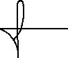
PART B – Action Plan
Risk Assessment Action Plan
Part no. | Action to be taken, incl. Cost | By whom | Target date |  | Review date | Outcome at review date
1 | Ensure all control measures are implemented! | Relevant committee members – president to ensure complete. | 18/09/2026 |  | 18/09/2026
 | Ensure the adequate first aid support is available on site (Tenpin Southampton) in case of emergency | Relevant committee member. | 18/09/2026 |  | 18/09/2026
 | Ensure attendees are informed to bring a water bottle ahead of the event. | Relevant committee members | 18/09/2026 |  | 18/09/2026
Responsible manager’s signature: |  |  |  |  | Responsible manager’s signature:
Print name: Fatima Nadeem |  |  |  | Date: 01/09/2026 | Print name: Mahira Sumra  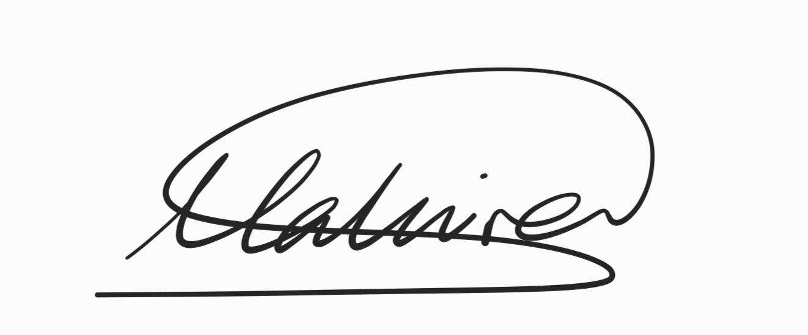 |  | Date: 01/09/2026

Assessment Guidance
- Eliminate | Remove the hazard wherever possible which negates the need for further controls | If this is not possible then explain why | 1  2  3  4  5
- Substitute | Replace the hazard with one less hazardous | If not possible then explain why | 1  2  3  4  5
- Physical controls | Examples: enclosure, fume cupboard, glove box | Likely to still require admin controls as well | 1  2  3  4  5
- Admin controls | Examples: training, supervision, signage |  | 1  2  3  4  5
- Personal protection | Examples: respirators, safety specs, gloves | Last resort as it only protects the individual | 1  2  3  4  5

LIKELIHOOD | 5 | 5 | 10 | 15 | 20 | 25
LIKELIHOOD | 4 | 4 | 8 | 12 | 16 | 20
LIKELIHOOD | 3 | 3 | 6 | 9 | 12 | 15
LIKELIHOOD | 2 | 2 | 4 | 6 | 8 | 10
LIKELIHOOD | 1 | 1 | 2 | 3 | 4 | 5
 |  | 1 | 2 | 3 | 4 | 5
 |  | IMPACT

Impact |  | Health & Safety
1 | Trivial - insignificant | Very minor injuries e.g. slight bruising
2 | Minor | Injuries or illness e.g. small cut or abrasion which require basic first aid treatment even in self-administered.
3 | Moderate | Injuries or illness e.g. strain or sprain requiring first aid or medical support.
4 | Major | Injuries or illness e.g. broken bone requiring medical support >24 hours and time off work >4 weeks.
5 | Severe – extremely significant | Fatality or multiple serious injuries or illness requiring hospital admission or significant time off work.
Risk process
Identify the impact and likelihood using the tables above.
Identify the risk rating by multiplying the Impact by the likelihood using the coloured matrix.
If the risk is amber or red – identify control measures to reduce the risk to as low as is reasonably practicable.
If the residual risk is green, additional controls are not necessary.
If the residual risk is amber the activity can continue but you must identify and implement further controls to reduce the risk to as low as reasonably practicable.
If the residual risk is red do not continue with the activity until additional controls have been implemented and the risk is reduced.
Control measures should follow the risk hierarchy, where appropriate as per the pyramid above.
The cost of implementing control measures can be taken into account but should be proportional to the risk i.e. a control to reduce low risk may not need to be carried out if the cost is high but a control to manage high risk means that even at high cost the control would be necessary.

Likelihood
1 | Rare e.g. 1 in 100,000 chance or higher
2 | Unlikely e.g. 1 in 10,000 chance or higher
3 | Possible e.g. 1 in 1,000 chance or higher
4 | Likely e.g. 1 in 100 chance or higher
5 | Very Likely e.g. 1 in 10 chance or higher

