Risk Assessment
Risk Assessment for the activity of | Morgan Sindall Outdoors Sport Centre Site Visit |  | Date | 18/11/2025
Group name | University of Southampton Civil Engineering Society (CivSoc) | Assessor | Adam Marsden
Supervisor | Prisha Naik (Vice President) | Signed off | SUSU USE ONLY
Description of event/activity | - A trip to witness and understand what civil engineering/construction is happening in Southampton.  - PPE will be required, some will be provided by Morgan & Sindall  - This trip will be led by an inducted site-engineer, beginning with a site induction including health and safety, followed by kitting up in PPE then being shown around the construction site with explanations of what, why and how they are constructing the Outdoors Sport Centre  - Project Director – Danny Brennan – Danny.Brennan@morgansindall.com  Travel Plan to Site:  - Total travel time – 15-20mins  - Start: University of Southampton Interchange  - End: Southampton Outdoors Sport Centre  - Leg 1: University of Southampton Interchange via Unlink U6H to Butterfield Rd Bus stop – 8-10mins  - Leg 2: Butterfield Rd Bus stop to Southampton Outdoor Sport Centre via walking – 5-10mins  - 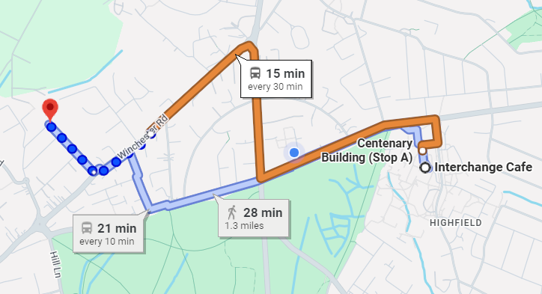  Return journey will be the exact same as the journey to site but in reverse.

PART A
(1) Risk identification |  |  | (2) Risk assessment |  |  |  | (3) Risk management
Hazard | Potential Consequences | Who might be harmed  (user; those nearby; those in the vicinity; members of the public) | Inherent |  |  |  | Residual |  |  | Further controls (use the risk hierarchy)
Hazard | Potential Consequences |  | Likelihood | Impact | Score | Control measures (use the risk hierarchy) | Likelihood | Impact | Score
General Considerations (including group meetings)
Active Construction Site – all specific hazards listed below | All potential consequences listed below | Event Organisers and Attendees,  Site Staff | 5 | 5 | 25 | Attendees will not enter the active construction site (attendees allowed in the compound eg. Site offices, car park, canteen) unless they’ve been made aware of all on-site hazards, attended a site induction, wearing all required PPE, made any existing medical conditions that could put themselves in danger made aware to the correct site staff, been authorised to enter by the relevant site staff and supervised at all times when on-site by site staff with a current active CSCS card  The active construction site will be barriered off from the compound to ensure attendees don’t enter areas of hazards/risks without being in compliance of any of the previously mentioned requirements | 2 | 2 | 4
Slips, trips and falls | Physical injury | Event organisers and attendees,  Site staff | 4 | 4 | 16 | Exclusion zones will be in place around excavations, if entering excavations, dedicated access/egress points shall be used  Site will be kept clear of trip/slip hazards prior to arrival. Attendees will be asked to be vigilant as the location is an active construction site. If trip hazards arise during our visit, relevant site staff will be informed to remove the hazard or prevent it becoming a risk using signage or cordoning it off using TM  Attendees will not be permitted to be at heights without appropriate safety systems in place such as barriers or netting. Attendees will not be permitted to access any height which requires more than barriers or netting to prevent falling | 1 | 3 | 3 | If the injury is serious and participant in a lot of pain or discomfort, seek medical attention immediately.  Call 999 in an emergency.  Any incidents need to be reported as soon as possible, ensuring duty manager/health and safety officers have been informed.  Follow SUSU incident reporting guide
Plant | Major Physical injury/fatality e.g. collision with moving vehicles, crushing/becoming trapped due to vehicles, | Event Organisers and Attendees,  Site Staff | 5 | 5 | 25 | Where possible attendees will stick to pedestrian only area and walkways. If this is not possible attendees will not approach or pass any plant unless they’ve made themselves clear to the operator and their plant is isolated or they’re signalled to do so by a banksman/signalman | 1 | 1 | 1
Cranes/Lifting Operations | Major Physical Injury/fatality e.g. materials/tools falling onto attendees causing concussion, bruising, crushing, collision with lifted materials, | Event Organisers and Attendees,  Site Staff | 3 | 5 | 15 | Attendees will not enter any area where lifting operations will occur, and site staff will ensure these areas are cordoned off | 1 | 1 | 1
Airbourne Dust Particles | Physical injury e.g. dust particles entering the eye, blindness  Long term illness e.g. scoliosis, lung cancer, asthma etc. | Event Organisers and Attendees, Site Staff | 4 | 2 | 8 | Attendees will not approach near to any works that could put dust particles in the air  Site staff will put measures in place to prevent dust particles becoming airborne such as spraying water onto soil when excavating, using dust suppression systems or vacuum attachments  Attendees will be provided with safety glasses which will be worn before entering site and if required will be supplied with the relevant RPPE if needed | 1 | 1 | 1
Attendees with pre-existing medical conditions/medication | Pre-existing medical condition could flare up/make them feel unwell/cause injury to themselves or others | Event Organisers and Attendees, Site Staff | 1 | 5 | 5 | Attendees will make relevant site staff aware of their condition/medication before being allowed onto site  Attendees are responsible for managing their own medication/prescriptions | 1 | 3 | 3
COSHH Materials | Burns/irritations/injury if skin/face encounters COSHH materials, Major or minor | Event Organisers and Attendees, Site Staff | 2 | 3 | 6 | Attendees will not be permitted to use or handle any COSHH materials  Attendees will be issued gloves, wear long sleeves and trousers to ensure that COSHH materials aren’t accidentally transferred to their skin | 1 | 2 | 2
Exposure to Lound/Continuous Noise | Major/minor Hearing damage/loss | Event Organisers and Attendees, Site Staff | 3 | 5 | 15 | Attendees will not enter any area of site where hearing protection is required. If hearing protection is supplied, then access to these areas will be at the relevant site staff’s discretion | 2 | 1 | 2
Fire | Major Burns, Smoke inhalation etc., | Event Organisers and Attendees, Site Staff | 1 | 5 | 5 | Attendees will be made aware of site emergency procedures, fire call alarms/call points, site access/egress points and assembly points  If attendees witness any possible fire safety risks, they are asked to raise it with the relevant site staff ASAP | 1 | 3 | 3 | In case of an emergency, please pull nearest fire alarm and ensure all participants leave the venue calmly and safely.  Once in a safe position to do so, call the emergency services on 999.  Any incidents need to be reported as soon as possible ensuring duty manager/health and safety officers have been informed.  Follow SUSU incident reporting guide
Reputational Risk:  For the club or society, as well as to SUSU and the University | Incidents causing reputational damage to the group, Southampton University Students’ Union or Southampton University itself. | Event Organisers and Attendees, Site Staff | 2 | 1 | 2 | Ensuring all parts of this risk assessment are adhered to.  Ensuring all members are reminded that they are representing the club/society, SUSU and the University, often in branded clothing.  Members are reminded that they need to adhere to SUSU’s Code of Conduct.  Consider risks at activities as well as digital presence (e.g. social media posts) | 1 | 1 | 1 | Ensure that any incidents involving public or others are recorded and addressed.  Follow SUSU incident reporting guide
Mobile Phone Use/ Lack of care | Physical Injury to themselves or others, cause damage to property, | Event Organisers and Attendees, Site Staff | 3 | 3 | 9 | Mobile phone use is prohibited when within the active site compound except for photography.  Attendees will be reminded that they should always be aware of their surroundings, no matter what they are undertaking, and they should never, due to lack of car/awareness or otherwise, put themselves or others in a position of danger | 1 | 3 | 3
Alcohol Consumption | Physical injury to themselves or others, emotional injury/distress to themselves or others, reputational damage to SUSU, Civsoc or the University, | Event Organisers and Attendees, Site Staff | 1 | 5 | 5 | Under NO circumstances will alcohol be consumed at any point when on site (in the active works or in the compound) or before entering site.  Any person found to be intoxicated when on-site or refuses to do an drugs/alcohol test will be immediately removed from site and will not be allowed to return to site within a year and face possible disciplinary actions within Civsoc, SUSU or the by the University | 1 | 2 | 2 | Follow SUSU incident reporting guide
Medical Emergency | May become unwell, further injury to themselves or others, emotional distress to others, | Event Organisers and Attendees, Site Staff | 1 | 5 | 5 | In the event of a medical emergency, Morgan Sindall on-site first aiders, who have current up-to date medical training for construction sites, will intervene and apply first aid if required.  The rest of the attendees will be escorted away from the incident to a safe location off-site by site staff or organisers.  First aiders will be made aware to attendees during the site induction and will have a sticker on their helmet for easy identification when on-site.  Contact emergency services as required 111/999.  Members can be referred to The Student Hub (02380 599 599, studenthub@soton.ac.uk) in case of distress. | 1 | 3 | 3 | Incidents are to be reported on the as soon as possible ensuring the duty manager/health and safety officer have been informed.  Follow SUSU incident reporting guide  Route from site to Southampton general A&E  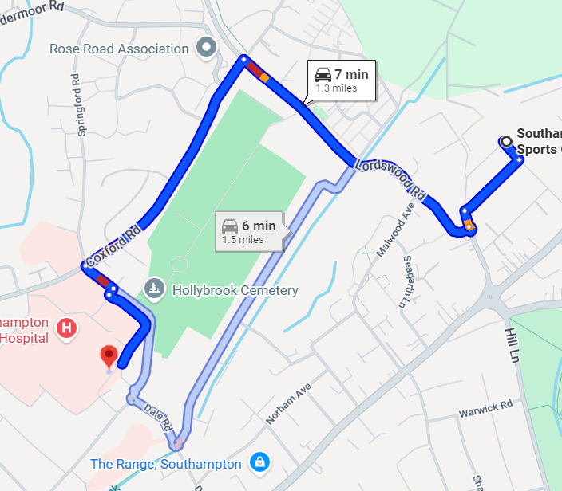
Adverse Weather | Hypo- or hyperthermia, illness, injury, slipping, burns | Event Organisers and Attendees, Site Staff | 2 | 3 | 6 | If the weather is going to be deemed unsafe when the event will be occurring, then the relevant site-staff will cancel/rearrange if necessary.  If the weather is deemed unsafe to continue with the event deemed by the relevant site staff, then attendees will be escorted off-site to the site offices. The call to return onto site will be made by the relevant site staff once the weather is no longer deemed unsafe  Appropriate clothing will be recommended by the organiser for the weather predicted. Required PPE provided however must not be adapted or changed no matter the weather conditions | 2 | 2 | 4 | All incidents are to be reported on the as soon as possible ensuring the duty manager/health and safety officer have been informed.  Follow SUSU incident reporting guide
Overcrowding / Inadequate Meeting Space | Minor Physical injury, distress, exclusion | Event Organisers and Attendees, Site Staff | 1 | 2 | 2 | The no. of attendees of the event will be restricted to a safe no. depending on the site activities that day and site safety regulations.  Multiple sessions made be held to insure everyone wishing to attend can do so in a safe way  No pushing or shoving especially when on-site due to increased risk tis will not be tolerated and attendees could be removed off site if deemed appropriate for safety | 1 | 1 | 1 | Welfare Officer to complete WIDE training.  All incidents are to be reported on the as soon as possible ensuring the duty manager/health and safety officer have been informed.  Follow SUSU incident reporting guide
Dangerous/antisocial behaviour | Physical/emotional injury/distress | Event Organisers and Attendees, Site Staff | 3 | 4 | 12 | Any behaviour that risks any other person’s safety in a way will not be tolerated and the attendees deemed dangerous will be removed from site immediately | 1 | 3 | 3
Travel to/from site – all specific hazards listed below | All potential consequences listed below | Event Organisers and Attendees, General Public
Loss of Attendees | Emotional distress, miss transport to/from Site | Event Organisers and Attendees | 2 | 2 | 4 | Everyone will travel to site together to ensure nobody becomes separated from the rest of the group via Unlink buses and walking.  Attendees will be asked not to leave by themselves at any point without informing somebody  When at Site attendees will be staying with a member of site staff. | 2 | 1 | 2
Cancellation/Diversion of Transport | Emotional distress, loss in time, confusion of where to go/when | Event Organisers and Attendees | 3 | 1 | 3 | If public transport plans change the entire group shall be informed before the diversion/change in route in a reasonable amount of time and by means of communication that ensures everybody receives it. If this isn’t possible then all attendees will have been asked to remain together till a plan has been organised  If any attendees are taking different modes/times of transport to the ones arranged, then they are to let the organiser know a reasonable amount of time beforehand  Event organisers will review possible cancellations/diversions beforehand to ensure “smooth travel” on the day | 3 | 1 | 3
Interaction with the public & harassment/abuse to or from the public  Inappropriate behaviour | Minor/Major Physical injury, emotion injury/distress | Event Organisers and Attendees, Public | 1 | 4 | 4 | If any incidents occur with the public that is negative towards our organisers/attendees, then the attendees will be removed from the situation. If the situation continues then the public will be asked to remove themselves. If the situation escalates to an unmanageable level, then if required emergency services will be called to deal with the situation and the trip will be stopped short due to safety concerns  If any injured are cause by the member of public or any abuse/harassment such as racism/homophobia/any form of prejudice etc. then emergency services will immediately be contacted and the trip cancelled due to safety concerns  If any attendee is abuse/harmful/rude etc. towards a member of the public that is deemed against the university guidelines, then they will be isolated and removed from the trip immediately with consequences that are of satisfactory level to the behaviour of the individual alongside an investigation into the incident. If the behaviour is attendee on attendee, then the same actions will be possibly taken | 1 | 4 | 4 | Gather all evidence and complete the incident form - If the Duty Manager is not present the incident report must be filled out immediately, it can be found on the SUSU website here.  https://www.susu.org/contact.htm
Traffic accident/collision | Physical/emotional injury, emotional distress | Event Organisers and Attendees | 1 | 5 | 5 | Attendees will walk only on designated footpaths and walkways and only using designated crossing when crossing the roads/cycle lanes  Where possible all routes to be undertaken by foot will be avoid major high-speed roads and must not walk on the road unless no other options are available  Attendees will be encouraged to walk in smaller groups and be aware of surrounding when walking along or nearby any road | 1 | 3 | 3 | Gather all evidence and complete the incident form - If the Duty Manager is not present the incident report must be filled out immediately, it can be found on the SUSU website here. https://www.susu.org/contact.htm

PART B – Action Plan
Risk Assessment Action Plan
Part no. | Action to be taken, incl. Cost | By whom | Target date |  | Review date | Outcome at review date
1 | Send out registration forms, emergency contacts, itinerary etc. | Event Lead | 22/11/2025
2 | Organisers Severe Weather and Natural Disaster Check prior to departure | Event Lead | 1/12/2025
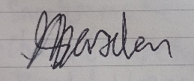  Responsible committee member signature 1: |  |  |  |  | 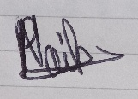  Responsible committee member signature 2:
Print name: ADAM MARSDEN |  |  |  | Date: 18/11/2025 | Print name: PRISHA NAIK |  | Date:  18/11/2025

Assessment Guidance
- Eliminate |  |  |  |  | Remove the hazard wherever possible which negates the need for further controls |  |  |  | If this is not possible then explain why | 
- Substitute |  |  |  |  | Replace the hazard with one less hazardous |  |  |  | If not possible then explain why
- Physical controls |  |  |  |  | Examples: enclosure, fume cupboard, glove box |  |  |  | Likely to still require admin controls as well
- Admin controls |  |  |  |  | Examples: training, supervision, signage
- Personal protection |  |  |  |  | Examples: respirators, safety specs, gloves |  |  |  | Last resort as it only protects the individual
LIKELIHOOD | 5 | 5 | 10 | 15 |  | 20 | 25
LIKELIHOOD | 4 | 4 | 8 | 12 |  | 16 | 20
LIKELIHOOD | 3 | 3 | 6 | 9 |  | 12 | 15
LIKELIHOOD | 2 | 2 | 4 | 6 |  | 8 | 10
LIKELIHOOD | 1 | 1 | 2 | 3 |  | 4 | 5
 |  | 1 | 2 | 3 |  | 4 | 5
 |  | IMPACT

Impact |  | Health & Safety
1 | Trivial - insignificant | Very minor injuries e.g. slight bruising
2 | Minor | Injuries or illness e.g. small cut or abrasion which require basic first aid treatment even in self-administered.
3 | Moderate | Injuries or illness e.g. strain or sprain requiring first aid or medical support.
4 | Major | Injuries or illness e.g. broken bone requiring medical support >24 hours and time off work >4 weeks.
5 | Severe – extremely significant | Fatality or multiple serious injuries or illness requiring hospital admission or significant time off work.

Likelihood
1 | Rare e.g. 1 in 100,000 chance or higher
2 | Unlikely e.g. 1 in 10,000 chance or higher
3 | Possible e.g. 1 in 1,000 chance or higher
4 | Likely e.g. 1 in 100 chance or higher
5 | Very Likely e.g. 1 in 10 chance or higher

