`Risk Assessment
Risk Assessment for the activity of | Civil Engineering Society ICE HQ trip (London) |  | Date | 13/02/2026
Group name | University of Southampton Civil Engineering Society (CivSoc) | Assessor | Adam Marsden
Supervisor | Prisha Naik (Vice Presidnets) | Signed off | SUSU USE ONLY
Description of event/activity | - A day trip to tour ICE Headquarters in London and find out more about the Institute of Civil Engineering (ICE) led by Carol Morgan showing us the history of the building and touring it followed by networking.  - Carol Morgan: Carol.Morgan@ice.org.uk  Route from Southampton Interchange to 1 Great George Street:  - Overview  - Total Jurney Time TO HQ: 110-150mins  - Tube - £???, ICE HQ tour – Free (Hopefully),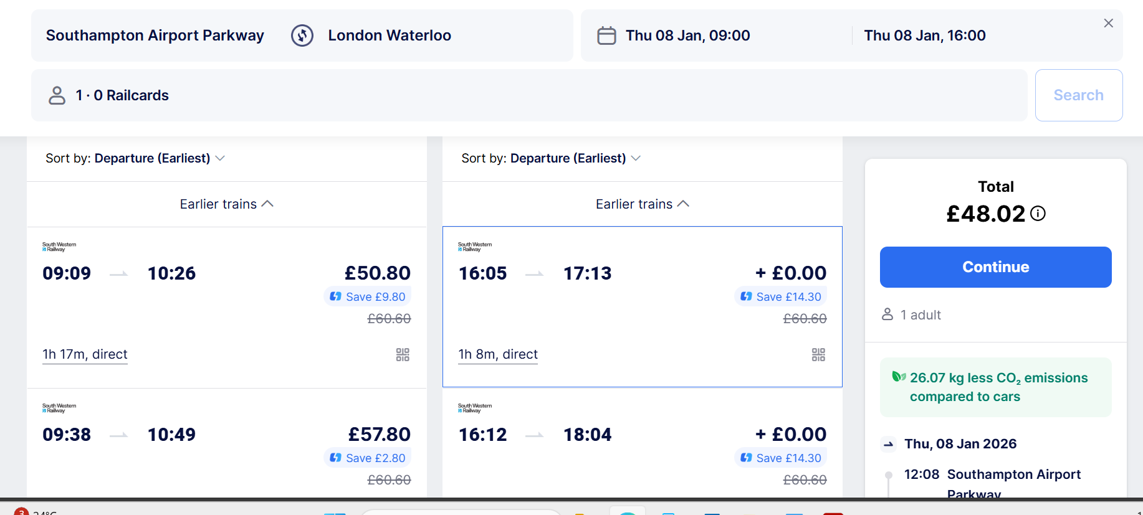  - 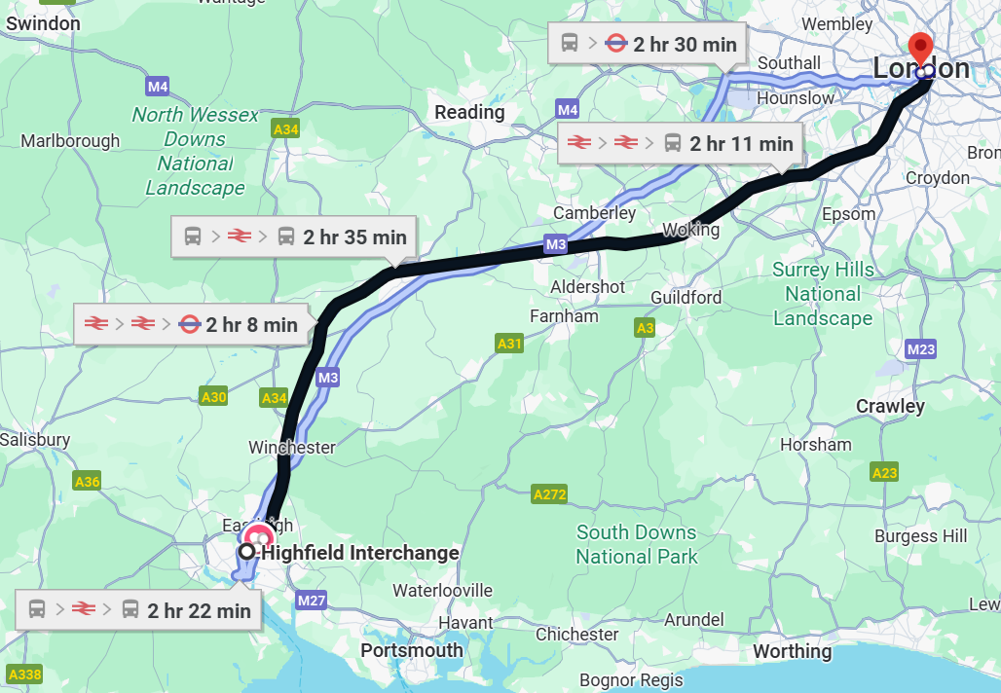  - Leg 1: U1A Bus to Southampton Airport Parkway from Southampton Interchange (10-20mins), Depart: TBC, Arrival TBC  - Leg 2: Train to London Waterloo Station from Southampton Airport Parkway (70-90mins), Depart: TBC, Arrival: TBC  - Leg 3 Option 1: Tube (Jubilee line) from London Waterloo Station to Westminster then walk from 1 Great Georges Street (10-15mins) Depart: TBC, Arrival: TBC  - Leg 3 Option 2: Walk from London Waterloo Station to 1 Great Georges Street (20-25mins), Depart: TBC, Arrival: TBC  - Return Journey Total Rime: mins  - Leg 1: Walk from 1 Great Georges Street to London Waterloo Station (20-25mins), Depart: TBC, Arrival: TBC  - Leg 2: Train to Southampton Airport Parkway (70-90mins), Depart: TBC, Arrival: TBC

PART A
(1) Risk identification |  |  | (2) Risk assessment |  |  |  | (3) Risk management
Hazard | Potential Consequences | Who might be harmed  (user; those nearby; those in the vicinity; members of the public) | Inherent |  |  |  | Residual |  |  | Further controls (use the risk hierarchy)
Hazard | Potential Consequences |  | Likelihood | Impact | Score | Control measures (use the risk hierarchy) | Likelihood | Impact | Score
General Considerations (including group meetings)
Slips, Trips, Falls | Minor/Major Physical Injury e.g. sprains, fractures, Concussions, bruising, cuts | Event Organisers and Attendees, Public | 1 | 3 | 3 | Attendees to be advised to wear appropriate, comfortable footwear for travelling by foot in London  Attendees will be told to be vigilant and avoid trip hazards as we’ll have no control over them and be careful especially on cobbled streets or crossing busy roads  Running is not necessary, attendees will be informed not to do this as this increasing the risk of tripping/falling | 1 | 3 | 3
Loss of Attendees | Emotional distress, miss transport to/from ICE HQ | Event Organisers and Attendees | 2 | 2 | 4 | Attendees will be asked to stick in groups and given information on important timings, locations, contact no.s and the plan for in case somebody does become lost  Attendees will be asked not to leave by themselves at any point without informing somebody  When at ICE HQ attendees will be staying with the guided tour/tour guide  Only reputable sources of transport shall be used such as uber, TFL, SWR etc. and Hitch-hiking is strictly FORBIDDEN | 2 | 1 | 2
Cancellation/Diversion of Transport | Emotional distress, loss in time, confusion of where to go/when | Event Organisers and Attendees | 3 | 1 | 3 | If public transport plans change the entire group shall be informed before the diversion/change in route in a reasonable amount of time and by means of communication that ensures everybody receives it. If this isn’t possible then all attendees will have been asked to remain together till a plan has been organised  If any attendees are taking different modes/times of transport to the ones arranged, then they are to let the organiser know a reasonable amount of time beforehand  Event organisers will review possible cancellations/diversions beforehand to ensure “smooth travel” on the day | 3 | 1 | 3
Interaction with the public & harassment/abuse to or from the public  Inappropriate behaviour | Minor/Major Physical injury, emotion injury/distress, | Event Organisers and Attendees, Public | 1 | 4 | 4 | If any incidents occur with the public that is negative towards our organisers/attendees, then the attendees will be removed from the situation. If the situation continues then the public will be asked to remove themselves. If the situation escalates to an unmanageable level, then if required emergency services will be called to deal with the situation and the trip will be stopped short due to safety concerns  If any injured are cause by the member of public or any abuse/harassment such as racism/homophobia/any form of prejudice etc. then emergency services will immediately be contacted and the trip cancelled due to safety concerns  If any attendee is abuse/harmful/rude etc. towards a member of the public that is deemed against the university guidelines, then they will be isolated and removed from the trip immediately with consequences that are of satisfactory level to the behaviour of the individual alongside an investigation into the incident. If the behaviour is attendee on attendee, then the same actions will be possibly taken | 1 | 4 | 4
Alcohol Consumption | Intoxication, emotional distress/injury, minor physical injury | Event Organisers and Attendees | 4 | 3 | 12 | Alcohol is permitted to be consumed however attendees are encouraged to not binge drink, stay in at least pairs and be sensible e.g. don’t leave drinks unattended, don’t leave somebody by themselves, don’t accept drinks from strangers etc.  Attendees are reminded only to buy alcohol from licensed vendors/ consume alcohol on licensed premises | 4 | 1 | 4
Traffic accident/collision | Physical/emotional injury, emotional distress | Event Organisers and Attendees | 1 | 5 | 5 | Attendees will walk only on designated footpaths and walkways and only using designated crossing when crossing the roads/cycle lanes  Where possible all routes to be undertaken by foot will be avoid major high speed roads and must not walk on the road unless no other options are available  Attendees will be encouraged to walk in smaller groups and be aware of surrounding when walking along or nearby any road | 1 | 3 | 3 | Gather all evidence and complete the incident form - If the Duty Manager is not present the incident report must be filled out immediately, it can be found on the SUSU website here. https://www.susu.org/contact.html
Loss of valuables | Emotional distress, loss of time and money | Event Organisers and Attendees | 2 | 2 | 4 | Attendees will be warned to not bring any valuables deemed unnecessary  Attendees will be reminded that any valuables they have should be kept hidden in a secure place and only remove it from their when needed  Attendees will be asked to have access to emergency money for food/travel in case of been robbed/loss of bank cards/loss of phone/no phone charge | 1 | 2 | 2
Adverse Weather | Hypo/hyperthermia, minor illnesses because of weather, sunstroke, sunburns etc., increased rick of slipping | Event Organisers and Attendees | 2 | 3 | 6 | Attendees will be advised to wear appropriate clothing for the predicted weather e.g. hat, gloves, waterproofs  Attendees will be advised to wear sunscreen if out in the sun for long periods of time or high UV rays  Lead Organiser will decide to postpone/rearrange/cancel the event if deemed the weather to dangerous for the activity | 1 | 3 | 3
Medical Emergency | Members may sustain injury /become unwell  Pre-existing medical conditions, sickness, distress | Event Organisers and Attendees | 1 | 5 | 5 | Advise participants to bring their personal medication if it might be required and must inform the event organisers of their pre-existing medical condition beforehand and inform them of their medical needs around it including location of medication  Members/Committee to carry out first aid if necessary and only if qualified and confident to do so.  Contact emergency services as required 111/999.  Contact SUSU Reception/venue staff for first aid support.  Members can be referred to The Student Hub (02380 599 599, studenthub@soton.ac.uk) in case of distress. | 1 | 3 | 3 | Incidents are to be reported on the as soon as possible ensuring the duty manager/health and safety officer have been informed.  Follow SUSU incident reporting guide  Route from 1 Great George Street to St Peters’ Hospital A&E  Driving: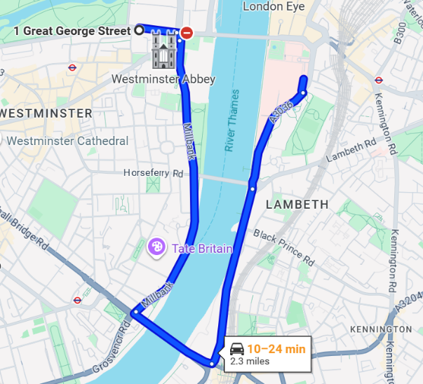  Walking: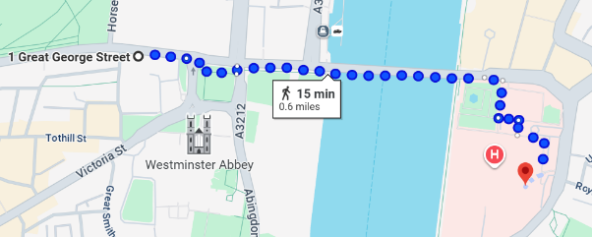
Disruption to events due to political events/terrorism/natural disasters/pandemics |  |  |  |  |  | In case of an incident with extreme immediate danger follow Run, Hide, Tell guidance. follow the advice of emergency services. Attendees will make their own way to the most local, safe but also major location which they will remain at till they receive further information on what to do  Stay away from large gatherings or demonstrations  Mobile phone access- ensure chargers are taken  Contact emergency services if required – 999  Contact SUSU if help and guidance is required
Fire | Major Burns, Smoke inhalation etc., | Event Organisers and Attendees, Site Staff | 1 | 5 | 5 | Attendees will be made aware of the building’s emergency procedures, fire call alarms/call points, site access/egress points and assembly points  Event organisers will take notes on building’s fire exit locations during the tour and if a fire would occur lead attendees to the closest fire exit. | 1 | 3 | 3 | In case of an emergency, please pull nearest fire alarm and ensure all participants leave the venue calmly and safely.  Once in a safe position to do so, call the emergency services on 999.  Any incidents need to be reported as soon as possible ensuring duty manager/health and safety officers have been informed.  Follow SUSU incident reporting guide

PART B – Action Plan
Risk Assessment Action Plan
Part no. | Action to be taken, incl. Cost | By whom | Target date |  | Review date | Outcome at review date
1 | Confirmation of travel route and itinerary | Event Organiser | 20/01/2026
3 | Attendee Health & Safety Briefing – information surrounding emergency contacts, emergency routes, itinerary and travel recap etc. | Event Organiser | 28/01/2026 – before departure
4 | Organisers Severe Weather and Natural Disaster Check prior to departure | Event Organiser | 27/01/2026
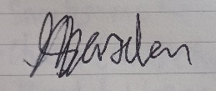  Responsible committee member signature 1: |  |  |  |  | Responsible committee member signature 2:
Print name: ADAM MARSDEN |  |  |  | Date:  13/01/2026 | Print name: PRISHA NAIK |  | Date: 13/01/2026

Assessment Guidance
- Eliminate |  |  |  |  | Remove the hazard wherever possible which negates the need for further controls |  |  |  | If this is not possible then explain why | 
- Substitute |  |  |  |  | Replace the hazard with one less hazardous |  |  |  | If not possible then explain why
- Physical controls |  |  |  |  | Examples: enclosure, fume cupboard, glove box |  |  |  | Likely to still require admin controls as well
- Admin controls |  |  |  |  | Examples: training, supervision, signage
- Personal protection |  |  |  |  | Examples: respirators, safety specs, gloves |  |  |  | Last resort as it only protects the individual
LIKELIHOOD | 5 | 5 | 10 | 15 |  | 20 | 25
LIKELIHOOD | 4 | 4 | 8 | 12 |  | 16 | 20
LIKELIHOOD | 3 | 3 | 6 | 9 |  | 12 | 15
LIKELIHOOD | 2 | 2 | 4 | 6 |  | 8 | 10
LIKELIHOOD | 1 | 1 | 2 | 3 |  | 4 | 5
 |  | 1 | 2 | 3 |  | 4 | 5
 |  | IMPACT

Impact |  | Health & Safety
1 | Trivial - insignificant | Very minor injuries e.g. slight bruising
2 | Minor | Injuries or illness e.g. small cut or abrasion which require basic first aid treatment even in self-administered.
3 | Moderate | Injuries or illness e.g. strain or sprain requiring first aid or medical support.
4 | Major | Injuries or illness e.g. broken bone requiring medical support >24 hours and time off work >4 weeks.
5 | Severe – extremely significant | Fatality or multiple serious injuries or illness requiring hospital admission or significant time off work.

Likelihood
1 | Rare e.g. 1 in 100,000 chance or higher
2 | Unlikely e.g. 1 in 10,000 chance or higher
3 | Possible e.g. 1 in 1,000 chance or higher
4 | Likely e.g. 1 in 100 chance or higher
5 | Very Likely e.g. 1 in 10 chance or higher

