`Risk Assessment
Risk Assessment for the activity of | SubSea7’s Offshore Geotechnics Talk |  | Date | 05/09/2026
Group name | University of Southampton Civil Engineering Society (CivSoc) | Assessor | Adam Marsden
Supervisor | Matthew Hoskins (President) | Signed off | SUSU USE ONLY
Description of event/activity | - An on campus delivered by Subsea 7 about current offshore geotechnics and how their company is involved.  - Speakers: Rowan Edmondson (rowan.edmondson@subsea7.com), Sophie Smith (sophie.smith@dnv.com),

PART A
(1) Risk identification |  |  | (2) Risk assessment |  |  |  | (3) Risk management
Hazard | Potential Consequences | Who might be harmed  (user; those nearby; those in the vicinity; members of the public) | Inherent |  |  |  | Residual |  |  | Further controls (use the risk hierarchy)
Hazard | Potential Consequences |  | Likelihood | Impact | Score | Control measures (use the risk hierarchy) | Likelihood | Impact | Score
General Considerations (including group meetings)
Slips, Trips, Falls | Minor/Major Physical Injury e.g. sprains, fractures, Concussions, bruising, cuts | Event Organisers and Attendees, Public | 1 | 3 | 3 | The event space will be kept clear and tidy to prevent hazard/accidents from occurring.  Attendees will remain vigilant of any hazards that appear at the event. | 1 | 3 | 3
Medical Emergency | Members may sustain injury /become unwell  Pre-existing medical conditions, sickness, distress | Event Organisers and Attendees | 1 | 5 | 5 | Advise participants to bring their personal medication if it might be required and must inform the event organisers of their pre-existing medical condition beforehand and inform them of their medical needs around it including location of medication  Members/Committee to carry out first aid if necessary and only if qualified and confident to do so.  Contact emergency services as required 111/999.  Contact SUSU Reception/venue staff for first aid support.  Members can be referred to The Student Hub (02380 599 599, studenthub@soton.ac.uk) in case of distress. | 1 | 3 | 3 | Incidents are to be reported on the as soon as possible ensuring the duty manager/health and safety officer have been informed.  Follow SUSU incident reporting guide  Route from Southampton University’s Boldrewood Campus to Southampton General Hospital Emergency Department  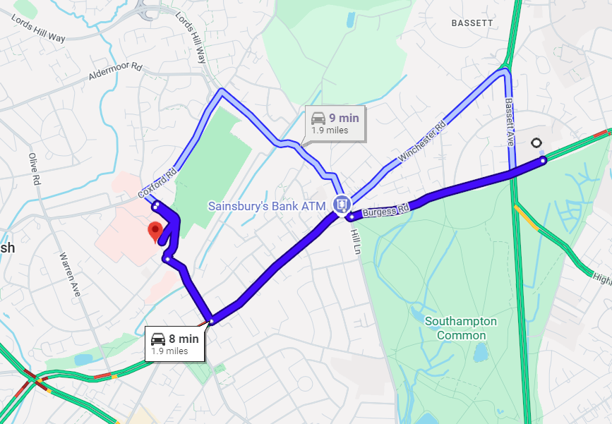
Fire | Major Burns, Smoke inhalation etc., | Event Organisers and Attendees, Site Staff | 1 | 5 | 5 | Attendees will be made aware of the building’s emergency procedures, fire call alarms/call points, site access/egress points and assembly points  Event organisers will take notes on building’s fire exit locations during the tour and if a fire would occur lead attendees to the closest fire exit. | 1 | 3 | 3 | In case of an emergency, please pull nearest fire alarm and ensure all participants leave the venue calmly and safely.  Once in a safe position to do so, call the emergency services on 999.  Any incidents need to be reported as soon as possible ensuring duty manager/health and safety officers have been informed.  Follow SUSU incident reporting guide

PART B – Action Plan
Risk Assessment Action Plan
Part no. | Action to be taken, incl. Cost | By whom | Target date |  | Review date |  | Outcome at review date
1
3
4
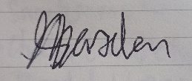  Responsible committee member signature 1: |  |  |  |  | Responsible committee member signature 2:  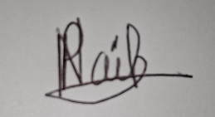
Print name: ADAM MARSDEN |  |  |  | Date:  06/09/2026 |  | Print name: PRISHA NAIK |  | Date: 06/09/2026

Assessment Guidance
- Eliminate |  |  |  |  | Remove the hazard wherever possible which negates the need for further controls |  |  |  | If this is not possible then explain why | 
- Substitute |  |  |  |  | Replace the hazard with one less hazardous |  |  |  | If not possible then explain why
- Physical controls |  |  |  |  | Examples: enclosure, fume cupboard, glove box |  |  |  | Likely to still require admin controls as well
- Admin controls |  |  |  |  | Examples: training, supervision, signage
- Personal protection |  |  |  |  | Examples: respirators, safety specs, gloves |  |  |  | Last resort as it only protects the individual
LIKELIHOOD | 5 | 5 | 10 | 15 |  | 20 | 25
LIKELIHOOD | 4 | 4 | 8 | 12 |  | 16 | 20
LIKELIHOOD | 3 | 3 | 6 | 9 |  | 12 | 15
LIKELIHOOD | 2 | 2 | 4 | 6 |  | 8 | 10
LIKELIHOOD | 1 | 1 | 2 | 3 |  | 4 | 5
 |  | 1 | 2 | 3 |  | 4 | 5
 |  | IMPACT

Impact |  | Health & Safety
1 | Trivial - insignificant | Very minor injuries e.g. slight bruising
2 | Minor | Injuries or illness e.g. small cut or abrasion which require basic first aid treatment even in self-administered.
3 | Moderate | Injuries or illness e.g. strain or sprain requiring first aid or medical support.
4 | Major | Injuries or illness e.g. broken bone requiring medical support >24 hours and time off work >4 weeks.
5 | Severe – extremely significant | Fatality or multiple serious injuries or illness requiring hospital admission or significant time off work.

Likelihood
1 | Rare e.g. 1 in 100,000 chance or higher
2 | Unlikely e.g. 1 in 10,000 chance or higher
3 | Possible e.g. 1 in 1,000 chance or higher
4 | Likely e.g. 1 in 100 chance or higher
5 | Very Likely e.g. 1 in 10 chance or higher

