Risk Assessment
Risk Assessment for the activity of | Jazzmanix Acoustic Night |  | Date | 25/09/2020
Unit/Faculty/Directorate | Jazzmanix | Assessor | Fiona Sunderland
Line Manager/Supervisor | Cameron Lamming - President | Signed off | 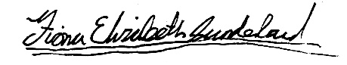

PART A
(1) Risk identification |  |  | (2) Risk assessment |  |  |  | (3) Risk management
Hazard | Potential Consequences | Who might be harmed  (user; those nearby; those in the vicinity; members of the public) | Inherent |  |  |  | Residual |  |  | Further controls (use the risk hierarchy)
 |  |  | Likelihood | Impact | Score | Control measures (use the risk hierarchy) | Likelihood | Impact | Score
Setting up stage | Possibility of strain injuries (pulling a muscle) | Committee, by lifting equipment incorrectly | 2 | 3 | 6 | Everyone should be aware of how to lift properly in order to avoid injury/heavier objects to be lifted in pairs | 1 | 3 | 3 | Making sure everyone is shown how to lift heavy items correctly at the beginning of the day/ during set venue set up
Setting up sound | Possible electrocution | Committee/ band members from loose wiring/ unsafe handling of electrical equipment | 1 | 5 | 5 | All items and wires are PAT tested | 1 | 5 | 5 | No utilisation of equipment if it has not passed PAT testing
Concert | Fainting | Performers, if they lock their legs or don't drink enough water | 2 | 2 | 4 | All performers have their own water on stage | 1 | 2 | 2 | Remind performers to drink a lot of water and to exit the stage if they are feeling dizzy/ unwell
COVID 19 | Transmission of the virus to audience members | Audience and other people that come into contact with | 4 | 5 | 20 | There will be no audience present, as the event will be live streamed instead | 1 | 5 | 5 | Not required.
COVID 19 | Transmission | Audience, performers and committee and other people that come into contact with | 4 | 5 | 20 | See COVID 19 Risk Assessment | 3 | 5 | 15 | Not required.
Loud Music | Damage to Hearing | All present, both performers and audience | 3 | 3 | 9 | Recommend the use of ear protection | 2 | 3 | 6 | Keep volume down  • Provide (disposable) ear protection  • Avoid pointing microphones near or pointing towards monitors to reduce/eliminate feedback
Tripping or falling off stage | Physical injury (Bruises, broken bones etc.) | Choir members | 3 | 3 | 9 | The choir are aware of how to behave during a concert and to be careful of wires/wires to be taped onto floor, equipment and instruments | 2 | 3 | 6 | Remind choir to look where they are walking and to behave on stage.

PART B – Action Plan

Risk Assessment Action Plan
Part no. | Action to be taken, incl. Cost | By whom | Target date |  | Review date | Outcome at review date
Responsible manager’s signature: 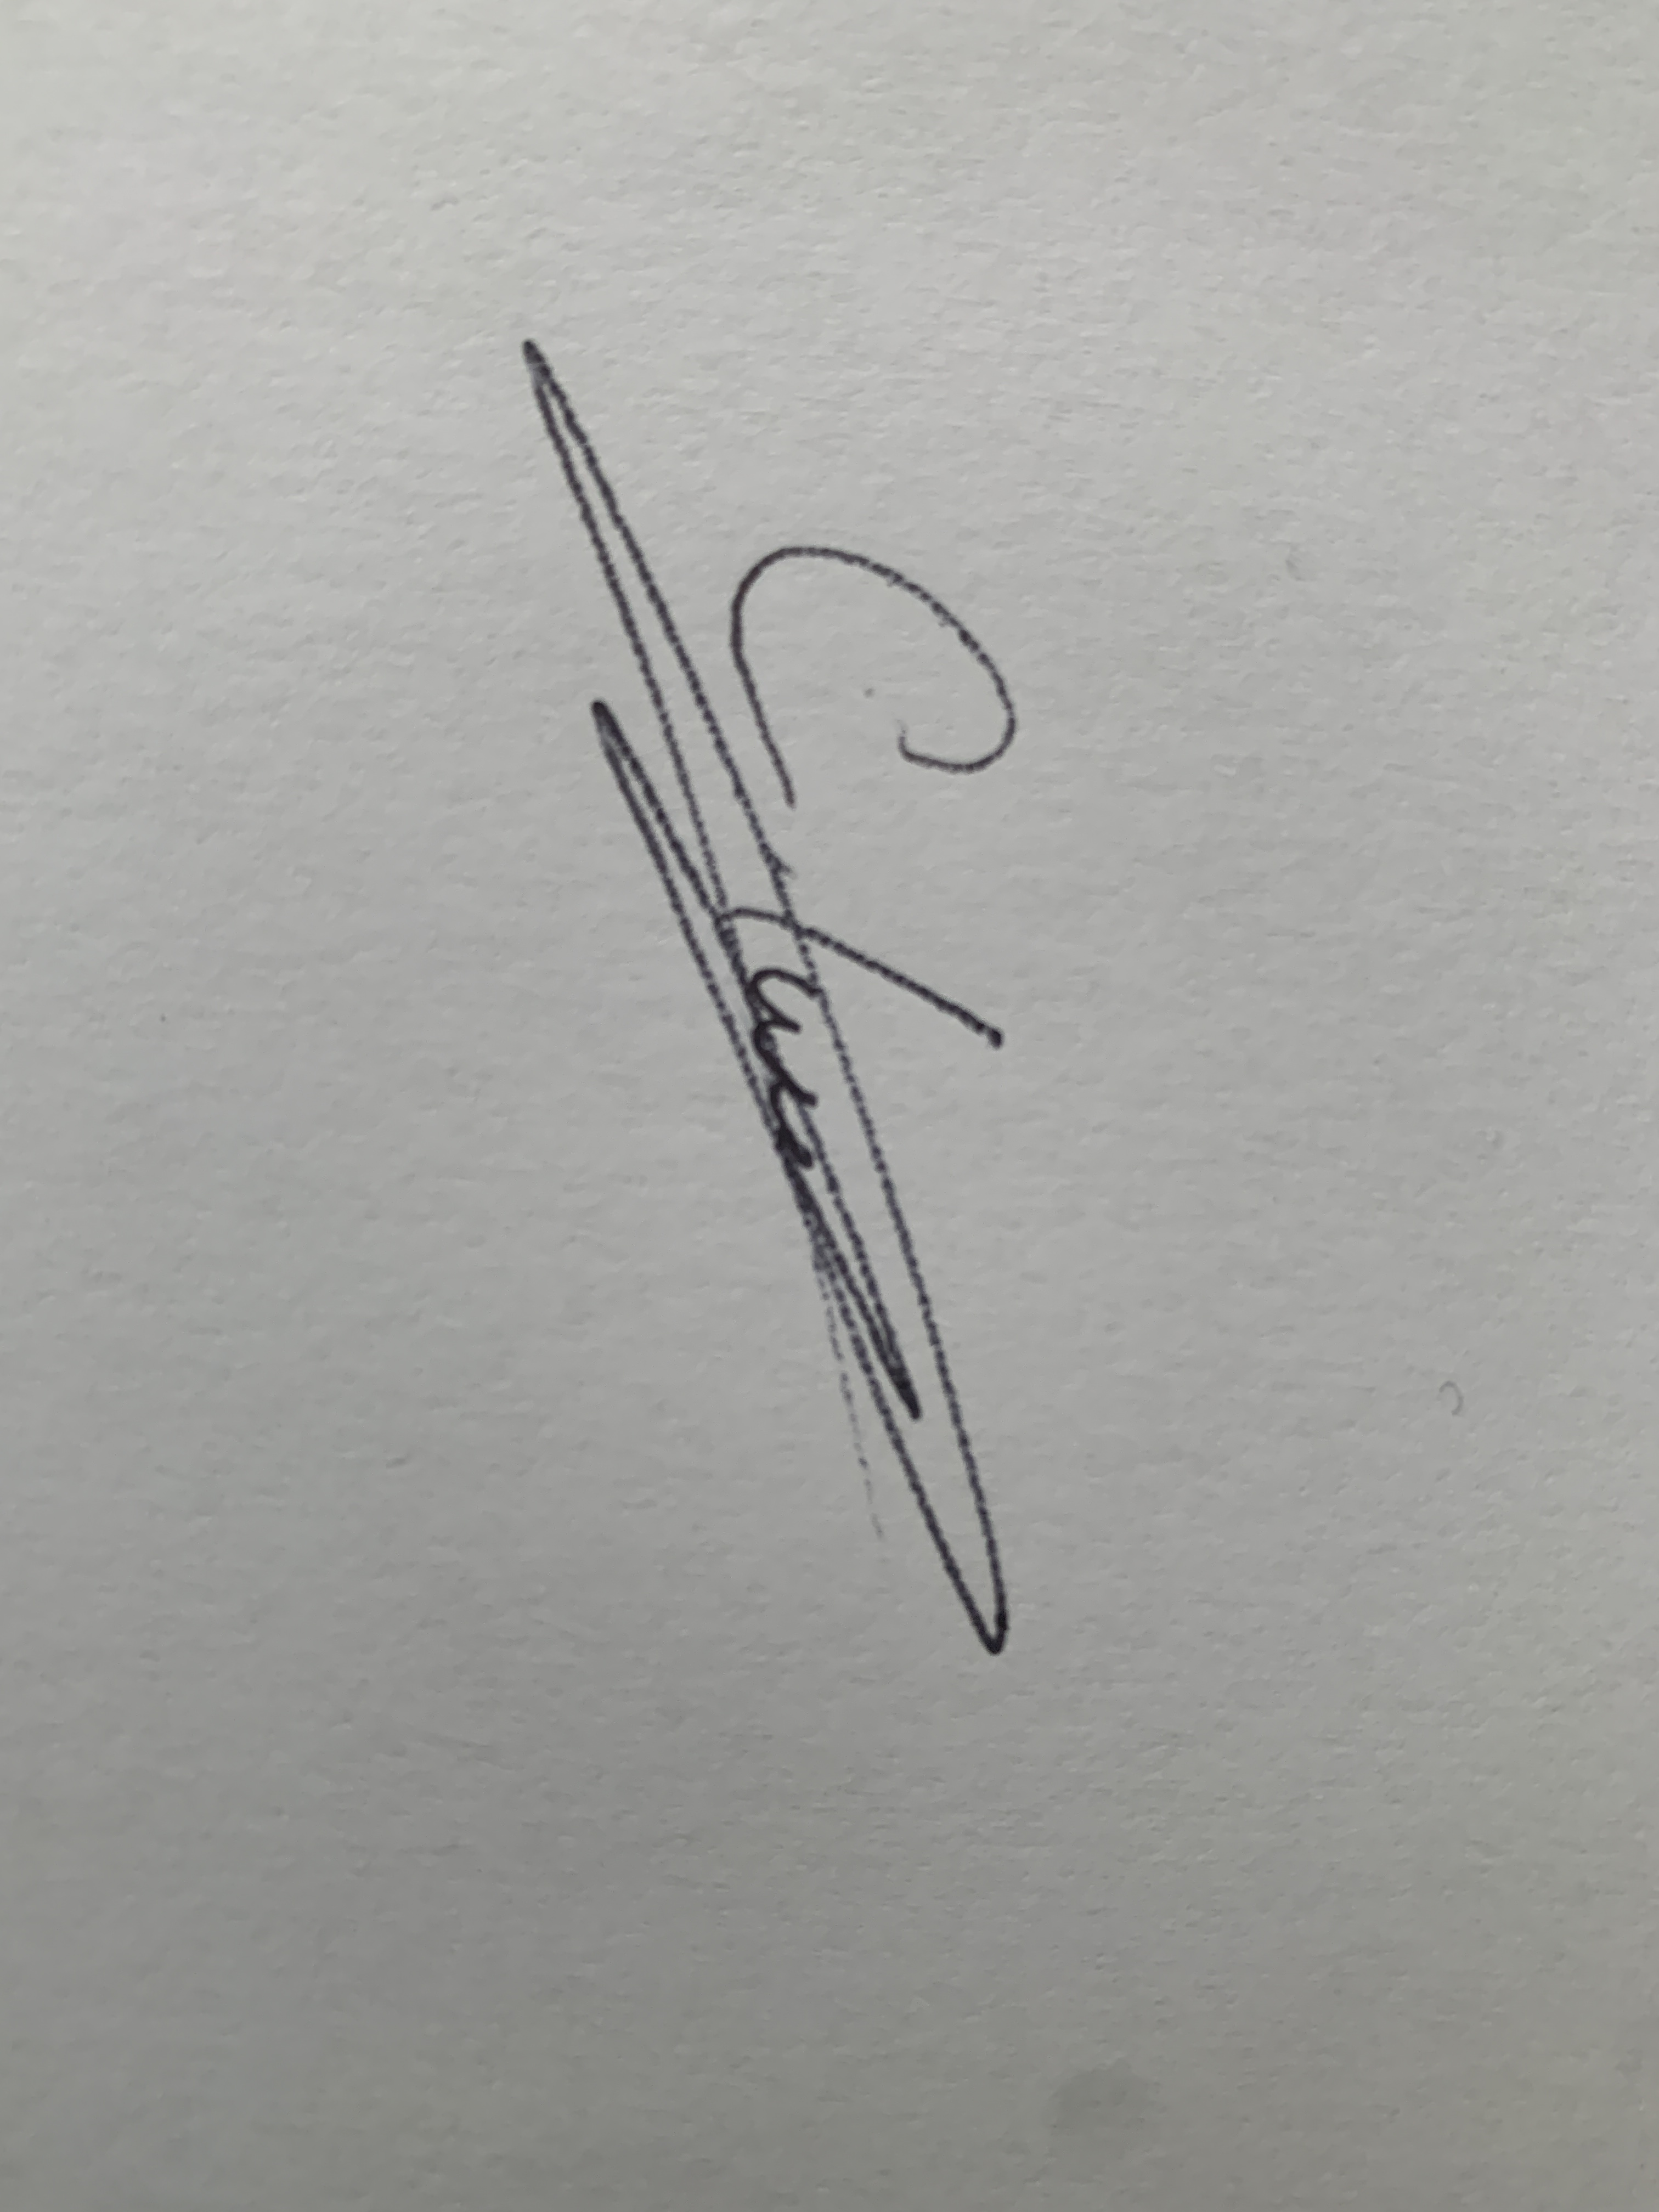 |  |  |  |  | Responsible manager’s signature:
Print name: Cameron Lamming |  |  |  | Date:09/2021 | Print name: |  | Date: 09/2021

Assessment Guidance
- Eliminate | Remove the hazard wherever possible which negates the need for further controls | If this is not possible then explain why
- Substitute | Replace the hazard with one less hazardous | If not possible then explain why
- Physical controls | Examples: enclosure, fume cupboard, glove box | Likely to still require admin controls as well
- Admin controls | Examples: training, supervision, signage
- Personal protection | Examples: respirators, safety specs, gloves | Last resort as it only protects the individual
LIKELIHOOD | 5 | 5 | 10 | 15 | 20 | 25
 | 4 | 4 | 8 | 12 | 16 | 20
 | 3 | 3 | 6 | 9 | 12 | 15
 | 2 | 2 | 4 | 6 | 8 | 10
 | 1 | 1 | 2 | 3 | 4 | 5
 |  | 1 | 2 | 3 | 4 | 5
 |  | IMPACT

Impact |  | Health & Safety
1 | Trivial - insignificant | Very minor injuries e.g. slight bruising
2 | Minor | Injuries or illness e.g. small cut or abrasion which require basic first aid treatment even in self-administered.
3 | Moderate | Injuries or illness e.g. strain or sprain requiring first aid or medical support.
4 | Major | Injuries or illness e.g. broken bone requiring medical support >24 hours and time off work >4 weeks.
5 | Severe – extremely significant | Fatality or multiple serious injuries or illness requiring hospital admission or significant time off work.
Risk process
- Identify the impact and likelihood using the tables above.
- Identify the risk rating by multiplying the Impact by the likelihood using the coloured matrix.
- If the risk is amber or red – identify control measures to reduce the risk to as low as is reasonably practicable.
- If the residual risk is green, additional controls are not necessary.
- If the residual risk is amber the activity can continue but you must identify and implement further controls to reduce the risk to as low as reasonably practicable.
- If the residual risk is red do not continue with the activity until additional controls have been implemented and the risk is reduced.
- Control measures should follow the risk hierarchy, where appropriate as per the pyramid above.
- The cost of implementing control measures can be taken into account but should be proportional to the risk i.e. a control to reduce low risk may not need to be carried out if the cost is high but a control to manage high risk means that even at high cost the control would be necessary.

Likelihood
1 | Rare e.g. 1 in 100,000 chance or higher
2 | Unlikely e.g. 1 in 10,000 chance or higher
3 | Possible e.g. 1 in 1,000 chance or higher
4 | Likely e.g. 1 in 100 chance or higher
5 | Very Likely e.g. 1 in 10 chance or higher

