Risk Assessment
Risk Assessment for the activity of | Running of Jazzmanix Society (weekly rehearsals, socials, concerts, tour)  Covid-19 information can be found towards end of Part A. |  | Date | Academic Year 2021-2022
Club or Society | Jazzmanix | Assessor (Name, Role and position to qualify sign off of document e.g. Coach)
President or Students’ Union staff member | Henrietta Simpson – President | Signed off

PART A
(1) Risk identification |  |  | (2) Risk assessment |  |  |  | (3) Risk management
Hazard | Potential Consequences | Who might be harmed  (user; those nearby; those in the vicinity; members of the public) | Inherent |  |  |  | Residual |  |  | Further controls (use the risk hierarchy)
 |  |  | Likelihood | Impact | Score | Control measures (use the risk hierarchy) | Likelihood | Impact | Score
Weekly Rehearsals
Injury whilst moving keyboard | Back injury from lifting something too heavy.  Injury from dropping keyboard on someone. | Those moving them and nearby people | 3 | 2 | 6 | 2 people to carry keyboard. Only committee members aware of risks to carry keyboard. Don’t allow anyone with existing back injuries to help | 2 | 1 | 2 | Not required.
Injury whilst moving stands/instruments into rehearsal space | Back injury from lifting something too heavy. Tripping walking into the building whilst carrying. Crushing fingers. Damaging instruments. | Those moving and nearby people | 4 | 2 | 8 | Using a room with lift access. Band setup before choir arrive. Having people only carry one item at a time/splitting up heavy items amongst people. Only having experienced people move large items (double bass) | 1 | 1 | 1 | Not required
Online Weekly Rehearsals (as a result of Covid-19 Restrictions)
Security/privacy issues related to use of video or voice call software. | Data protection breach | All participants | 3 | 2 | 6 | Use Microsoft Teams so only members of the university and invited guests can access the call. Avoid publishing links and passwords on public social media pages. Have a meeting host approve or deny access to members who wait in a virtual lobby. This host will have right to remove participants from call if necessary. | 1 | 2 | 2 | Not Required.
Using other person’s personal details to host or participate in public events | Data protection breach | Person whose details are used | 3 | 2 | 6 | Use Microsoft Teams so members can only join call using their own university, or guest, details. | 1 | 2 | 2 | Not Required.
Unauthorised recording of sessions | Data protection breach | All participants | 2 | 3 | 6 | Switch off in software settings where applicable. Ensure all participants are aware that the session must not be recorded by any person unless agreed and publicised clearly beforehand and with a clear description of how the recording will be used and who it will be available to. If observed to be recording; activity hosts to ask the person to stop. Refusal justifies removal from the activity. | 1 | 3 | 3 | Not Required.
Inappropriate behaviour | Bullying and harassment of participants | All participants | 2 | 3 | 6 | Participants to be reminded to be respectful of others.  Activity host to read SUSU’s Expect Respect Policy (https://www.susu.org/downloads/SUSU-Expect-Respect-Policy.pdf). Activity host to remove participants from the online activity if they are behaving inappropriately.  Activity host to report inappropriate behaviour to SUSU’s Activities team (activities@susu.org). | 1 | 3 | 3 | Not Required.
Concert Events
Transporting to and setting up for concerts. | Injury carrying/moving equipment. Accidents whilst making tea/coffee to serve as refreshments to those watching the concerts. | Members and audience members | 3 | 2 | 6 | Make sure people are carrying things correctly and are taking care. Large items to be transported by car and everyone able to help, helping carry things. Only designated people to be in the kitchen making hot drinks. | 2 | 1 | 2 | Not Required.
Activities during concerts such as dehydration, electrical failures, lights and speakers falling over. | Dehydration, electric shocks, injury due to heavy equipment falling on top of someone, injury due to tripping. | Members and audience members | 3 | 4 | 12 | Encourage choir to eat and drink plenty - allow time for eating and water bottles on stage. All wires to be safely protected and taped down. All equipment used to be PAT tested and set up by someone competent e.g. StageSoc. | 2 | 2 | 4 | Not required unless stated by concert venue.
Socials
Socials including nights out in town, and activities such as trampolining | Injuries, assault or theft whilst out especially as a result of/worsened by consumption of alcohol. Injury whilst taking part in injuries or as a result of travel. | Members attending each social | 3-5 | 3-4 | 9-20 | For nights out everyone talked to about staying safe, make sure no one is drinking too much (committee members to be responsible) make sure no one is going off/home alone. For activities make sure everyone knows what appropriate clothing to wear, reads any relevant safety material and attends any safety talk on activity. | 2-4 | 1-4 | 2-16 | Additional risk assessments for any particularly high-risk activities (those which would still have a high risk score).
Tour
Injury and damage incurred during tour and people getting lost. | Loss or theft of instruments, or damage in transit. Injury from travel including serious injury from vehicular collisions. Theft whilst staying in accommodation or theft of instruments/ pickpocketing whilst busking and out and about. Reactions to food/medication resulting in health problems. | Members attending the tour | 4 | 5 | 20 | Ensure all drivers are adequately qualified and comfortable driving. Make sure members keep rooms locked and instruments all kept securely and out of sight. Make sure members don’t go off alone and have contact details for tour leader and others. Make sure everyone declares medical issues and allergies, and have appropriate medication at all times including epipens. | 3 | 4 | 12 | Separate risk assessment to be completed
Busking | Theft/damage of instruments. Injury or theft of members particularly when carrying instruments, stands, music etc. Particular danger in bad weather. | Members participating in busking | 2 | 3 | 6 | Cancel busking if weather is not deemed appropriate (rain, severe wind etc.). Make sure heavy instruments are taken by someone driving, everyone able to help carrying to help moving equipment and no one to take too much. Make sure members are all comfortable. | 1 | 2 | 2 | Not required.
Fresher’s Fair
Injury whilst setting up stall | Back injury from lifting something too heavy. Tripping walking into the building whilst carrying. Crushing fingers. Damaging computers. | Those moving and nearby people | 4 | 2 | 8 | Committee set up before other members of the university community, freshers etc, arrive. Having people only carry one item at a time/splitting up heavy items amongst people. Only having experienced people move large items. Taking extra care when carrying electronics. Ensuring stall is stable before visitors from the university community arrive. | 1 | 1 | 1 | Not required
Collecting other people’s personal details to contact them about the society later | Data protection breach | Person whose details are used | 3 | 2 | 6 | Ensuring that visitors to the stall only provide their personal details in the form of university email addresses, and give them the choice to follow the society on social media if they wish. Do not collect other personal details. Ensure details that are collected and stored are only used for the purposes set out – for mailing lists. | 1 | 2 | 2 | Not Required.
General
Loud music being played | Damage to Hearing | All present, both performers and audience | 3 | 3 | 9 | Recommend the use of ear protection | 2 | 3 | 6 | Keep volume down  • Provide (disposable) ear protection  • Avoid pointing microphones near or pointing towards monitors to reduce/eliminate feedback
COVID-19
Covid-19 | Transmission of COVID-19 to members, and consequently to other people that they contact | - Society Members  - Vulnerable groups – Elderly, Pregnant members, those with existing underlying health conditions  - Anyone else who physically comes in contact with Jazzmanix members | 3 | 5 | 15 | Listed below | 2 | 5 | 10 | Not required.
 |  |  | 1 | 5 | 5 | Hand Washing:  - Encouraging members to take part in good personal and hand hygiene practises  - Providing hand sanitizer around the environment, in addition to washrooms  - Frequently cleaning and disinfecting objects and surfaces that are touched regularly, especially equipment in-between use by different people  - Enhancing cleaning for busy areas  - Setting clear use and cleaning guidance for toilets  - Providing hand drying facilities – either paper towels or electrical dryers | 1 | 3 | 3 | Not Required.
 |  |  | 2 | 5 | 10 | Social Distancing:  - Reducing the number of persons in any activity area to comply with the university’s social distancing guidelines (https://www.southampton.ac.uk/coronavirus.page)  - Encouragement of social distancing can be achieved by:  - Putting up signs to remind members and visitors of social distancing guidance  - Avoiding sharing workstations and equipment  - Using floor tape or paint to mark areas to help people keep distanced  - Arranging one-way traffic through the location if possible  - Switching to members engaging by appointment only / ticketed activities  - Holding events outside if possible  - Holding rehearsals in their designated time slot and room | 2 | 3 | 6 | Not Required.
 |  |  | 2 | 5 | 10 | Following University Guidelines:  - Jazzmanix will follow the appropriate meeting room and local guidance as outlined by the university  - Ensure an updated Risk Assessment is available on Groups Hub and the Jazzmanix page for committee and members to read  - Use social media and email communications to make all members aware about changes to activities and precautions that should be taken  - Start activities with a reminder of key COVID-19 precautions and how to maintain them  - Ensure participants are aware of the consequences of not complying with guidance | 1 | 4 | 4 | Not Required.
 |  |  | 4 | 5 | 20 | Protecting Members Who Are At Higher Risk:  - Ask members to clarify if they have any specific health conditions which may put them in the ‘at risk’ category  - Plan for people who are unable to engage in activities in person  - Provide meaningful alternative activity for those who are shielding / self-isolating / have someone at home who is shielding  - Help members at increased risk to engage from home, either in their current role or an alternative role | 2 | 5 | 10 | Not Required.
 |  |  | 4 | 5 | 20 | Taking action when aware of symptoms of Covid-19…  - If a member becomes unwell with a new continuous cough or high temperature, they will be sent home and advised to follow the stay-at-home guidance and advise to get a test.  - Committee Members will maintain regular contact with members during this time.  - If advised that a member has developed Covid-19 and that they were recently in contact with other members, the committee will contact SUSU Activities Team and will encourage the person to contact Public Health England to discuss the case, identify people who have been in contact with them and will take advice on any actions or precautions that should be taken (https://www.publichealth.hscni.net/).  - Meaningful activity will be provided for those who have to isolate at home due to Covid-19. | 3 | 5 | 15 | Not Required.
 |  |  |  |  |  | Face Coverings:  - Encourage members to wear face masks in indoor or crowded areas in accordance with university guidelines (https://www.southampton.ac.uk/coronavirus.page)  - Encourage the wearing of tight-fitting respirators (such as disposable FFP3 masks and reusable half masks) that have a good seal with the wearer’s face.  - Remind members of guidelines of putting on and disposing of masks correctly. |  |  |  | Not Required.
 |  |  | 3 | 5 | 15 | Being aware of the impacts of Covid-19 on mental health:  - Committee members will promote mental health and wellbeing awareness to members will offer support through training such as WIDE  - Committee to share relevant support services to members i.e. Student Services, Security, Enabling Team, Advice Centre, Emergency Services | 2 | 4 | 8 | - Regular communication of mental health information and SUSU policies for those who need additional support.
 |  |  | 3 | 5 | 15 | Care of Shared Equipment / Spaces:  - Sharing of equipment such as music stands, sheet music, instruments will be avoided where possible  - Brass or wind instruments will not be shared  - Attempts will be made to avoid the sharing of equipment, such as the provision of electronic sheet music that can be accessed via an individual’s own device  - Any equipment that is shared, such as the keyboard, will be cleaned thoroughly with anti-bacterial spray/wipes in between users  - Members will be encouraged to wash their hands before and after handling equipment that is shared  - Any rooms or common spaces that are shared, such as the rehearsal space, will be cleaned between users  - This will involve the use of anti-bacterial spray/wipes to clean common touch points such as door/window handles and chairs  - Members will be encouraged to wash their hands before and after using shared rooms or common spaces | 2 | 5 | 10 | Not Required.

PART B – Action Plan

Risk Assessment Action Plan
Part no. | Action to be taken, incl. Cost | By whom | Target date |  | Review date | Outcome at review date
A | Separate risk assessment to be made for tour if it can go ahead | Tour secretary | 01/05/22 |  | TBC
A | Risk assessments to be made for any individual socials which still have high residual risk | Social secretary | TBC |  | TBC
A | Risk assessments for in person concerts if required by the venue | Vice President | TBC |  | TBC
Responsible committee member signature:  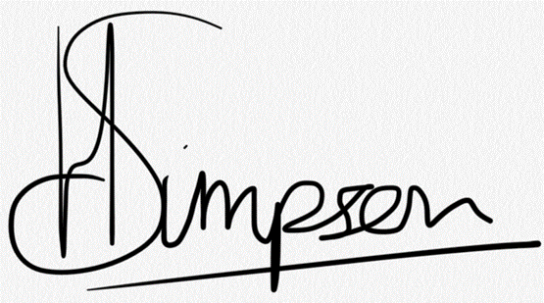 |  |  |  |  | 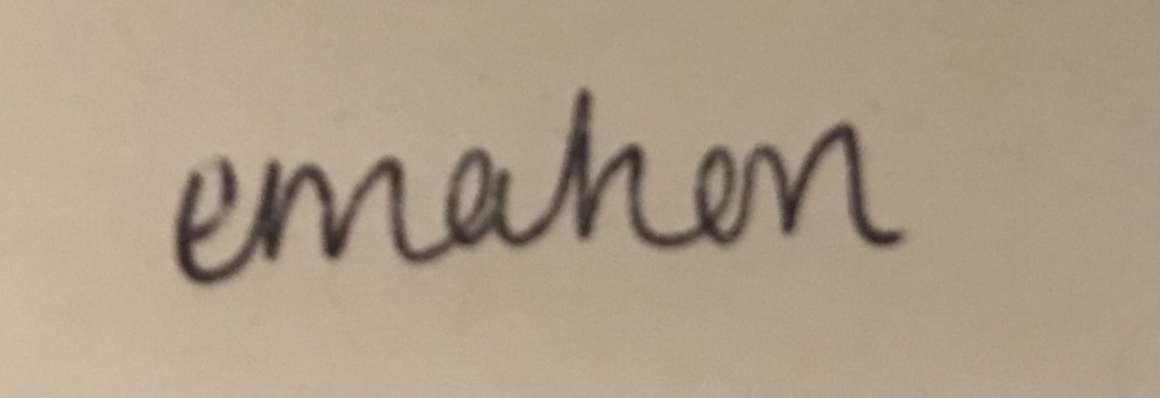  Responsible committee member signature:
Print name: Henrietta Simpson |  |  |  | Date: 23/08/2021 | Print name: Emma Mahon |  | Date:  23/08/21

Assessment Guidance
- Eliminate | Remove the hazard wherever possible which negates the need for further controls | If this is not possible then explain why
- Substitute | Replace the hazard with one less hazardous | If not possible then explain why
- Physical controls | Examples: enclosure, fume cupboard, glove box | Likely to still require admin controls as well
- Admin controls | Examples: training, supervision, signage
- Personal protection | Examples: respirators, safety specs, gloves | Last resort as it only protects the individual
LIKELIHOOD | 5 | 5 | 10 | 15 | 20 | 25
 | 4 | 4 | 8 | 12 | 16 | 20
 | 3 | 3 | 6 | 9 | 12 | 15
 | 2 | 2 | 4 | 6 | 8 | 10
 | 1 | 1 | 2 | 3 | 4 | 5
 |  | 1 | 2 | 3 | 4 | 5
 |  | IMPACT

Impact |  | Health & Safety
1 | Trivial - insignificant | Very minor injuries e.g. slight bruising
2 | Minor | Injuries or illness e.g. small cut or abrasion which require basic first aid treatment even in self-administered.
3 | Moderate | Injuries or illness e.g. strain or sprain requiring first aid or medical support.
4 | Major | Injuries or illness e.g. broken bone requiring medical support >24 hours and time off work >4 weeks.
5 | Severe – extremely significant | Fatality or multiple serious injuries or illness requiring hospital admission or significant time off work.
Risk process
- Identify the impact and likelihood using the tables above.
- Identify the risk rating by multiplying the Impact by the likelihood using the coloured matrix.
- If the risk is amber or red – identify control measures to reduce the risk to as low as is reasonably practicable.
- If the residual risk is green, additional controls are not necessary.
- If the residual risk is amber the activity can continue but you must identify and implement further controls to reduce the risk to as low as reasonably practicable.
- If the residual risk is red do not continue with the activity until additional controls have been implemented and the risk is reduced.
- Control measures should follow the risk hierarchy, where appropriate as per the pyramid above.
- The cost of implementing control measures can be taken into account but should be proportional to the risk i.e. a control to reduce low risk may not need to be carried out if the cost is high but a control to manage high risk means that even at high cost the control would be necessary.

Likelihood
1 | Rare e.g. 1 in 100,000 chance or higher
2 | Unlikely e.g. 1 in 10,000 chance or higher
3 | Possible e.g. 1 in 1,000 chance or higher
4 | Likely e.g. 1 in 100 chance or higher
5 | Very Likely e.g. 1 in 10 chance or higher

