Could Lead to an increased likelihood of injury or when hot, fainting.

This document contains both ‘Part 1: Event Information’ AND ‘Part 2: Risk Assessment’. Both parts are required to be completed by the organising group.
Part 1
Event Information
1A) Contact Information:
Main Contact for The Event:  Neeraja Govindan | Email Address for Main Contact:  ng2g23@soton.ac.uk | Club or Society Name:  Malayali Society | Contact Number:  +44 7450 663491
1B) Event Information:
Event Name:  Onam 2026 | Event Date:  03/10/2026 | Event Venue/s:  St Denys Hall | Total Attendees:  100
Event Timings: | Set Up: 8:00 am  Event Start: 9:30 am  Event End: 5:00 pm  Pack Down: 6:00 pm
Event Breakdown  This includes everything happening at your event, including fundraising, food provision, any performance or sporting activity, etc. | 8:00 – 9:30 am – Committee team set up tables and decorations  9:30- 10:00 am – Doors open for arrival; welcome guests with tea (chaya) and snacks.  10:00 am – Guest expected to arrive  10:30 am – Last entry  10:30 - 11:00 am- Settling/ preparation for the programme. Anchoring and programme starts  11:00 am – 12:00 pm- 1st half of performances and games start  12:00 – 14:00 pm - Food (sadhya) starts to be served  14:00 – 16:00 pm – 2nd half of performances and games starts  16:00 –16:15 pm – Vote of Thanks, DJ set up  16:15 – 17:00 pm - Disco  17:00 pm – Guests leave  17:00 – 18:00 pm- Pack down
Overview of event concept  Description of the activities taking place. This includes everything happening at your event e.g. fundraising, food provision and any performance or sporting activity) | - Opening ceremony, including the lighting of the lamp and a brief Onam story introduction.  - Maveli segment, including Maveli's arrival and traditional Onam activities.  - Cultural performances, including Thiruvathira, songs and other performances, with the first-round finishing by approximately 12:00 PM.  - Sadhya (traditional Onam meal) from approximately 12:00 PM, including organised table seating and interactive games/activities.  - Second round of performances from 2:00 PM, including a Maveli Q&A, committee dance, songs and games.  - Vote of thanks and prize-giving at approximately 4:00 PM, lasting no more than 15 minutes.  - Disco/music session from 4:15–5:00 PM, involving a DJ and music.  - Venue clean-up from 5:00–6:00 PM, including clearing tables, food and event equipment.
Volunteers hosting the event  List all committee and volunteers that will be present and responsible for the event, as well as their role. | Event lead: Neeraja Govindan  Host: Neeraja Govindan  Performance lead: Alisha Prasath  Doors: Godwin Dominic  Food Lead: Aksa John  Volunteers for set up: Minna Joby and Alvin Thomas
Food provision  For full guidance on this click here. | Food provided by external caterer (Scaria)  (full details in part 1C)
Security & First Aid Requirements  Is external first aid or security being hired? Who are the qualified first aiders in the group should a medical emergency occur? | Name of security company- St Denys security  Name of first aid provider or first aid trained member- Ashika Giby
Provisional Budget  If you would like a more extensive budget tracker, click here. | Projected ticket income: £1400 (based on 80% of tickets being sold)  Venue hire: £158  Tech: £0  Food: £1000  Security: £0  Projected profit: £200
1C) Only required if an external company will be on site for the event
- If you are inviting an external speaker to campus for your event, you are required to submit an external speaker form at least 3 weeks before the event. For more guidance on this please click here.
Business Name:  Scaria Food | Business Contact Name:  Scaria | Email Address:  N/A | Contact Number:  07877393238
Arrival On Site:  11:00 am  Departure time: 12:00 pm | 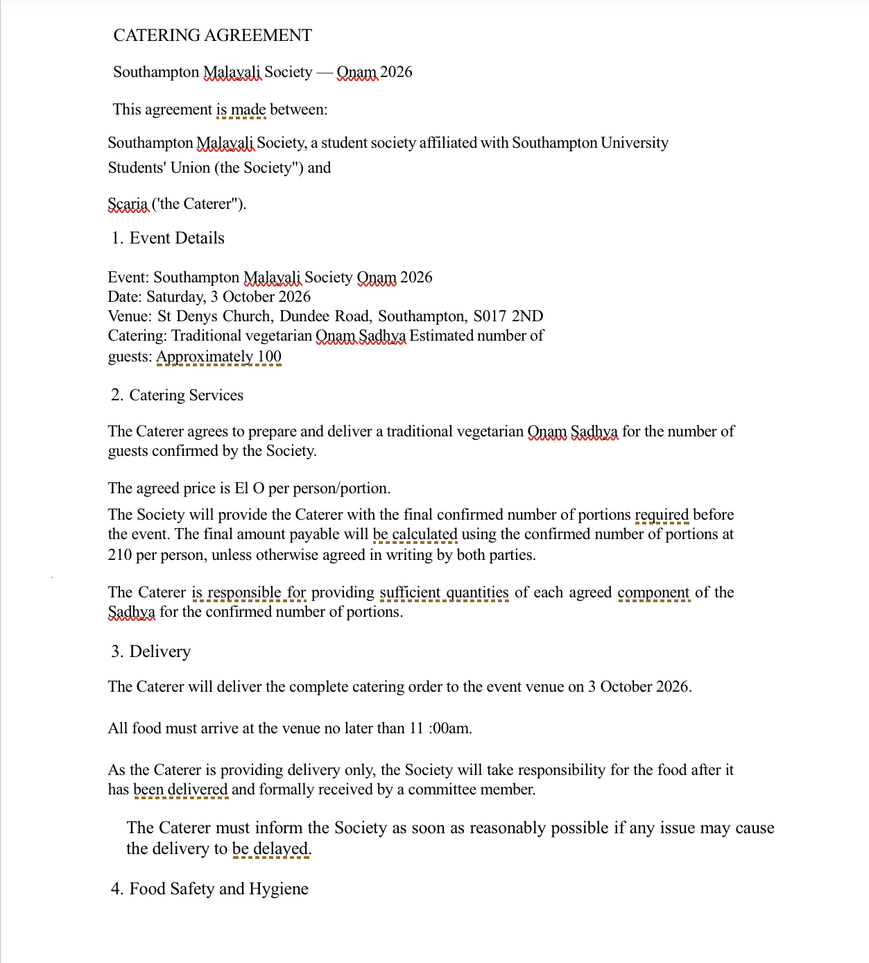  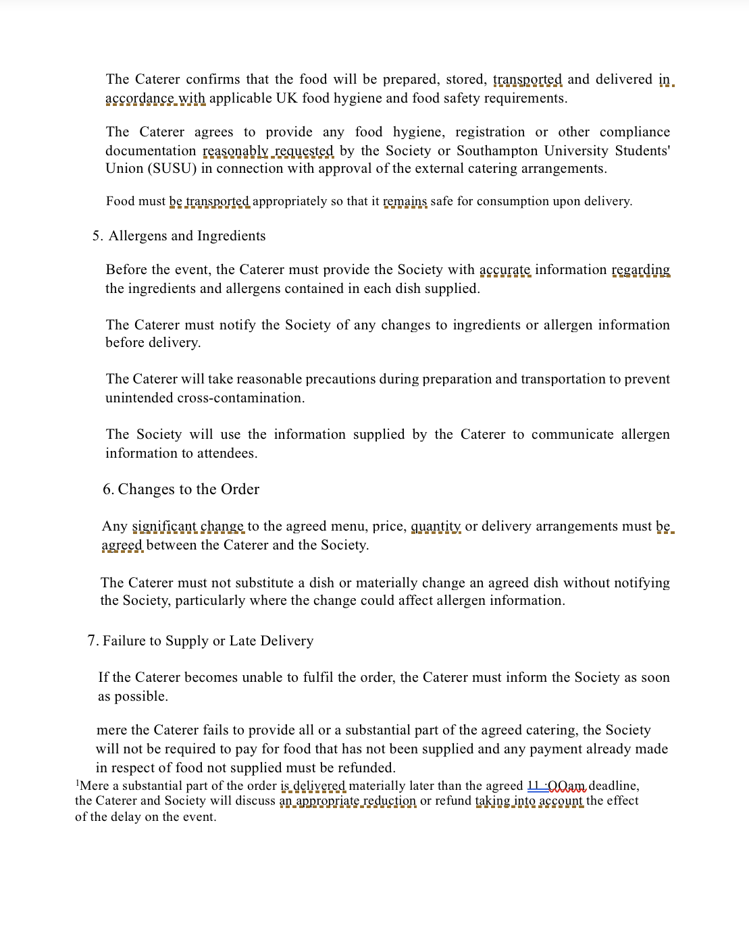  Company’s Risk Assessment Link:  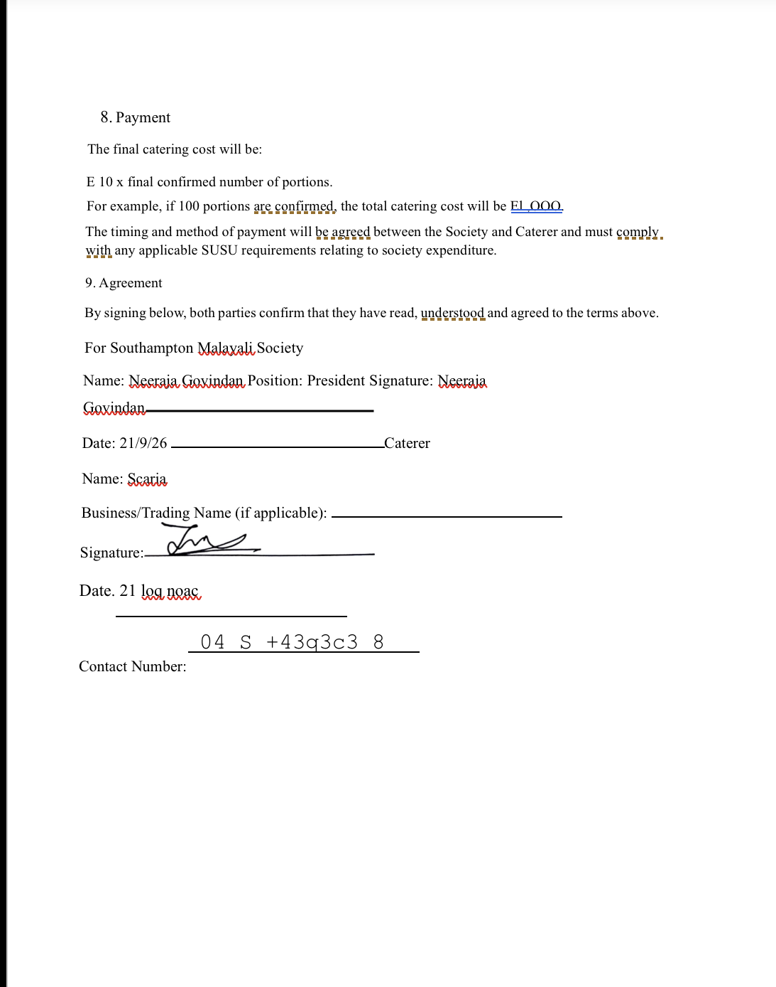  We will send it when requested | Company’s Insurance Link:  N/A | Company’s Public Liability Information Link:  N/A

Part 2A
Risk Assessment
(1) Risk identification |  |  | (2) Risk assessment |  |  |  | (3) Risk management
Hazard | Potential Consequences | Who might be harmed  (user; those nearby; those in the vicinity; members of the public) | Inherent |  |  |  | Residual |  |  | Further controls (use the risk hierarchy)
Hazard | Potential Consequences |  | Likelihood | Impact | Score | Control measures (use the risk hierarchy) | Likelihood | Impact | Score
Slips, trips and falls | Physical injury | Event organisers and attendees | 2 | 3 | 6 | All boxes and equipment to be stored away from main meeting area, e.g. stored under tables.  Floors to be kept clear and dry, and visual checks to be maintained throughout the meeting by organisers.  Extra vigilance will be paid to make sure that any spilled food products/objects are cleaned up quickly and efficiently in the area.  Report any trip hazards to facilities teams/venue staff asap. If cannot be removed, mark off with hazard signs. | 1 | 4 | 4 | If the injury is serious and participant in a lot of pain or discomfort, seek medical attention immediately.  Call 999 in an emergency.  Any incidents need to be reported as soon as possible, ensuring duty manager/health and safety officers have been informed.  Follow SUSU incident report policy.
Manual handling, including setting up of equipment. E.g. table and chairs | Bruising or broken bones from tripping over table and chairs. | Meeting organisers and attendees | 2 | 3 | 6 | Follow manual handling guidelines.  Ensure that at least 2 people carry tables or other bulky items.  Setting up tables will be done by organisers.  Work in teams when handling other large and bulky items.  Request tools to support with the moving of heavy objects from SUSU Facilities/venue. E.g. hand truck, dolly, skates.  Make sure anyone with any pre-existing conditions isn’t doing any unnecessary lifting and they are comfortable. | 1 | 3 | 3 | Seek assistance from facilities staff/venue staff if needed.  Seek medical attention from SUSU/venue Reception if in need.  Contact emergency services if needed.  All incidents are to be reported on the as soon as possible ensuring the duty manager/health and safety officer have been informed.  Follow SUSU incident report policy.
Overcrowding / Inadequate Meeting Space | Physical injury, distress, exclusion | Event organisers and attendees | 2 | 3 | 6 | Do not push/shove.  If large crowds form, request barriers from SUSU facilities team or external venue to assist with crowd management.  Committee checks on space, lighting, access, tech available, etc.  Use ticketing system (SUSU Box Office) for regular sessions/meetings to avoid exceeding venue capacity.  Ensure space meets needs of members e.g. considering location & accessibility of space (use AcessAble database to check accessibility information of venues).  If an open activity, committee will consider all accessibility requirements and ensure that the area chosen is as accessible as possible.  Committee to consult members on needs and make reasonable adjustments where possible  Provide remote meeting options for members where possible. | 1 | 3 | 3 | Seek medical attention if problem arises.  Liaise with SUSU reception/Activities Team and UoS Room Booking team on available spaces for meetings.  Postpone meetings where space cannot be found.  Welfare Officer to complete WIDE training.  All incidents are to be reported on the as soon as possible ensuring the duty manager/health and safety officer have been informed.  Follow SUSU incident report policy.
Reputational Risk:  For the club or society, as well as to SUSU and the University | Incidents causing reputational damage to the group, Southampton University Students’ Union or Southampton University itself.  This could be controversial posts, conduct during a game, conduct during social, or anything else that brings the clubs/societies, SUSU or the University’s name into disrepute. | The club, SUSU or the University’s reputation | 2 | 1 | 2 | Ensuring all parts of this risk assessment are adhered to.  Ensuring all members are reminded that they are representing the club/society, SUSU and the University, often in branded clothing.  Members are reminded that they need to adhere to SUSU’s Code of Conduct. | 1 | 1 | 1 | Ensure that any incidents involving public or others are recorded and addressed.  Report any incidents to the Activities Team.
Costumes/Fancy Dress | Props/costumes causing injury or offence | Participants  Members of the public | 2 | 1 | 2 | Ask members to only bring small items and use sensibly.  Members of the society are responsible for their own possessions and the use of them.  Choose a theme unlikely to cause offence.  Any participant wearing items deemed offensive asked to remove these.  Society to follow and share with members Code of Conduct/SUSU Expect Respect policy. | 1 | 1 | 1 | SUSU Expect Respect policy to be followed.  Committee WIDE training.  Ensure that any incidents involving public or others are recorded and addressed.  Report any incidents to the Activities Team.
Alcohol consumption | Peer pressure/coercion, alcohol poisoning, spiking, increased risk to personal safety | Event organisers, event attendees, | 2 | 4 | 8 | Members are responsible for their individual safety though and are expected to act sensibly.  Initiation behaviour not to be tolerated and drinking games to be discouraged.  For socials at bars/pubs etc., bouncers will be present at most venues.  Bar Security staff will need to be alerted and emergency services called as required.  Where possible the consumption of alcohol will take place at licensed premises. The conditions on the license will be adhered to and alcohol will not be served to customers who have drunk to excess  Committee to select ‘student friendly’ bars/clubs and contact them in advance to inform them of the event.  Committee to advise and remind members to always watch their own drinks.  Society to follow and share with members Code of conduct/SUSU Expect Respect policy. | 1 | 3 | 3 | Follow SUSU incident report policy.  Call emergency services as required 111/999.  Welfare Officer to complete WIDE training.
Spiked Drinks/Alcohol Poisoning | Illness, loss of consciousness, loss of self- control | Event organisers, event attendees, | 2 | 5 | 10 | Committee to supervise meetings/socials and attend each venue. Ideally, they will not drink to excess during the event.  Bouncers/trained staff in pubs should watch for excessive drinking and watch people who are believed to have consumed a lot of alcohol.  Report any suspicious/unusual behaviour to staff.  Participants encouraged to stay with a nominated ‘buddy’ where possible.  The organisers have confirmed the premise is licensed. Action organisers (Part B).  The consumption of alcohol will take place at licensed premises. The conditions on the license will be adhered to and alcohol will not be served to customers who have drunk to excess.  Members/participants are advised to watch their own drinks.  Games involving binge drinking or the consumption of excessive amounts of alcohol are not to be undertaken.- Society to follow Code of conduct/Expect Respect policy | 2 | 3 | 6 | Members are responsible for their individual safety and are expected to act sensibly when walking around.  For anyone who is too inebriated it will be suggested to them that they should return home rather than continue on the social. Taxis will be called if required (look at SUSU Safety Bus, Radio Taxis options).  If they need to go to the hospital they will also be accompanied there.  Participants advised to avoid leaving drinks unattended and if you think anything has been added to a drink; report it; try and retain the drink for testing.  All incidents are to be reported on the as soon as possible ensuring the duty manager/health and safety officer have been informed.  Follow SUSU incident report policy
Travel by foot | Disturbance to neighbourhood, participants getting lost, increased risk to personal safety, vehicle collision causing serious injury | Event organisers, event attendees, Members of the public | 4 | 3 | 12 | Members are responsible for their individual safety and are expected to act sensibly.  Local venues known to UoS students chosen.  Event organisers will be available to direct people between venues.  Attendees will be encouraged to identify a ‘buddy’, this will make it easier for people to stay together.  They will be encouraged (but not expected) to look out for one another and check in throughout the night where possible.  Avoid large groups of people totally blocking the pavement or spilling in to the road.  Anybody in the group who is very drunk or appears unwell and therefore not safe should be encouraged to go home ideally with someone else. If required a taxi will be called for them (ideally SUSU Safety Bus will be used, or Radio Taxis).  Be considerate of other pedestrians and road users, keep disturbance and noise down. | 2 | fire | 4 | Where possible venue chosen for the event will be local/known to members and within a short travel distance for members.  Contact emergency services as required 111/999.  Incidents are to be reported as soon as possible ensuring the duty manager/health and safety officer have been informed.  Follow SUSU incident report policy
Travel by car, train, bus, plane when leaving the local area. | Vehicle collision – causing anything from minor to severe injuries, as well as mental health issues. | Members, those driving, members of the public | 2 | 5 | 10 | Group committee to check that drivers have the relevant licences and insurance for the mode of travel. This includes if they have completed a SUSU minibus test.  Members expected to drive or travel in a sensible manner, with those doing otherwise to face disciplinary action (from the club/society in the first instance).  Can cause reputational issues, especially if driving SUSU branded vehicles. Importance of this to be reminded. | 1 | 5 | 5 | Contact emergency services as required 111/999.  Incidents are to be reported on the as soon as possible ensuring the duty manager/health and safety officer have been informed.  Follow SUSU incident report policy
Medical emergency | Members may sustain injury /become unwell  Pre-existing medical conditions, sickness, distress | Members | 1 | 5 | 5 | Advise participants to bring their personal medication if it might be required.  Members/Committee to carry out first aid if necessary and only if qualified and confident to do so.  Contact emergency services as required 111/999.  Contact SUSU Reception/venue staff for first aid support.  Members can be referred to The Student Hub (02380 599 599, studenthub@soton.ac.uk) in case of distress. | 1 | 4 | 4 | Incidents are to be reported on the as soon as possible ensuring the duty manager/health and safety officer have been informed.  Follow SUSU incident report policy.
Fire | Smoke inhalation, burns. Risk of extreme harm. | All participants and organisers, any staff and spectators | 1 | 5 | 5 | Those leading the session must ensure they are aware of and fully understand the venue or location’s fire procedures.  Those leading must make sure that all exit routes are clearly highlighted and report any issues immediately to the venue.  Highlight to all the participants the nearest emergency exit routes at the start of a session, and the importance of leaving calmly in case of an emergency.  Avoid build-up of debris in the activity area.  Consider accessibility requirements. | 1 | 4 | 4 | In case of an emergency, please pull nearest fire alarm and ensure all participants leave the venue calmly and safely.  Once in a safe position to do so, call the emergency services on 999.  Any incidents need to be reported as soon as possible ensuring duty manager/health and safety officers have been informed.  Follow SUSU incident report policy.
Anti-social, violent, or offensive behaviour | Disturbance to the neighbourhood, reputational damage, injury and distress as a result of violence | Event organisers, event attendees, public | 2 | 5 | 10 | Bouncers/security will be present at most licensed venues.  Bar/venue security staff will need to be alerted and emergency services called as required.  Do not personally engage with any violent behaviour. Stay safe and inform the bar staff/police if necessary.  The consumption of alcohol will take place at licensed premises. The conditions on the license will be adhered to and alcohol will not be served to customers who have drunk to excess.  Committee to select ‘student friendly’ bars/clubs and contact them in advance to inform them of the event.  Society to follow and share with members Code of conduct/SUSU Expect Respect policy. | 1 | 3 | 5 | If the situation becomes very serious and results in the participant being arrested then it will be made clear that they cannot be accompanied to the police station.  Follow SUSU incident report policy.  Call emergency services as required.
Adverse weather | Hypo- or hyperthermia, illness, injury, slipping, burns | Event organisers, event attendees | 3 | 4 | 12 | Lead organiser to check the weather are suitable for activities on the day.  Warn those attending to prepare by wearing appropriate clothing and footwear e.g. via social media posts, email invites.  In the case of hot weather organisers to advice participants to bring/wear appropriate level sunscreen, and to hydrate (especially if drinking alcohol). | 2 | 2 | 4 | If adverse weather is too extreme to be controlled, the event should ultimately be cancelled or postponed to a different date.  Contact emergency services if needed.  All incidents are to be reported on the as soon as possible ensuring the duty manager/health and safety officer have been informed.  Follow SUSU incident report policy.
Incident- Experience of terrorism | Distress, serious injury, fatality | Students  Public,  Wider student community | 2 | 5 | 10 | In the event of an immediate threat or incident, call 999 and follow instructions from emergency services.  In case of a terrorism incident follow Run, Hide, Tell guidance.  Organisers to check the current national terrorism threat level on Gov.uk website  If the national threat level is ‘severe’, organisers to liaise with venue management in advance to confirm:  - Emergency procedures  - Lockdown arrangements (if applicable)  - Evacuation points and places of relative safety  Confirm who has authority to stop or evacuate the event in an emergency. Brief all organisers/staff on terrorism response procedures and ensure emergency exits and evacuation routes are clearly communicated to attendees (e.g. signage, verbal briefing).  If the national threat level is ‘critical’, consider cancelling/postponing large-scale events  Organisers and volunteers to remain alert to suspicious behaviour or unattended items and report concerns immediately to venue staff or police.  Organisers to have at hand details of local emergency phone numbers  Organisers must make sure that all exit routes are clearly highlighted and report any issues immediately to the venue  Avoid scheduling events near planned demonstrations, protests, or known high-risk locations where practicable.  Mobile phone access- ensure there is mobile phone service at the event venue in case of emergency | 1 | 5 | 5 | Organisers to be aware of nearest first aid kit for minor injuries.  Organisers to report any (suspected) terrorist activity to ACT (Action Counters Terrorism)  Committee to complete SUSU Incident report as soon as possible – available here  Provide signposting to wellbeing support if attendees and/or organisers are distressed following a serious incident.
Financial risk | Group debt | Group members, SUSU | 4 | 3 | 12 | Create a cost balance sheet, including:  How much profit is expected to be made?  What is the contingency plan if not enough tickets are sold? e.g. cancelling or postponing  You can find templates and guidance here. | 2 | 3 | 6 | Contact SUSU Activities Team if you have any questions or concerns about this – we would rather know sooner than later!
Events Involving Food | Allergies  Food poisoning  Choking | All | 3 | 5 | 15 | If members are making and/or serving food,  OR  you are using hired catering services  YOU MUST consider extra risks here.  Only order/buy food at establishments with appropriate food hygiene (EHO) rating.  Food to only be provided/eaten when other activities are stopped.  Follow good food hygiene practices - no handling food when ill, tie back hair, wash hands regularly using warm water and soap, refrigerate necessary products.  For store-bought items/snacks, keep packaging to hand for ingredient and allergen information. | 1 | 5 | 5 | SUSU food hygiene level 2 course available for completion- requests made to Activities Team.  Call for first aid/emergency services a required .  Report incidents via SUSU incident report procedure.
Dance performances:  Physical Exertion/Injury | People may trip, fall, or slip, due to generally slippery flooring or due to trip hazards | Performers, attendees | 2 | 2 | 4 | Encourage all dancers to wear appropriate footwear and advise on what is  Ensure trip hazards are identified and removed  Ensure regular drinks breaks in class especially in hot weather  Ensure there is access to a first aid kit and ice packs incase of injury | 1 | 3 | 3 | Ask attendees at start of event of any previous injuries so committee can accommodate this  Call 999 in emergency  Any incidents need to be reported as soon as possible ensuring duty manager/health and safety officers have been informed. Follow SUSU incident report policy
Dance performances:  Falling while participating in activity | Injuries and bruising | Performers, attendees | 3 | 1 | 3 | Rehearse, ensure adequate space, no obstacles on stage area | 2 | 1 | 2 | If an individual is at risk of falling due to slippery footwear, ask them to change and dance in a more suitable and safe clothing If the injury is serious and participant in a lot of pain or discomfort, seek medical attention immediately.  Call 999 in an emergency.  Any incidents need to be reported as soon as possible ensuring duty manager/health and safety officers have been informed. Follow SUSU incident report policy
Dance performaces: Exhaustion | Could Lead to an increased likelihood of injury or when hot, fainting. | Performers, Attendees | 2 | 1 | 2 | Make aware of where people can get water  Ensure plenty of water breaks.  Ensure no dancer feels obligated to over-exert themself. | 1 | 1 | 1 | If a student appears exhausted, be proactive in advising them to sit out and eliminate risk of further exhaustion. If the injury is serious and participant in a lot of pain or discomfort, seek medical attention immediately.  Call 999 in an emergency.  Any incidents need to be reported as soon as possible ensuring duty manager/health and safety officers have been informed. Follow SUSU incident report policy.
Dance performances:  Footwear | Injury, bruising, damage | Performers, attendees wearing shoes | 2 | 3 | 6 | Ensure all dancers have proper dance footwear. ·  Ensure the space is equipped for wearing shoes such as tap shoes. ·  Ensure any shoes and styles that require adequate training eg: pointe is checked before individuals are allowed to participate. · Ensure if people are borrowing dance shoes a committee member will advise on what size is correct. | 1 | 3 | 3 | Ensure equipment is set up prior to letting students into class If a student appears hurt, be proactive in advising them to sit out and eliminate risk of further strain  If the injury is serious and participant in a lot of pain or discomfort, seek medical attention immediately. Call 999 in an emergency.  Any incidents need to be reported as soon as possible ensuring duty manager/health and safety officers have been informed. Follow SUSU incident report policy

PART 2B – Action Plan
Risk Assessment Action Plan
Part no. | Action to be taken, incl. Cost | By whom | Target date |  | Review date | Outcome at review date
1 | Risk assessment shared with all organisers and checked through before the event  Follow SUSU Food Provision Guidance for events involving home-cooked/prepared food or external catering. | Neeraja Govindan | 23/09/2026 |  | 03/10/2026
2 | Committee to read and share SUSU Expect Respect Policy | All committee members | 23/09/2026 |  | 03/10/2026
3 | Complete a financial assessment of the event | Ashika | 23/09/2026 |  | 03/10/2026
4 | Liaise with external companies (e.g. venue, DJ, caterers) for all necessary paperwork. | Neeraja Govindan | 23/09/2026 |  | 03/10/2026
5 | Share travel info with attendees | All committee members | 23/09/2026 |  | 03/10/2026
Responsible committee member signature 1: Neeraja Govindan |  |  |  |  | Responsible committee member signature 2: Aksa John
Print name: Neeraja Govindan |  |  |  | Date: 23/09/2026 | Print name: Aksa John |  | Date: 23/09/2026

Assessment Guidance
- Eliminate |  |  |  |  | Remove the hazard wherever possible which negates the need for further controls |  |  |  | If this is not possible then explain why | 
- Substitute |  |  |  |  | Replace the hazard with one less hazardous |  |  |  | If not possible then explain why
- Physical controls |  |  |  |  | Examples: enclosure, fume cupboard, glove box |  |  |  | Likely to still require admin controls as well
- Admin controls |  |  |  |  | Examples: training, supervision, signage
- Personal protection |  |  |  |  | Examples: respirators, safety specs, gloves |  |  |  | Last resort as it only protects the individual
LIKELIHOOD | 5 | 5 | 10 | 15 |  | 20 | 25
LIKELIHOOD | 4 | 4 | 8 | 12 |  | 16 | 20
LIKELIHOOD | 3 | 3 | 6 | 9 |  | 12 | 15
LIKELIHOOD | 2 | 2 | 4 | 6 |  | 8 | 10
LIKELIHOOD | 1 | 1 | 2 | 3 |  | 4 | 5
 |  | 1 | 2 | 3 |  | 4 | 5
 |  | IMPACT

Impact |  | Health & Safety
1 | Trivial - insignificant | Very minor injuries e.g. slight bruising
2 | Minor | Injuries or illness e.g. small cut or abrasion which require basic first aid treatment even in self-administered.
3 | Moderate | Injuries or illness e.g. strain or sprain requiring first aid or medical support.
4 | Major | Injuries or illness e.g. broken bone requiring medical support >24 hours and time off work >4 weeks.
5 | Severe – extremely significant | Fatality or multiple serious injuries or illness requiring hospital admission or significant time off work.

Likelihood
1 | Rare e.g. 1 in 100,000 chance or higher
2 | Unlikely e.g. 1 in 10,000 chance or higher
3 | Possible e.g. 1 in 1,000 chance or higher
4 | Likely e.g. 1 in 100 chance or higher
5 | Very Likely e.g. 1 in 10 chance or higher

