Risk Assessment
Risk Assessment for the activity of | Bluetits Netball Club |  | Date | 19/06/22
Unit/Faculty/Directorate |  | Assessor
Line Manager/Supervisor |  | Signed off

PART A
(1) Risk identification |  |  | (2) Risk assessment |  |  |  | (3) Risk management
Hazard | Potential Consequences | Who might be harmed  (user; those nearby; those in the vicinity; members of the public) | Inherent |  |  |  | Residual |  |  | Further controls (use the risk hierarchy)
 |  |  | Likelihood | Impact | Score | Control measures (use the risk hierarchy) | Likelihood | Impact | Score
Adverse weather conditions on outdoor courts | A player may cause damage to herself or others as a result of a slip on a wet or icy court, for example, sprain their ankle. | All individuals | 3 | 2 | 6 | Any small spills will be cleared up before activity commences. A decision by the captains shall be made about play on wet courts and play on wet courts will be avoided to prevent falls. | 2 | 2 | 4
Slips and trips | A player may trip during sessions and cause harm to herself or others. | All individuals | 2 | 3 | 6 | All players will be required to wear appropriate sports clothing and trainers with good grip. | 1 | 3 | 3
Pre-existing medical conditions | Pre-existing medical conditions may be aggravated due to physical activity. | Members with pre-existing medical conditions. | 1 | 3 | 3 | Members shall be encouraged to notify the committee of any medical conditions in order to make adjustments to accommodate these. | 1 | 2 | 2
Hit by a ball | Players risk being hit by a ball during activity due to the fast-paced nature of netball. | All individuals | 3 | 1 | 3 | Ensure catching and passing skills are covered in the first session and ensuring members know what is going on around them. | 2 | 1 | 2
Injury during Competitive game play | Risk of injury to self or others through accidental contact or collisions. | All individuals | 3 | 2 | 6 | Ensure players are of a good standard to be playing competitively, that they are aware of the posts and other players. Ensure that spectators are sat in a suitable area, away from the pitch and in the stands and aware of what is going on, on the pitch.  First aid on site. | 2 | 2 | 4
Road accident | Accident due to travel to/from matches may result in injury to players. | All individuals and those in the vicinity of the vehicle. | 1 | 5 | 5 | Drivers must have a current, clean driving license and if driving a SUSU minibus have passed the SUSU minibus test. Driver will not use mobile phone unless the vehicle is safely parked. Driver will inform DVLA of any pre-existing medical conditions that may affect their driving. Drivers must adhere to reasonable working hours, and take a 15-minute break for every 2-hours of driving. Driver will not drive if under the influence of alcohol, drugs or medication. | 1 | 3 | 3
Accidents from jewellery | Potential injury exists from jewellery worn during play such as puncture wounds and ripped piercings | All individuals wearing jewellery | 2 | 2 | 4 | Players will be advised to remove any jewellery before taking part in any activity. | 1 | 2 | 2
Theft | Loss of personal property | All Individuals | 2 | 3 | 6 | All players will be encouraged to not leave personal valuables unattended. | 1 | 3 | 3

PART B – Action Plan

Risk Assessment Action Plan
Part no. | Action to be taken, incl. Cost | By whom | Target date |  | Review date | Outcome at review date
1 | Clean any hazards on court and suspend play in the case of slippery courts | A, B and NAMS captain | 06/09/22 |  | 26/05/23
2 | Players to be advised to wear appropriate clothing and footwear with grip. | A, B and NAMS captain | 06/09/22 |  | 26/05/23
3 | Notify sessions leads of any pre-existing medical conditions or relevant information. | A, B and NAMS Captain | 06/09/22 |  | 26/05/23
4 | Teaching of safe technique and briefing of care to be taken | A, B and NAMS captain | 06/09/22 |  | 26/05/23
5 | First aid kit to be taken to matches | A, B and NAMS captain | 06/09/22 |  | 26/05/23
6 | CC to check all drivers have clean driving license and any mini-bus drivers to have passed test | Club captain | 06/09/22 |  | 26/05/23
7 | Jewellery to be removed before activity | A, B and NAMS captain | 06/09/22 |  | 26/05/23
8 | Members to be advised not to leave valuables unattended and to lock away if possible. | A, B and NAMS captain | 06/09/22 |  | 26/05/23
Responsible manager’s signature:  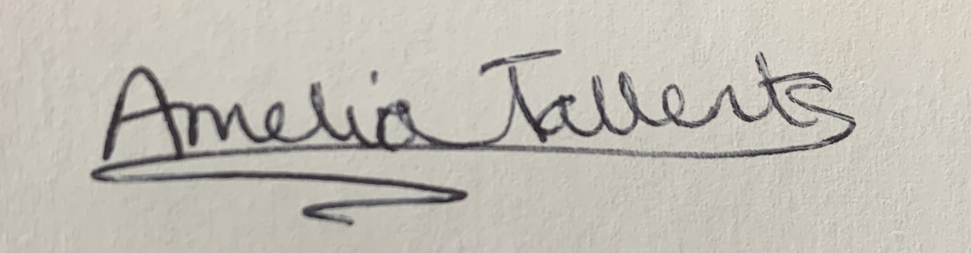 |  |  |  |  | 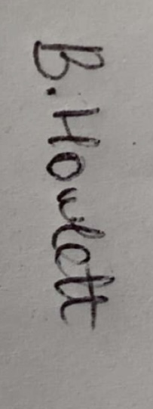  Responsible manager’s signature:
Print name: AMELIA TALLENTS |  |  |  | Date: 19/06/22 | Print name: BELLE HOWLETT |  | Date: 19/06/22

Assessment Guidance
- Eliminate | Remove the hazard wherever possible which negates the need for further controls | If this is not possible then explain why
- Substitute | Replace the hazard with one less hazardous | If not possible then explain why
- Physical controls | Examples: enclosure, fume cupboard, glove box | Likely to still require admin controls as well
- Admin controls | Examples: training, supervision, signage
- Personal protection | Examples: respirators, safety specs, gloves | Last resort as it only protects the individual
LIKELIHOOD | 5 | 5 | 10 | 15 | 20 | 25
 | 4 | 4 | 8 | 12 | 16 | 20
 | 3 | 3 | 6 | 9 | 12 | 15
 | 2 | 2 | 4 | 6 | 8 | 10
 | 1 | 1 | 2 | 3 | 4 | 5
 |  | 1 | 2 | 3 | 4 | 5
 |  | IMPACT

Impact |  | Health & Safety
1 | Trivial - insignificant | Very minor injuries e.g. slight bruising
2 | Minor | Injuries or illness e.g. small cut or abrasion which require basic first aid treatment even in self-administered.
3 | Moderate | Injuries or illness e.g. strain or sprain requiring first aid or medical support.
4 | Major | Injuries or illness e.g. broken bone requiring medical support >24 hours and time off work >4 weeks.
5 | Severe – extremely significant | Fatality or multiple serious injuries or illness requiring hospital admission or significant time off work.

Likelihood
1 | Rare e.g. 1 in 100,000 chance or higher
2 | Unlikely e.g. 1 in 10,000 chance or higher
3 | Possible e.g. 1 in 1,000 chance or higher
4 | Likely e.g. 1 in 100 chance or higher
5 | Very Likely e.g. 1 in 10 chance or higher

