Risk Assessment
Risk Assessment for the activity of | Day to Day work of the Obstetrics & Gynaecology Society as well as face to face events |  | Date | 20/8/2021
Unit/Faculty/Directorate | MedSoc SUSU | Assessor
Line Manager/Supervisor | SUSU Activities Teams | Signed off

PART A
(1) Risk identification |  |  | (2) Risk assessment |  |  |  | (3) Risk management
Hazard | Potential Consequences | Who might be harmed  (user; those nearby; those in the vicinity; members of the public) | Inherent |  |  |  | Residual |  |  | Further controls (use the risk hierarchy)
 |  |  | Likelihood | Impact | Score | Control measures (use the risk hierarchy) | Likelihood | Impact | Score
Security/privacy issues related to use of video or voice call software. | Data protection breach | All participants | 3 | 2 | 6 | - Create password for participants  - Ask participants to verify whether they are a student/member of SUSU using their University email address  - Avoid publishing links and passwords on social media or in public forums  - Participants to be directed not to pass on link details to persons who are not members of SUSU, regardless as to how well they know them  - Non-members should only be allowed to join if they are trusted by the committee, provide a clear benefit to the society such as instruction/guidance and can be verified by the host  - Meeting host to compare the list of participants within the digital platform against the list of those expected to be in attendance at the start of every meeting. | 1 | 2 | 2 | Virtual meeting host to remove uninvited participants from the meeting where possible
Using other person’s personal details to host or participate in public events | Data protection breach | Person whose details are used | 3 | 2 | 6 | - Students to stream and join sessions using their own software account and identity rather than using another person’s details  - If a participant is using another person’s device, they should change the automatic participation name where applicable (e.g. John’s iPad) | 1 | 2 | 2
Unauthorised recording of sessions | Data protection breach | All participants | 2 | 3 | 6 | - Switch off in software settings where applicable  - Ensure all participants are aware that the session must not be recorded by any person unless agreed and publicised clearly beforehand and with a clear description of how the recording will be used and who it will be available to. | 1 | 3 | 3 | - Activity hosts to make participants aware if they notice a person is recording session without prior agreement  - If observed to be recording; activity hosts to ask the person to stop. Refusal justifies removal from the activity.
Inappropriate behaviour | Bullying and harassment of participants | All participants | 2 | 3 | 6 | SUSU believes everyone should be able to enjoy their time at university and all the experiences that go along with that. SUSU has a zero-tolerance approach regarding discrimination, prejudice, hate crime, racism, sexual misconduct, and any vicitimisation through any activity, including online  - Participants to be reminded to be respectful of others  - Activity host to have read SUSU’s Expect Respect Policy  https://www.susu.org/downloads/SUSU-Expect-Respect-Policy.pdf | 1 | 3 | 3 | - Activity host to remove participants from the online activity if they are behaving inappropriately  - Activity host to report inappropriate behaviour to SUSU’s Activities team (activities@susu.org)
Physical injury while setting up venue for face to face events | Physical injury | Committee members involved in organising the event  Invited Speakers | 2 | 2 | 4 | - Ensure committee members are aware of possible physical hazards when setting up venues  - Committee members and invited speakers coordinate the organised and careful setting up of venues, including the transfer or materials and props such as obstetric models and medical equipment (e.g. speculums) | 1 | 3 | 3 | - Administrative control by ensuring the team work and supervision of transfer of materials and setting up venues by at least one member of the committee in a supervisory role.
COVID-19 transmission in face to face events | Physical illness and community transmission of virus | All participants, including committee members, guests, speakers, attending society members | 4 | 4 | 16 | - Wear and encourage face coverings when moving around inside our buildings or in crowded spaces  - Practise good personal and hand hygiene by offering hand sanitiser gel and hand washing facilities to participants  - Continue to practise physical distancing wherever possible  - Ensure areas of common space used are cleaned regularly  - . Follow appropriate meeting room and local guidance | 3 | 4 | 12 | - Physical controls – social distancing, regular cleaning of common areas, hand washing facilities and equipment, adequate room space and ventilation  - PPE – Encourage use of face coverings inside building and in crowded spaces  - Admin – collect contact details of all participants to allow tracking & tracing should there be any COVID-19 cases  - Facility guidance to be followed as per updated University Conduct Code found at https://www.southampton.ac.uk/coronavirus.page

PART B – Action Plan

Risk Assessment Action Plan
Part no. | Action to be taken, incl. Cost | By whom | Target date |  | Review date | Outcome at review date
1 | Ensure hand sanitisers available at event venues (source from University) | Co-Presidents | TBC (on day of event) |  | TBC
2 | Ask all event attendees to ensure a negative lateral flow test before attending event | Co-presidents | TBC (before day of event) |  | TBC
3 | Ensure contact details of participants to face to face events are collected on the day | Committee Members | TBC (on day of event) |  | TBC
4 | Encourage wearing face masks and social distancing at all events | Committee Members | TBC (on day of event) |  | TBC
Responsible manager’s signature: 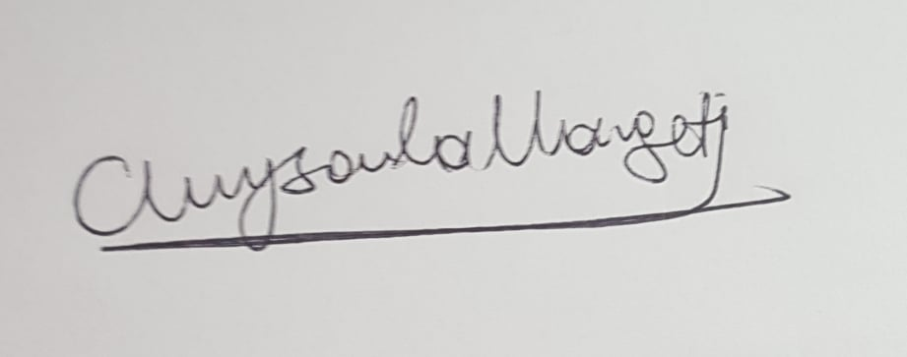 |  |  |  |  | 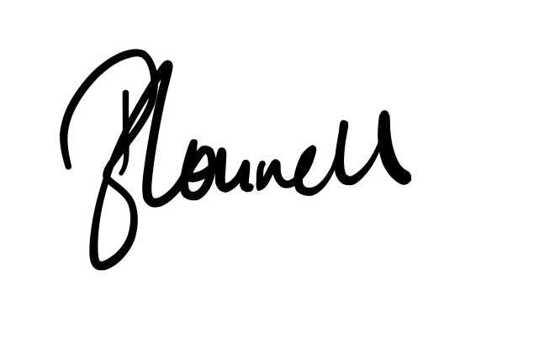  Responsible manager’s signature:
Print name: CHRYSOULA MARGETI |  |  |  | Date: 20/8/21 | Print name: BETHANY CONNELL |  | Date 20/08/21

Assessment Guidance
- Eliminate | Remove the hazard wherever possible which negates the need for further controls | If this is not possible then explain why
- Substitute | Replace the hazard with one less hazardous | If not possible then explain why
- Physical controls | Examples: enclosure, fume cupboard, glove box | Likely to still require admin controls as well
- Admin controls | Examples: training, supervision, signage
- Personal protection | Examples: respirators, safety specs, gloves | Last resort as it only protects the individual
LIKELIHOOD | 5 | 5 | 10 | 15 | 20 | 25
 | 4 | 4 | 8 | 12 | 16 | 20
 | 3 | 3 | 6 | 9 | 12 | 15
 | 2 | 2 | 4 | 6 | 8 | 10
 | 1 | 1 | 2 | 3 | 4 | 5
 |  | 1 | 2 | 3 | 4 | 5
 |  | IMPACT

Impact |  | Health & Safety
1 | Trivial - insignificant | Very minor injuries e.g. slight bruising
2 | Minor | Injuries or illness e.g. small cut or abrasion which require basic first aid treatment even in self-administered.
3 | Moderate | Injuries or illness e.g. strain or sprain requiring first aid or medical support.
4 | Major | Injuries or illness e.g. broken bone requiring medical support >24 hours and time off work >4 weeks.
5 | Severe – extremely significant | Fatality or multiple serious injuries or illness requiring hospital admission or significant time off work.
Risk process
- Identify the impact and likelihood using the tables above.
- Identify the risk rating by multiplying the Impact by the likelihood using the coloured matrix.
- If the risk is amber or red – identify control measures to reduce the risk to as low as is reasonably practicable.
- If the residual risk is green, additional controls are not necessary.
- If the residual risk is amber the activity can continue but you must identify and implement further controls to reduce the risk to as low as reasonably practicable.
- If the residual risk is red do not continue with the activity until additional controls have been implemented and the risk is reduced.
- Control measures should follow the risk hierarchy, where appropriate as per the pyramid above.
- The cost of implementing control measures can be taken into account but should be proportional to the risk i.e. a control to reduce low risk may not need to be carried out if the cost is high but a control to manage high risk means that even at high cost the control would be necessary.

Likelihood
1 | Rare e.g. 1 in 100,000 chance or higher
2 | Unlikely e.g. 1 in 10,000 chance or higher
3 | Possible e.g. 1 in 1,000 chance or higher
4 | Likely e.g. 1 in 100 chance or higher
5 | Very Likely e.g. 1 in 10 chance or higher

