Risk Assessment
Risk Assessment for the activity of | SULS Bunfight/Refreshers Stalls |  | Date | 07/05/2020
Club or Society | Southampton University Labour Society | Assessor | Victoria Crawshaw
President or Students’ Union staff member |  | Signed off

PART A
(1) Risk identification |  |  | (2) Risk assessment |  |  |  | (3) Risk management
Hazard | Potential Consequences | Who might be harmed  (user; those nearby; those in the vicinity; members of the public) | Inherent |  |  |  | Residual |  |  | Further controls (use the risk hierarchy)
 |  |  | Likelihood | Impact | Score | Control measures (use the risk hierarchy) | Likelihood | Impact | Score
(1) Supplies and Equipment -Manual Handling | Damage to supplies/equipment  Injury when transporting supplies/equipment | People transporting supplies/equipment; those nearby | 3 | 3 | 9 | The society will ensure that minimal lifting is required. Any heavy loads will be broken down to make moving supplies/equipment much more manageable. | 2 | 1 | 2 | Those who are transporting supplies/equipment (likely volunteering committee members) will clear a route from the origin to the destination to ensure easy transit and reduce the likelihood of injury or damage.
(2) Event - Spilling of liquid | Trips, slips and falls | All | 3 | 4 | 12 | The volunteers will use cloths to clean up spills as soon as they occur on the scene.  The walkway will not be obstructed by our stall, possessions or volunteers. | 2 | 1 | 2 | Volunteers to monitor spillage.  If an injury occurs and it is deemed necessary, a SUSU representative and the appropriate emergency services will be contacted. A mobile telephone will be available to contact the emergency services.
(3) Event –  Fire | Fire could be caused by power socket overload, or irresponsible use of water near electrical equipment. | Those in the vicinity | 3 | 5 | 15 | Keep all water and general liquids away from the electrical points  Raise alarm if a fire is noticed  All electrical equipment must be PAT-tested | 2 | 2 | 4 | Make sure stall volunteers know where the fire exits and fire extinguishers are located, which are only to be used if a volunteer feels confident.  The walkway will not be obstructed by our stall, possessions or volunteers.  A mobile telephone will be available to contact the emergency services.
(4) Event - Damage to personal possessions/ Union Southampton Property/University Property | Theft and loss of items | All | 2 | 3 | 6 | All volunteers will be informed that personal possessions are taken into buildings at their own risk and the committee/university/SUSU cannot be held responsible for any loss or damage. |  |  |  | Volunteers will ensure that conduct of attendees remains respectful and will report anyone who is not following these guidelines to SUSU staff. Volunteers will contact university security if deemed necessary to ensure that the person is escorted off the property.  If lost items are found by a volunteer, they will be returned to SUSU reception if reasonably possible.
(5) Event – Serving of pre-packaged or prepared food and drink | Food allergies  Contamination of food | All | 3 | 4 | 12 | All food/drink that is served must be unopened and not require cooking (e.g. biscuits or lemonade); volunteers will ensure an ingredients list is available and will make information clear to attendees if the items contains any allergens. | 2 | 2 | 4 | If allergic reaction or injury occurs, a SUSU representative and the appropriate emergency services will be contacted if deemed necessary. A mobile telephone will be available to contact the emergency services.
(6) Event - Use of blindfold in ‘pin the tail on the donkey’ activity | Very minor injuries e.g. slight bruising  Injuries e.g. small cut or abrasion which might require basic first aid treatment. | All attendees who participate; those in the vicinity of the stall | 3 | 2 | 6 | A volunteer will supervise the attendee.  The game will be kept away from obstructions and the walkway.  The floorspace surrounding the game will be kept clear.  A basic first aid kit will be kept at the stall if the activity takes place. | 2 | 2 | 4 | If an injury occurs, a SUSU representative and the appropriate emergency services will be contacted if deemed necessary. A mobile telephone will be available to contact the emergency services.

PART B – Action Plan

Risk Assessment Action Plan
Part no. | Action to be taken, incl. Cost | By whom | Target date | Review date | Outcome at review date
2,3,5, 6 | A mobile telephone will be available to contact the emergency services. (No cost) | All Committee | 30/09/2020 | 01/10/2020 | -
3 | Attendees will be made aware of where the nearest fire exits and fire extinguishers are located. (No cost) | All Committee | 30/09/2020 | 01/10/2020 | -
4 | Attendees will be informed that personal possessions are taken into meetings at their own risk and the committee/university/SUSU cannot be held responsible for any loss or damage. (No cost) | All Committee | 30/09/2020 | 01/10/2020 | -
4 | The phone number for university security will be distributed to all committee members. (No cost) | President  Elect | 01/09/2020 | 02/09/2020 | -
6 | Obtain a basic first aid kit if pin-the-tail activity proceeds at 2020 Bunfight (approximately £8) | President Elect | 01/09/2020 | 02/09/2020 | -
Responsible committee member signature:  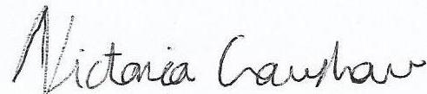 |  |  |  | Responsible committee member signature:  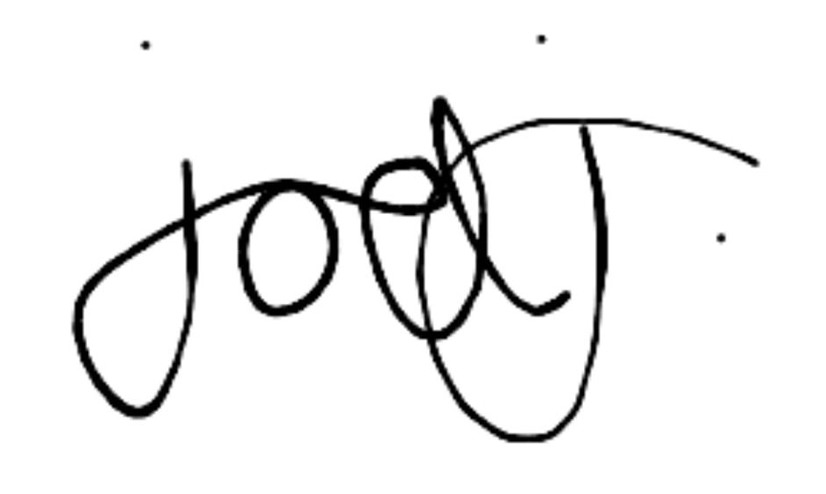
Print name: VICTORIA CRAWSHAW |  |  | Date: 07/05/2020 | Print name: JOEL JORDAN |  | Date: 07/05/2020

Assessment Guidance
- Eliminate | Remove the hazard wherever possible which negates the need for further controls | If this is not possible then explain why
- Substitute | Replace the hazard with one less hazardous | If not possible then explain why
- Physical controls | Examples: enclosure, fume cupboard, glove box | Likely to still require admin controls as well
- Admin controls | Examples: training, supervision, signage
- Personal protection | Examples: respirators, safety specs, gloves | Last resort as it only protects the individual
LIKELIHOOD | 5 | 5 | 10 | 15 | 20 | 25
 | 4 | 4 | 8 | 12 | 16 | 20
 | 3 | 3 | 6 | 9 | 12 | 15
 | 2 | 2 | 4 | 6 | 8 | 10
 | 1 | 1 | 2 | 3 | 4 | 5
 |  | 1 | 2 | 3 | 4 | 5
 |  | IMPACT

Impact |  | Health & Safety
1 | Trivial - insignificant | Very minor injuries e.g. slight bruising
2 | Minor | Injuries or illness e.g. small cut or abrasion which require basic first aid treatment even in self-administered.
3 | Moderate | Injuries or illness e.g. strain or sprain requiring first aid or medical support.
4 | Major | Injuries or illness e.g. broken bone requiring medical support >24 hours and time off work >4 weeks.
5 | Severe – extremely significant | Fatality or multiple serious injuries or illness requiring hospital admission or significant time off work.
Risk process
- Identify the impact and likelihood using the tables above.
- Identify the risk rating by multiplying the Impact by the likelihood using the coloured matrix.
- If the risk is amber or red – identify control measures to reduce the risk to as low as is reasonably practicable.
- If the residual risk is green, additional controls are not necessary.
- If the residual risk is amber the activity can continue but you must identify and implement further controls to reduce the risk to as low as reasonably practicable.
- If the residual risk is red do not continue with the activity until additional controls have been implemented and the risk is reduced.
- Control measures should follow the risk hierarchy, where appropriate as per the pyramid above.
- The cost of implementing control measures can be taken into account but should be proportional to the risk i.e. a control to reduce low risk may not need to be carried out if the cost is high but a control to manage high risk means that even at high cost the control would be necessary.

Likelihood
1 | Rare e.g. 1 in 100,000 chance or higher
2 | Unlikely e.g. 1 in 10,000 chance or higher
3 | Possible e.g. 1 in 1,000 chance or higher
4 | Likely e.g. 1 in 100 chance or higher
5 | Very Likely e.g. 1 in 10 chance or higher

